**DISEASE SEVERITY TRACKER-CROP(SOYABEAN)**

*A*

*Report*

*Submitted in partial fulfilment of the*

*Requirements for the award of the Degree of*

**BACHELOR OF ENGINEERING**

**IN**

**INFORMATION TECHNOLOGY**

**By**

**T N Sree Ram <1602-21-737-054>**

**Under the guidance of Ms B. Leelavathy**



**Department of Information Technology**

**Vasavi College of Engineering (Autonomous)**

**(Affiliated to Osmania University)**

**Ibrahimbagh, Hyderabad-31**

**2022-2023**

**ABSTRACT**

The disease severity tracker for soybean crops is a database management system that enables farmers to track the growth of their crops and monitor the severity of diseases that may affect them. The system consists of five tables, namely Crops, Diseases, Disease_Severity, Fields, and Field_Crops. These tables store information about the crops planted, the diseases that may affect them, severity scores for different diseases on specific dates, and the fields where the crops are planted. Farmers can use this information to make informed decisions about how to manage their crops and prevent or mitigate disease outbreaks, ultimately increasing their crop yields and improving the efficiency of their farming operations.

**Requirement Analysis**

**List of Tables:**

1. Crops

2. Diseases

3. Disease Severity

4. Fields

5. Field Crops

List of attibutes and data types:

1.Crops

* crop_id (Number)
* crop_name (varchar)
* crop_planted_date (DATE)

2.Diseases

* disease_id (Number)
* disease_name (varchar)

3.Disease_severity

* severity_id (Number)
* crop_id (Number)
* disease_id (Number)
* dat (DATE)
* severity_score (Number)

4.Fields

* field_id (Number)
* field_name (varchar)
* field_size (Number)

5.Field_crops

* field_crop_id (Number)
* field_id (Number)
* crop_id(Number)
* date_planted (DATE)

Constraints and cardinalities :

Crops:

Cardinality: One Crop can be planted in many Field_Crops. One Field_Crop can only have one Crop.

Constraints: Each Crop should have a unique name and ID.

Diseases:

Cardinality: One Disease can have many Disease_Severity. One Disease_Severity can only have one Disease.

Constraints: Each Disease should have a unique name and ID.

Disease_Severity:

Cardinality: One Disease_Severity can only have one Crop and one Disease. One Crop can have many Disease_Severity. One Disease can have many Disease_Severity.

Constraints: Each Disease_Severity should have a unique ID. The Crop ID and Disease ID in each Disease_Severity record should refer to valid IDs in the Crops and Diseases tables, respectively.

Fields:

Cardinality: One Field can have many Field_Crops. One Field_Crop can only have one Field.

Constraints: Each Field should have a unique name and ID.

Field_Crops:

Cardinality: One Field_Crop can only have one Crop and one Field. One Crop can be planted in many Field_Crops. One Field can have many Field_Crops.

Constraints: Each Field_Crop should have a unique ID. The Crop ID and Field ID in each Field_Crop record should refer to valid IDs in the Crops and Fields tables, respectively.

DESIGN

Entity Relationship Diagram

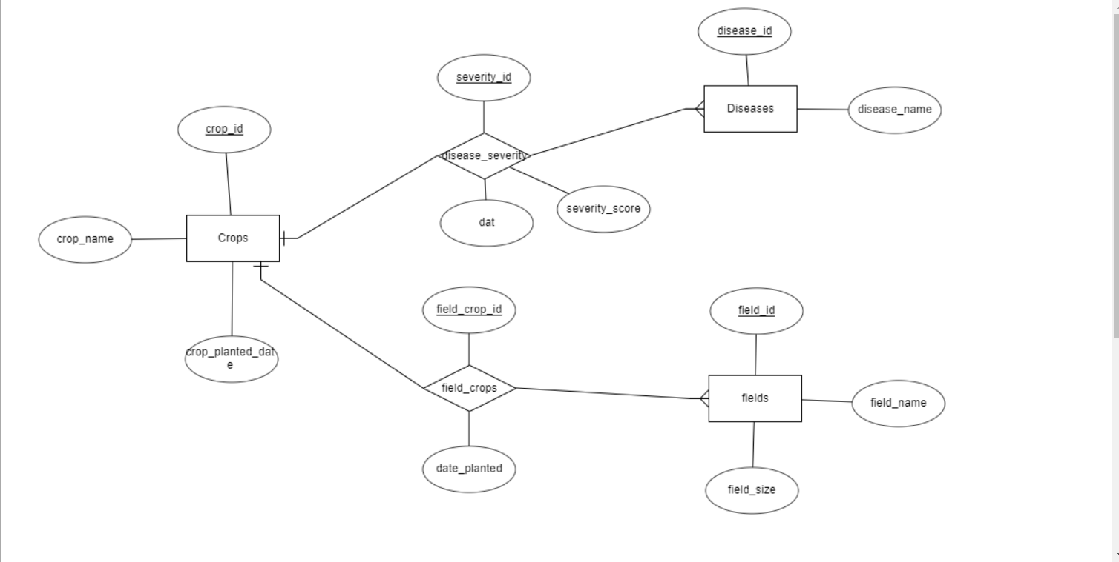

DDL Commands:

SQL> create table crops(

2 crop_id int primary key,

3 crop_name VARCHAR(50),

4 crop_planted_date DATE

5 );

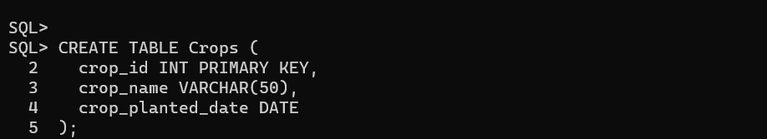

SQL> create table Disease_severity(

2 severity_id int primary key,

3 crop_id int,

4 disease_id int,

5 dat DATE,

6 severity_score INT,

7 FOREIGN KEY (crop_id) REFERENCES Crops(crop_id),

8 FOREIGN KEY (disease_id) REFERENCES Diseases(disease_id)

9 );

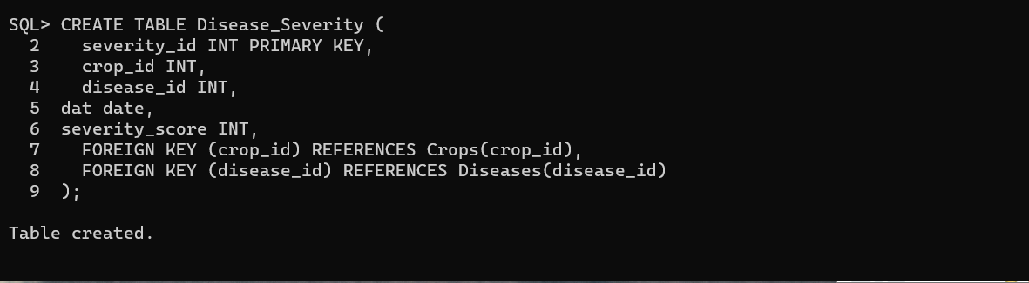

SQL> create table Diseases(

2 disease_id INT PRIMARY KEY,

3 disease_name VARCHAR(50)

4 );

SQL> create table Fields(

2 field_id INT PRIMARY KEY,

3 field_name VARCHAR(50),

4 field_size INT

5 );

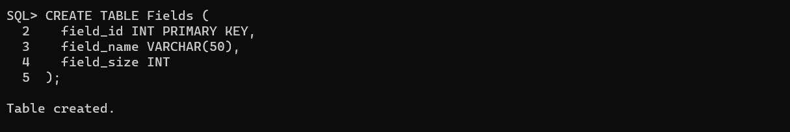

SQL> create table Field_crops(

field_crop_id INT PRIMARY KEY,

field_id INT,

crop_id INT,

date_planted DATE,

FOREIGN KEY (field_id) REFERENCES Fields(field_id),

FOREIGN KEY (crop_id) REFERENCES Crops(crop_id)

);

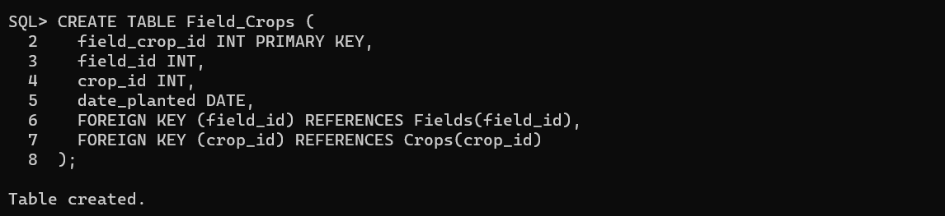

TABLES:

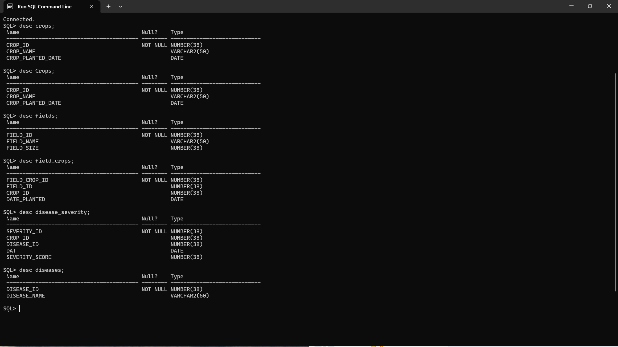

DML Commands:

SQL> insert into crops values(&crop_id,'&crop_name','&crop_planted_date');

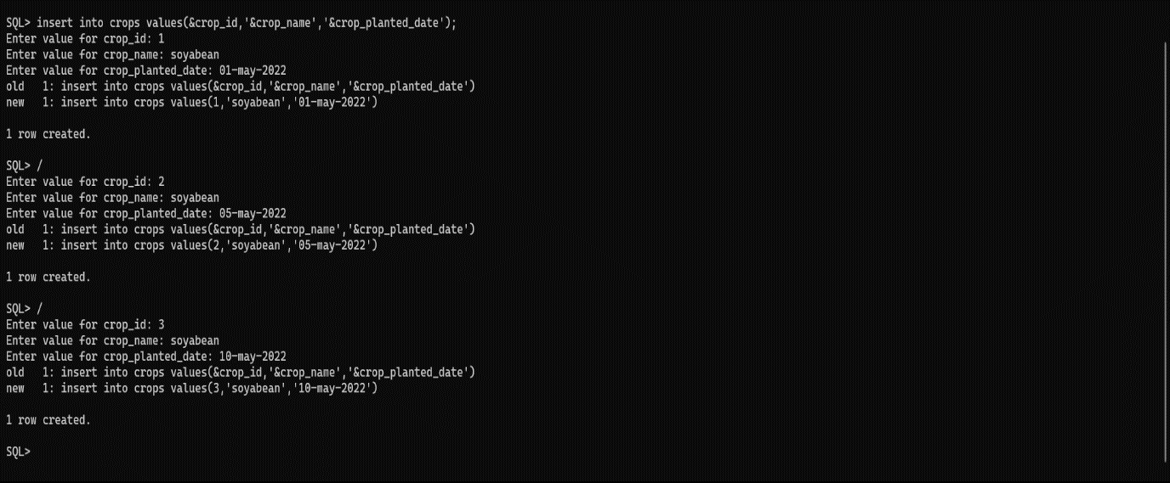

SQL> insert into diseases values(&disease_id,'&disease_name');

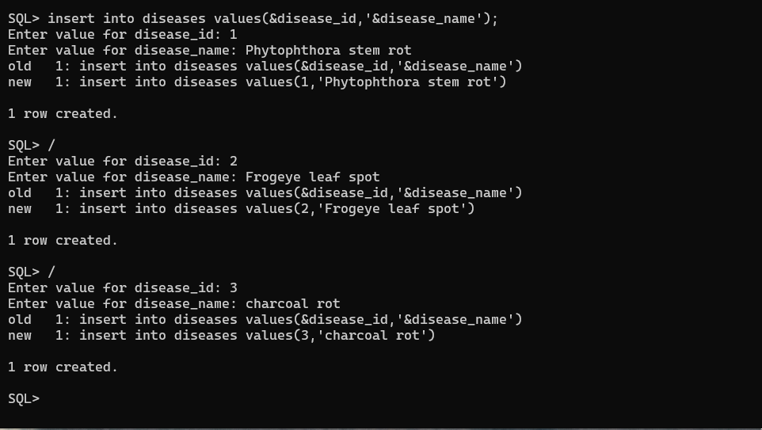

SQL> insert into disease_severity values(&severity_id,&crop_id,&disease_id,’&dat’,&severity_score);

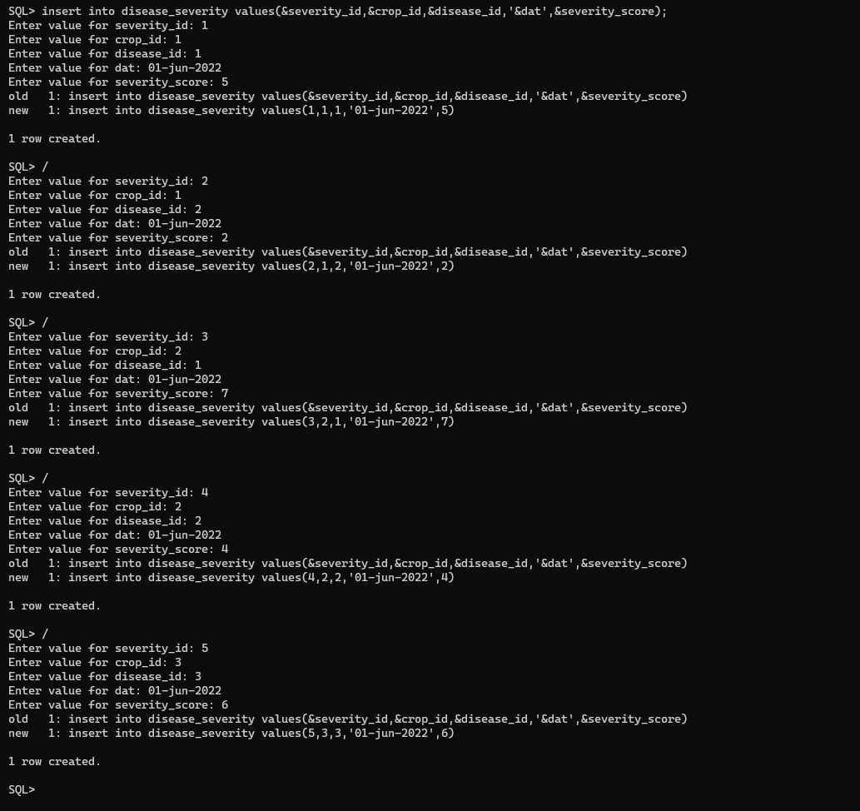

SQL> insert into fields values(&field_id,’&field_name’,&field_size);

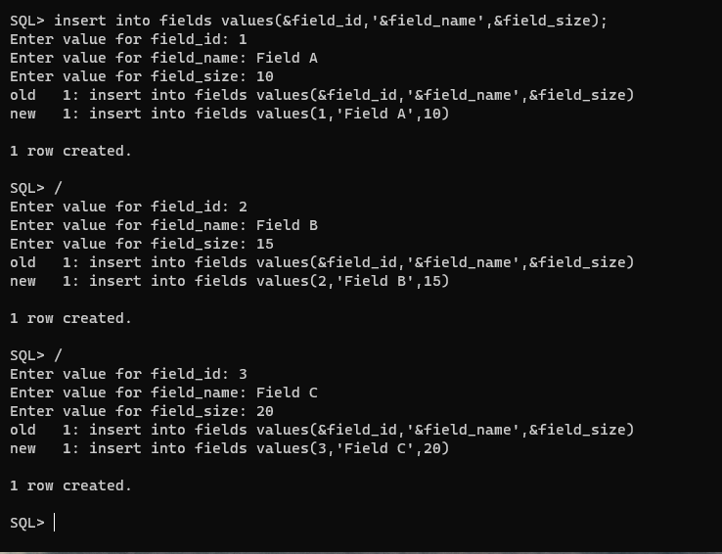

SQL> insert into field_crops values(&field_crop_id,&field_id,&crop_id,’&date_planted’);

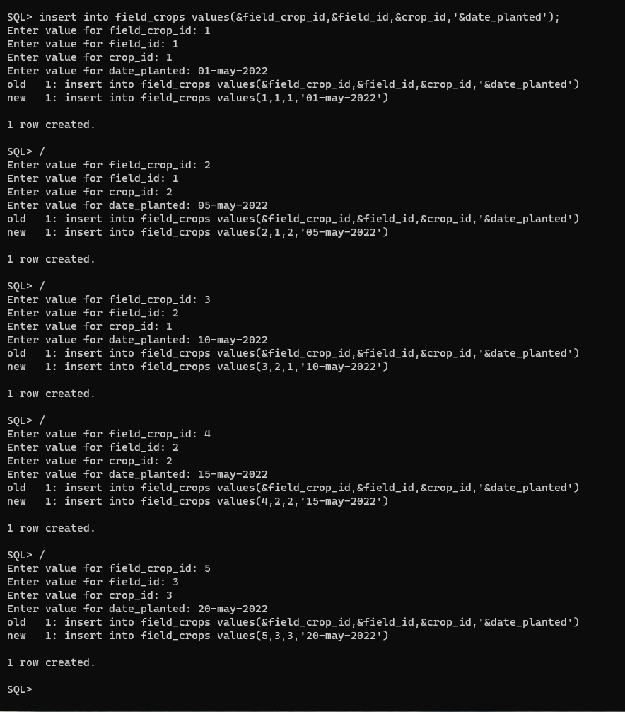

IMPLEMENTATION

JAVA-SQL Connectivity using JDBC:

JAVA Database Connectivity (JDBC) is an application programming interface (API) for the programming language Java,which defines how a client may access a database.It is a java based access technology used for java database connectivity.It is part of Java Standard Edition Platform,from Oracle Corporation.It provides methods to query and update data in database and is oriented towards relational databases.

Code

The java file is disease_crop.

import javax.swing.*;

import java.awt.*;

import java.awt.event.ActionEvent;

import java.awt.event.ActionListener;

import java.sql.*;

import java.text.SimpleDateFormat;

public class disease_crop {

private JFrame frame;

private JComboBox<String> tableComboBox;

private JButton insertButton;

private JButton updateButton;

private JButton deleteButton;

private JButton displayButton;

private JButton clearButton;

private JButton analyzeButton;

private JButton maxButton;

private JButton minButton;

private JTextArea outputTextArea;

private Connection connection;

public disease_crop() {

try {

// Establish the database connection

connection = DriverManager.getConnection("jdbc:oracle:thin:@localhost:1521:xe","sreeram","vasavi");

} catch (SQLException e) {

e.printStackTrace();

JOptionPane.showMessageDialog(null, "Error: Failed to connect to the database.", "Database Connection Error", JOptionPane.ERROR_MESSAGE);

}

}

public void start() {

frame = new JFrame("Disease Severity Tracker In Soyabean Crop");

frame.setDefaultCloseOperation(JFrame.EXIT_ON_CLOSE);

setFrameSizeWithMargin(20);

JPanel mainPanel = new JPanel();

mainPanel.setLayout(new FlowLayout());

outputTextArea = new JTextArea();

outputTextArea.setEditable(false);

JScrollPane scrollPane = new JScrollPane(outputTextArea);

scrollPane.setBounds(20, 125, 560, 300);

frame.add(scrollPane);

clearButton = new JButton("Clear");

clearButton.setBounds(260, 80, 80, 30);

analyzeButton = new JButton("Analyze");

analyzeButton.setBounds(170,80,80,30);

displayButton= new JButton("Display");

displayButton.setBounds(80,80,80,30);

maxButton=new JButton("Max severity");

maxButton.setBounds(600,160,140,30);

minButton=new JButton("Min severity");

minButton.setBounds(600,220,140,30);

frame.add(clearButton);

frame.add(analyzeButton);

frame.add(displayButton);

frame.add(maxButton);

frame.add(minButton);

JLabel tableLabel = new JLabel("Select a table:");

tableComboBox = new JComboBox<>();

tableComboBox.addItem("crops");

tableComboBox.addItem("diseases");

tableComboBox.addItem("disease_severity");

tableComboBox.addItem("fields");

tableComboBox.addItem("field_crops");

insertButton = new JButton("Submit");

updateButton = new JButton("Modify");

deleteButton = new JButton("Delete");

mainPanel.add(tableLabel);

mainPanel.add(tableComboBox);

mainPanel.add(insertButton);

mainPanel.add(updateButton);

mainPanel.add(deleteButton);

insertButton.addActionListener(new ActionListener() {

public void actionPerformed(ActionEvent e) {

String tableName = (String) tableComboBox.getSelectedItem();

if (tableName != null && !tableName.isEmpty()) {

if (tableName.equals("crops")) {

insertCropsRecord();

} else if (tableName.equals("diseases")) {

insertDiseasesRecord();

} else if (tableName.equals("fields")) {

insertFieldsRecord();

} else if(tableName.equals("field_crops")) {

insertFieldCropRecord();

} else if(tableName.equals("disease_severity")) {

insertDiseaseSeverityRecord();

}

else {

insertRecord(tableName);

}

}

}

});

updateButton.addActionListener(new ActionListener() {

public void actionPerformed(ActionEvent e) {

String tableName = (String) tableComboBox.getSelectedItem();

if (tableName != null && !tableName.isEmpty()) {

if (tableName.equals("crops")) {

updateCropsRecord();

} else if (tableName.equals("diseases")) {

updateDiseasesRecord();

}

else if(tableName.equals("fields")) {

updateFieldsRecord();

} else if(tableName.equals("field_crops")) {

updateFieldCropRecord();

} else if(tableName.equals("disease_severity")) {

updateDiseaseSeverityRecord();

}

else {

updateRecord(tableName);

}

}

}

});

deleteButton.addActionListener(new ActionListener() {

public void actionPerformed(ActionEvent e) {

String tableName = (String) tableComboBox.getSelectedItem();

if (tableName != null && !tableName.isEmpty()) {

if (tableName.equals("crops")) {

deleteCropsRecord();

} else if (tableName.equals("diseases")) {

deleteDiseasesRecord();

} else if(tableName.equals("fields")) {

deleteFieldsRecord();

} else if(tableName.equals("field_crops")) {

deleteFieldCropRecord();

} else if(tableName.equals("disease_severity")) {

deleteDiseaseSeverityRecord();

}

else {

deleteRecord(tableName);

}

}

}

});

displayButton.addActionListener(new ActionListener() {

public void actionPerformed(ActionEvent e) {

String tableName = (String) tableComboBox.getSelectedItem();

if(tableName !=null && !tableName.isEmpty()) {

if(tableName.equals("crops")) {

displayCrops();

} else if(tableName.equals("diseases")) {

displayDiseases();

} else if(tableName.equals("disease_severity")) {

displayDiseaseSeverity();

} else if(tableName.equals("fields")) {

displayFields();

} else if(tableName.equals("field_crops")) {

displayFieldCrops();

} else {

displayRecord(tableName);

}

}

}

});

clearButton.addActionListener(new ActionListener() {

public void actionPerformed(ActionEvent e) {

outputTextArea.setText(null);

}

});

analyzeButton.addActionListener(new ActionListener() {

public void actionPerformed(ActionEvent e) {

outputTextArea.setText(null); // Clear the text area

try {

Statement statement = connection.createStatement();

ResultSet resultSet = statement.executeQuery("select ds.crop_id,c.crop_name,c.crop_planted_date,ds.disease_id,d.disease_name,ds.severity_id,ds.dat,ds.severity_score from crops c,diseases d,disease_severity ds where c.crop_id=ds.crop_id and ds.disease_id=d.disease_id");

StringBuilder sb = new StringBuilder();

while (resultSet.next()) {

int cropId = resultSet.getInt("crop_id");

String cropName = resultSet.getString("crop_name");

Date cropdate=resultSet.getDate("crop_planted_date");

int diseaseId = resultSet.getInt("disease_id");

String diseaseName = resultSet.getString("disease_name");

int severityId = resultSet.getInt("severity_id");

Date date = resultSet.getDate("dat");

double severityScore = resultSet.getDouble("severity_score");

SimpleDateFormat dateFormat = new SimpleDateFormat("dd-MMM-yyyy");

String formattedDate = dateFormat.format(date);

SimpleDateFormat dateFormat1 = new SimpleDateFormat("dd-MMM-yyyy");

String formatteddate = dateFormat1.format(cropdate);

sb.append(" Crop ID: ").append(cropId).append("\n");

sb.append(" Crop Name: ").append(cropName).append("\n");

sb.append(" Crop Planted Date: ").append(formatteddate).append("\n");

sb.append(" Disease ID: ").append(diseaseId).append("\n");

sb.append(" Disease Name: ").append(diseaseName).append("\n");

sb.append(" Severity ID: ").append(severityId).append("\n");

sb.append(" Date: ").append(formattedDate).append("\n");

sb.append(" Severity Score: ").append(severityScore).append("\n");

sb.append("\n");

// Retrieve other columns as needed

}

outputTextArea.setText(sb.toString());

outputTextArea.append("------------------------------------------------------------------------------------------------------------------------------------\nTHE DETAILS OF CROPS WITH DISEASES ARE DISPLAYED ABOVE.\n");

resultSet.close();

statement.close();

} catch (SQLException ex) {

ex.printStackTrace();

JOptionPane.showMessageDialog(null, "Error: Failed to analyze disease severity data.", "Analysis Error", JOptionPane.ERROR_MESSAGE);

}

}

});

maxButton.addActionListener(new ActionListener() {

public void actionPerformed(ActionEvent e) {

outputTextArea.setText(null);

try {

Statement statement = connection.createStatement();

ResultSet resultSet = statement.executeQuery("select ds.crop_id,c.crop_name,c.crop_planted_date,ds.disease_id,d.disease_name,ds.severity_id,ds.dat,ds.severity_score from crops c,diseases d,disease_severity ds where c.crop_id=ds.crop_id and ds.disease_id=d.disease_id and ds.severity_score=(select max(severity_score) from disease_severity)");

StringBuilder sb = new StringBuilder();

while (resultSet.next()) {

int cropId = resultSet.getInt("crop_id");

String cropName = resultSet.getString("crop_name");

Date cropdate=resultSet.getDate("crop_planted_date");

int diseaseId = resultSet.getInt("disease_id");

String diseaseName = resultSet.getString("disease_name");

int severityId = resultSet.getInt("severity_id");

Date date = resultSet.getDate("dat");

double severityScore = resultSet.getDouble("severity_score");

SimpleDateFormat dateFormat = new SimpleDateFormat("dd-MMM-yyyy");

String formattedDate = dateFormat.format(date);

SimpleDateFormat dateFormat1 = new SimpleDateFormat("dd-MMM-yyyy");

String formatteddate = dateFormat1.format(cropdate);

sb.append(" Crop ID: ").append(cropId).append("\n");

sb.append(" Crop Name: ").append(cropName).append("\n");

sb.append(" Crop Planted Date: ").append(formatteddate).append("\n");

sb.append(" Disease ID: ").append(diseaseId).append("\n");

sb.append(" Disease Name: ").append(diseaseName).append("\n");

sb.append(" Severity ID: ").append(severityId).append("\n");

sb.append(" Date: ").append(formattedDate).append("\n");

sb.append(" Severity Score: ").append(severityScore).append("\n");

sb.append("\n");

// Retrieve other columns as needed

}

outputTextArea.setText(sb.toString());

outputTextArea.append("------------------------------------------------------------------------------------------------------------------------------------\nTHE DETAILS OF CROP WITH MAXIMUM SEVERITY SCORE IS DISPLAYED ABOVE.\n");

resultSet.close();

statement.close();

} catch (SQLException ex) {

ex.printStackTrace();

JOptionPane.showMessageDialog(null, "Error: Failed to analyze disease severity data.", "Analysis Error", JOptionPane.ERROR_MESSAGE);

}

}

});

minButton.addActionListener(new ActionListener() {

public void actionPerformed(ActionEvent e) {

outputTextArea.setText(null);

try {

Statement statement = connection.createStatement();

ResultSet resultSet = statement.executeQuery("select ds.crop_id,c.crop_name,c.crop_planted_date,ds.disease_id,d.disease_name,ds.severity_id,ds.dat,ds.severity_score from crops c,diseases d,disease_severity ds where c.crop_id=ds.crop_id and ds.disease_id=d.disease_id and ds.severity_score=(select min(severity_score) from disease_severity)");

StringBuilder sb = new StringBuilder();

while (resultSet.next()) {

int cropId = resultSet.getInt("crop_id");

String cropName = resultSet.getString("crop_name");

Date cropdate=resultSet.getDate("crop_planted_date");

int diseaseId = resultSet.getInt("disease_id");

String diseaseName = resultSet.getString("disease_name");

int severityId = resultSet.getInt("severity_id");

Date date = resultSet.getDate("dat");

double severityScore = resultSet.getDouble("severity_score");

SimpleDateFormat dateFormat = new SimpleDateFormat("dd-MMM-yyyy");

String formattedDate = dateFormat.format(date);

SimpleDateFormat dateFormat1 = new SimpleDateFormat("dd-MMM-yyyy");

String formatteddate = dateFormat1.format(cropdate);

sb.append(" Crop ID: ").append(cropId).append("\n");

sb.append(" Crop Name: ").append(cropName).append("\n");

sb.append(" Crop Planted Date: ").append(formatteddate).append("\n");

sb.append(" Disease ID: ").append(diseaseId).append("\n");

sb.append(" Disease Name: ").append(diseaseName).append("\n");

sb.append(" Severity ID: ").append(severityId).append("\n");

sb.append(" Date: ").append(formattedDate).append("\n");

sb.append(" Severity Score: ").append(severityScore).append("\n");

sb.append("\n");

// Retrieve other columns as needed

}

outputTextArea.setText(sb.toString());

outputTextArea.append("------------------------------------------------------------------------------------------------------------------------------------\nTHE DETAILS OF CROP WITH MINIMUM SEVERITY SCORE IS DISPLAYED ABOVE.\n");

resultSet.close();

statement.close();

} catch (SQLException ex) {

ex.printStackTrace();

JOptionPane.showMessageDialog(null, "Error: Failed to analyze disease severity data.", "Analysis Error", JOptionPane.ERROR_MESSAGE);

}

}

});

frame.add(mainPanel);

frame.setLocationRelativeTo(null);

frame.setSize(1000,500);

frame.setVisible(true);

}

private void insertRecord(String tableName) {

// Implement the insert operation for the selected table

// Use the 'connection' object to execute the SQL statement

JOptionPane.showMessageDialog(null, "Insert operation for table " + tableName + " selected.");

}

private void insertCropsRecord() {

// Prompt for input for columns of crops table

String cropIdStr = JOptionPane.showInputDialog(null, "Enter Crop ID:");

String cropName = JOptionPane.showInputDialog(null, "Enter Crop Name:");

String cropPlantedDate = JOptionPane.showInputDialog(null, "Enter Crop Planted Date (yyyy-MM-dd):");

try {

int cropId = Integer.parseInt(cropIdStr);

// Prepare the SQL statement

String sql = "INSERT INTO crops (crop_id, crop_name, crop_planted_date) VALUES (?, ?, TO_DATE(?, 'yyyy-MM-dd'))";

PreparedStatement statement = connection.prepareStatement(sql);

statement.setInt(1, cropId);

statement.setString(2, cropName);

statement.setString(3, cropPlantedDate);

// Execute the SQL statement

int rowsAffected = statement.executeUpdate();

// Check the number of rows affected to determine if the insert was successful

if (rowsAffected > 0) {

JOptionPane.showMessageDialog(null, "Crop record inserted successfully.");

} else {

JOptionPane.showMessageDialog(null, "Failed to insert crop record.", "Insert Error", JOptionPane.ERROR_MESSAGE);

}

// Close the statement

statement.close();

} catch (SQLException e) {

e.printStackTrace();

JOptionPane.showMessageDialog(null, "Error: Failed to insert crop record.", "Insert Error", JOptionPane.ERROR_MESSAGE);

} catch (NumberFormatException e) {

JOptionPane.showMessageDialog(null, "Error: Invalid Crop ID. Please enter a valid integer.", "Invalid Input", JOptionPane.ERROR_MESSAGE);

}

}

private void insertDiseasesRecord() {

// Prompt for input for columns of diseases table

String diseaseIdStr = JOptionPane.showInputDialog(null, "Enter Disease ID:");

String diseaseName = JOptionPane.showInputDialog(null, "Enter Disease Name:");

try {

// Parse the disease ID as an integer

int diseaseId = Integer.parseInt(diseaseIdStr);

// Prepare the SQL statement

String sql = "INSERT INTO diseases (disease_id, disease_name) VALUES (?, ?)";

PreparedStatement statement = connection.prepareStatement(sql);

statement.setInt(1, diseaseId);

statement.setString(2, diseaseName);

// Execute the SQL statement

int rowsAffected = statement.executeUpdate();

// Check the number of rows affected to determine if the insert was successful

if (rowsAffected > 0) {

JOptionPane.showMessageDialog(null, "Disease record inserted successfully.");

} else {

JOptionPane.showMessageDialog(null, "Failed to insert disease record.", "Insert Error", JOptionPane.ERROR_MESSAGE);

}

// Close the statement

statement.close();

} catch (SQLException e) {

e.printStackTrace();

JOptionPane.showMessageDialog(null, "Error: Failed to insert disease record.", "Insert Error", JOptionPane.ERROR_MESSAGE);

} catch (NumberFormatException e) {

JOptionPane.showMessageDialog(null, "Error: Invalid Disease ID. Please enter a valid integer.", "Invalid Input", JOptionPane.ERROR_MESSAGE);

}

}

private void insertFieldsRecord() {

// Prompt for input for columns of fields table

String fieldIdStr = JOptionPane.showInputDialog(null, "Enter Field ID:");

String fieldName = JOptionPane.showInputDialog(null, "Enter Field Name:");

String fieldSize = JOptionPane.showInputDialog(null, "Enter Field size:");

try {

// Parse the field ID as an integer

int fieldId = Integer.parseInt(fieldIdStr);

int fieldsize=Integer.parseInt(fieldSize);

// Prepare the SQL statement

String sql = "INSERT INTO fields (field_id, field_name, field_size) VALUES (?, ?, ?)";

PreparedStatement statement = connection.prepareStatement(sql);

statement.setInt(1, fieldId);

statement.setString(2, fieldName);

statement.setInt(3, fieldsize);

// Execute the SQL statement

int rowsAffected = statement.executeUpdate();

// Check the number of rows affected to determine if the insert was successful

if (rowsAffected > 0) {

JOptionPane.showMessageDialog(null, "Field record inserted successfully.");

} else {

JOptionPane.showMessageDialog(null, "Failed to insert field record.", "Insert Error", JOptionPane.ERROR_MESSAGE);

}

// Close the statement

statement.close();

} catch (SQLException e) {

e.printStackTrace();

JOptionPane.showMessageDialog(null, "Error: Failed to insert field record.", "Insert Error", JOptionPane.ERROR_MESSAGE);

} catch (NumberFormatException e) {

JOptionPane.showMessageDialog(null, "Error: Invalid Field ID. Please enter a valid integer.", "Invalid Input", JOptionPane.ERROR_MESSAGE);

}

}

private void insertFieldCropRecord() {

// Prompt for input for columns of field_crops table

String fieldCropIdStr = JOptionPane.showInputDialog(null, "Enter Field Crop ID:");

String fieldIdStr = JOptionPane.showInputDialog(null, "Enter Field ID:");

String cropIdStr = JOptionPane.showInputDialog(null, "Enter Crop ID:");

String datePlanted = JOptionPane.showInputDialog(null, "Enter Date Planted (YYYY-MM-DD):");

try {

// Parse the input values

int fieldCropId = Integer.parseInt(fieldCropIdStr);

int fieldId = Integer.parseInt(fieldIdStr);

int cropId = Integer.parseInt(cropIdStr);

// Prepare the SQL statement

String sql = "INSERT INTO field_crops (field_crop_id, field_id, crop_id, date_planted) VALUES (?, ?, ?, TO_DATE(?,'yyyy-MM-dd'))";

PreparedStatement statement = connection.prepareStatement(sql);

statement.setInt(1, fieldCropId);

statement.setInt(2, fieldId);

statement.setInt(3, cropId);

statement.setString(4, datePlanted);

// Execute the SQL statement

int rowsAffected = statement.executeUpdate();

// Check the number of rows affected to determine if the insert was successful

if (rowsAffected > 0) {

JOptionPane.showMessageDialog(null, "Field crop record inserted successfully.");

} else {

JOptionPane.showMessageDialog(null, "Failed to insert field crop record.", "Insert Error", JOptionPane.ERROR_MESSAGE);

}

// Close the statement

statement.close();

} catch (SQLException e) {

e.printStackTrace();

JOptionPane.showMessageDialog(null, "Error: Failed to insert field crop record.", "Insert Error", JOptionPane.ERROR_MESSAGE);

} catch (NumberFormatException e) {

JOptionPane.showMessageDialog(null, "Error: Invalid input. Please enter valid integer values.", "Invalid Input", JOptionPane.ERROR_MESSAGE);

}

}

private void insertDiseaseSeverityRecord() {

// Prompt for input for columns of disease_severity table

String severityIdStr = JOptionPane.showInputDialog(null, "Enter Severity ID:");

String cropIdStr = JOptionPane.showInputDialog(null, "Enter Crop ID:");

String diseaseIdStr = JOptionPane.showInputDialog(null, "Enter Disease ID:");

String dateStr = JOptionPane.showInputDialog(null, "Enter Date (YYYY-MM-DD):");

String severityScoreStr = JOptionPane.showInputDialog(null, "Enter Severity Score:");

try {

// Parse the input values

int severityId = Integer.parseInt(severityIdStr);

int cropId = Integer.parseInt(cropIdStr);

int diseaseId = Integer.parseInt(diseaseIdStr);

int severityScore = Integer.parseInt(severityScoreStr);

// Prepare the SQL statement

String sql = "INSERT INTO disease_severity (severity_id, crop_id, disease_id, dat, severity_score) VALUES (?, ?, ?, TO_DATE(?,'yyyy-MM-dd'), ?)";

PreparedStatement statement = connection.prepareStatement(sql);

statement.setInt(1, severityId);

statement.setInt(2, cropId);

statement.setInt(3, diseaseId);

statement.setString(4, dateStr);

statement.setInt(5, severityScore);

// Execute the SQL statement

int rowsAffected = statement.executeUpdate();

// Check the number of rows affected to determine if the insert was successful

if (rowsAffected > 0) {

JOptionPane.showMessageDialog(null, "Disease severity record inserted successfully.");

} else {

JOptionPane.showMessageDialog(null, "Failed to insert disease severity record.", "Insert Error", JOptionPane.ERROR_MESSAGE);

}

// Close the statement

statement.close();

} catch (SQLException e) {

e.printStackTrace();

JOptionPane.showMessageDialog(null, "Error: Failed to insert disease severity record.", "Insert Error", JOptionPane.ERROR_MESSAGE);

} catch (NumberFormatException e) {

JOptionPane.showMessageDialog(null, "Error: Invalid input. Please enter valid integer and numeric values.", "Invalid Input", JOptionPane.ERROR_MESSAGE);

}

}

private void updateRecord(String tableName) {

// Implement the update operation for the selected table

// Use the 'connection' object to execute the SQL statement

JOptionPane.showMessageDialog(null, "Update operation for table " + tableName + " selected.");

}

private void updateCropsRecord() {

// Prompt for input for columns of crops table

String cropIdStr = JOptionPane.showInputDialog(null, "Enter Crop ID to update:");

String cropName = JOptionPane.showInputDialog(null, "Enter Updated Crop Name:");

String cropPlantedDate = JOptionPane.showInputDialog(null, "Enter Updated Crop Planted Date (yyyy-MM-dd):");

try {

// Parse the crop ID as an integer

int cropId = Integer.parseInt(cropIdStr);

// Prepare the SQL statement

String sql = "UPDATE crops SET crop_name = ?, crop_planted_date = TO_DATE(?, 'yyyy-MM-dd') WHERE crop_id = ?";

PreparedStatement statement = connection.prepareStatement(sql);

statement.setString(1, cropName);

statement.setString(2, cropPlantedDate);

statement.setInt(3, cropId);

// Execute the SQL statement

int rowsAffected = statement.executeUpdate();

// Check the number of rows affected to determine if the update was successful

if (rowsAffected > 0) {

JOptionPane.showMessageDialog(null, "Crop record updated successfully.");

} else {

JOptionPane.showMessageDialog(null, "Failed to update crop record.", "Update Error", JOptionPane.ERROR_MESSAGE);

}

// Close the statement

statement.close();

} catch (SQLException e) {

e.printStackTrace();

JOptionPane.showMessageDialog(null, "Error: Failed to update crop record.", "Update Error", JOptionPane.ERROR_MESSAGE);

} catch (NumberFormatException e) {

JOptionPane.showMessageDialog(null, "Error: Invalid Crop ID. Please enter a valid integer.", "Invalid Input", JOptionPane.ERROR_MESSAGE);

}

}

private void updateDiseasesRecord() {

// Prompt for input for columns of diseases table

String diseaseIdStr = JOptionPane.showInputDialog(null, "Enter Disease ID to update:");

String diseaseName = JOptionPane.showInputDialog(null, "Enter Updated Disease Name:");

try {

// Parse the disease ID as an integer

int diseaseId = Integer.parseInt(diseaseIdStr);

// Prepare the SQL statement

String sql = "UPDATE diseases SET disease_name = ? WHERE disease_id = ?";

PreparedStatement statement = connection.prepareStatement(sql);

statement.setString(1, diseaseName);

statement.setInt(2, diseaseId);

// Execute the SQL statement

int rowsAffected = statement.executeUpdate();

// Check the number of rows affected to determine if the update was successful

if (rowsAffected > 0) {

JOptionPane.showMessageDialog(null, "Disease record updated successfully.");

} else {

JOptionPane.showMessageDialog(null, "Failed to update disease record.", "Update Error", JOptionPane.ERROR_MESSAGE);

}

// Close the statement

statement.close();

} catch (SQLException e) {

e.printStackTrace();

JOptionPane.showMessageDialog(null, "Error: Failed to update disease record.", "Update Error", JOptionPane.ERROR_MESSAGE);

} catch (NumberFormatException e) {

JOptionPane.showMessageDialog(null, "Error: Invalid Disease ID. Please enter a valid integer.", "Invalid Input", JOptionPane.ERROR_MESSAGE);

}

}

private void updateFieldsRecord() {

// Prompt for input for columns of fields table

String fieldIdStr = JOptionPane.showInputDialog(null, "Enter Field ID to update:");

String fieldName = JOptionPane.showInputDialog(null, "Enter updated Field Name:");

String fieldSize = JOptionPane.showInputDialog(null, "Enter updated Field Size:");

try {

// Parse the field ID as an integer

int fieldId = Integer.parseInt(fieldIdStr);

int fieldsize = Integer.parseInt(fieldSize);

// Prepare the SQL statement

String sql = "UPDATE fields SET field_name = ?, field_size = ? WHERE field_id = ?";

PreparedStatement statement = connection.prepareStatement(sql);

statement.setString(1, fieldName);

statement.setInt(2, fieldsize);

statement.setInt(3, fieldId);

// Execute the SQL statement

int rowsAffected = statement.executeUpdate();

// Check the number of rows affected to determine if the update was successful

if (rowsAffected > 0) {

JOptionPane.showMessageDialog(null, "Field record updated successfully.");

} else {

JOptionPane.showMessageDialog(null, "Failed to update field record.", "Update Error", JOptionPane.ERROR_MESSAGE);

}

// Close the statement

statement.close();

} catch (SQLException e) {

e.printStackTrace();

JOptionPane.showMessageDialog(null, "Error: Failed to update field record.", "Update Error", JOptionPane.ERROR_MESSAGE);

} catch (NumberFormatException e) {

JOptionPane.showMessageDialog(null, "Error: Invalid Field ID. Please enter a valid integer.", "Invalid Input", JOptionPane.ERROR_MESSAGE);

}

}

private void updateFieldCropRecord() {

// Prompt for input to identify the record to update

String fieldCropIdStr = JOptionPane.showInputDialog(null, "Enter Field Crop ID:");

try {

// Parse the input value

int fieldCropId = Integer.parseInt(fieldCropIdStr);

// Prompt for input to update columns of field_crops table

String fieldIdStr = JOptionPane.showInputDialog(null, "Enter Field ID:");

String cropIdStr = JOptionPane.showInputDialog(null, "Enter Crop ID:");

String datePlanted = JOptionPane.showInputDialog(null, "Enter Date Planted (YYYY-MM-DD):");

// Prepare the SQL statement

String sql = "UPDATE field_crops SET field_id = ?, crop_id = ?, date_planted = TO_DATE(?,'yyyy-MM-dd') WHERE field_crop_id = ?";

PreparedStatement statement = connection.prepareStatement(sql);

statement.setInt(1, Integer.parseInt(fieldIdStr));

statement.setInt(2, Integer.parseInt(cropIdStr));

statement.setString(3, datePlanted);

statement.setInt(4, fieldCropId);

// Execute the SQL statement

int rowsAffected = statement.executeUpdate();

// Check the number of rows affected to determine if the update was successful

if (rowsAffected > 0) {

JOptionPane.showMessageDialog(null, "Field crop record updated successfully.");

} else {

JOptionPane.showMessageDialog(null, "Failed to update field crop record.", "Update Error", JOptionPane.ERROR_MESSAGE);

}

// Close the statement

statement.close();

} catch (SQLException e) {

e.printStackTrace();

JOptionPane.showMessageDialog(null, "Error: Failed to update field crop record.", "Update Error", JOptionPane.ERROR_MESSAGE);

} catch (NumberFormatException e) {

JOptionPane.showMessageDialog(null, "Error: Invalid input. Please enter valid integer and date values.", "Invalid Input", JOptionPane.ERROR_MESSAGE);

}

}

private void updateDiseaseSeverityRecord() {

// Prompt for input for the columns to update

String severityIdStr = JOptionPane.showInputDialog(null, "Enter Severity ID:");

String cropIdStr = JOptionPane.showInputDialog(null, "Enter Crop ID:");

String diseaseIdStr = JOptionPane.showInputDialog(null, "Enter Disease ID:");

String dateStr = JOptionPane.showInputDialog(null, "Enter Date (YYYY-MM-DD):");

String severityScoreStr = JOptionPane.showInputDialog(null, "Enter Severity Score:");

try {

// Parse the input values

int severityId = Integer.parseInt(severityIdStr);

int cropId = Integer.parseInt(cropIdStr);

int diseaseId = Integer.parseInt(diseaseIdStr);

int severityScore = Integer.parseInt(severityScoreStr);

// Prepare the SQL statement

String sql = "UPDATE disease_severity SET crop_id = ?, disease_id = ?, dat = TO_DATE(?,'yyyy-MM-dd'), severity_score = ? WHERE severity_id = ?";

PreparedStatement statement = connection.prepareStatement(sql);

statement.setInt(1, cropId);

statement.setInt(2, diseaseId);

statement.setString(3, dateStr);

statement.setInt(4, severityScore);

statement.setInt(5, severityId);

// Execute the SQL statement

int rowsAffected = statement.executeUpdate();

// Check the number of rows affected to determine if the update was successful

if (rowsAffected > 0) {

JOptionPane.showMessageDialog(null, "Disease severity record updated successfully.");

} else {

JOptionPane.showMessageDialog(null, "Failed to update disease severity record.", "Update Error", JOptionPane.ERROR_MESSAGE);

}

// Close the statement

statement.close();

} catch (SQLException e) {

e.printStackTrace();

JOptionPane.showMessageDialog(null, "Error: Failed to update disease severity record.", "Update Error", JOptionPane.ERROR_MESSAGE);

} catch (NumberFormatException e) {

JOptionPane.showMessageDialog(null, "Error: Invalid input. Please enter valid integer and numeric values.", "Invalid Input", JOptionPane.ERROR_MESSAGE);

}

}

private void deleteRecord(String tableName) {

// Implement the delete operation for the selected table

// Use the 'connection' object to execute the SQL statement

JOptionPane.showMessageDialog(null, "Delete operation for table " + tableName + " selected.");

}

private void deleteDiseasesRecord() {

// Prompt for input for columns of diseases table

String diseaseIdStr = JOptionPane.showInputDialog(null, "Enter Disease ID to delete:");

try {

// Parse the disease ID as an integer

int diseaseId = Integer.parseInt(diseaseIdStr);

// Prepare the SQL statement

String sql = "DELETE FROM diseases WHERE disease_id = ?";

PreparedStatement statement = connection.prepareStatement(sql);

statement.setInt(1, diseaseId);

// Execute the SQL statement

int rowsAffected = statement.executeUpdate();

// Check the number of rows affected to determine if the delete was successful

if (rowsAffected > 0) {

JOptionPane.showMessageDialog(null, "Disease record deleted successfully.");

} else {

JOptionPane.showMessageDialog(null, "Failed to delete disease record.", "Delete Error", JOptionPane.ERROR_MESSAGE);

}

// Close the statement

statement.close();

} catch (SQLException e) {

e.printStackTrace();

JOptionPane.showMessageDialog(null, "Error: Failed to delete disease record.", "Delete Error", JOptionPane.ERROR_MESSAGE);

} catch (NumberFormatException e) {

JOptionPane.showMessageDialog(null, "Error: Invalid Disease ID. Please enter a valid integer.", "Invalid Input", JOptionPane.ERROR_MESSAGE);

}

}

private void deleteCropsRecord() {

// Prompt for input for columns of crops table

String cropIdStr = JOptionPane.showInputDialog(null, "Enter Crop ID to delete:");

try {

// Parse the crop ID as an integer

int cropId = Integer.parseInt(cropIdStr);

// Prepare the SQL statement

String sql = "DELETE FROM crops WHERE crop_id = ?";

PreparedStatement statement = connection.prepareStatement(sql);

statement.setInt(1, cropId);

// Execute the SQL statement

int rowsAffected = statement.executeUpdate();

// Check the number of rows affected to determine if the delete was successful

if (rowsAffected > 0) {

JOptionPane.showMessageDialog(null, "Crop record deleted successfully.");

} else {

JOptionPane.showMessageDialog(null, "Failed to delete crop record.", "Delete Error", JOptionPane.ERROR_MESSAGE);

}

// Close the statement

statement.close();

} catch (SQLException e) {

e.printStackTrace();

JOptionPane.showMessageDialog(null, "Error: Failed to delete crop record.", "Delete Error", JOptionPane.ERROR_MESSAGE);

} catch (NumberFormatException e) {

JOptionPane.showMessageDialog(null, "Error: Invalid Crop ID. Please enter a valid integer.", "Invalid Input", JOptionPane.ERROR_MESSAGE);

}

}

private void deleteFieldsRecord() {

// Prompt for input for the field ID to delete

String fieldIdStr = JOptionPane.showInputDialog(null, "Enter Field ID to delete:");

try {

// Parse the field ID as an integer

int fieldId = Integer.parseInt(fieldIdStr);

// Prepare the SQL statement

String sql = "DELETE FROM fields WHERE field_id = ?";

PreparedStatement statement = connection.prepareStatement(sql);

statement.setInt(1, fieldId);

// Execute the SQL statement

int rowsAffected = statement.executeUpdate();

// Check the number of rows affected to determine if the delete was successful

if (rowsAffected > 0) {

JOptionPane.showMessageDialog(null, "Field record deleted successfully.");

} else {

JOptionPane.showMessageDialog(null, "Failed to delete field record.", "Delete Error", JOptionPane.ERROR_MESSAGE);

}

// Close the statement

statement.close();

} catch (SQLException e) {

e.printStackTrace();

JOptionPane.showMessageDialog(null, "Error: Failed to delete field record.", "Delete Error", JOptionPane.ERROR_MESSAGE);

} catch (NumberFormatException e) {

JOptionPane.showMessageDialog(null, "Error: Invalid Field ID. Please enter a valid integer.", "Invalid Input", JOptionPane.ERROR_MESSAGE);

}

}

private void deleteFieldCropRecord() {

// Prompt for input to identify the record to delete

String fieldCropIdStr = JOptionPane.showInputDialog(null, "Enter Field Crop ID:");

try {

// Parse the input value

int fieldCropId = Integer.parseInt(fieldCropIdStr);

// Prepare the SQL statement

String sql = "DELETE FROM field_crops WHERE field_crop_id = ?";

PreparedStatement statement = connection.prepareStatement(sql);

statement.setInt(1, fieldCropId);

// Execute the SQL statement

int rowsAffected = statement.executeUpdate();

// Check the number of rows affected to determine if the delete was successful

if (rowsAffected > 0) {

JOptionPane.showMessageDialog(null, "Field crop record deleted successfully.");

} else {

JOptionPane.showMessageDialog(null, "Failed to delete field crop record.", "Delete Error", JOptionPane.ERROR_MESSAGE);

}

// Close the statement

statement.close();

} catch (SQLException e) {

e.printStackTrace();

JOptionPane.showMessageDialog(null, "Error: Failed to delete field crop record.", "Delete Error", JOptionPane.ERROR_MESSAGE);

} catch (NumberFormatException e) {

JOptionPane.showMessageDialog(null, "Error: Invalid input. Please enter a valid integer.", "Invalid Input", JOptionPane.ERROR_MESSAGE);

}

}

private void deleteDiseaseSeverityRecord() {

// Prompt for input for the severity ID of the record to delete

String severityIdStr = JOptionPane.showInputDialog(null, "Enter Severity ID:");

try {

// Parse the severity ID

int severityId = Integer.parseInt(severityIdStr);

// Prepare the SQL statement

String sql = "DELETE FROM disease_severity WHERE severity_id = ?";

PreparedStatement statement = connection.prepareStatement(sql);

statement.setInt(1, severityId);

// Execute the SQL statement

int rowsAffected = statement.executeUpdate();

// Check the number of rows affected to determine if the delete was successful

if (rowsAffected > 0) {

JOptionPane.showMessageDialog(null, "Disease severity record deleted successfully.");

} else {

JOptionPane.showMessageDialog(null, "Failed to delete disease severity record.", "Delete Error", JOptionPane.ERROR_MESSAGE);

}

// Close the statement

statement.close();

} catch (SQLException e) {

e.printStackTrace();

JOptionPane.showMessageDialog(null, "Error: Failed to delete disease severity record.", "Delete Error", JOptionPane.ERROR_MESSAGE);

} catch (NumberFormatException e) {

JOptionPane.showMessageDialog(null, "Error: Invalid Severity ID. Please enter a valid integer.", "Invalid Input", JOptionPane.ERROR_MESSAGE);

}

}

private void displayRecord(String tableName) {

JOptionPane.showMessageDialog(null,"Display operation for " +tableName+ "selected.");

}

private void displayCrops() {

try {

Statement statement = connection.createStatement();

ResultSet resultSet = statement.executeQuery("SELECT * FROM crops");

StringBuilder sb = new StringBuilder();

while (resultSet.next()) {

int cropId = resultSet.getInt("crop_id");

String cropName = resultSet.getString("crop_name");

Date cropDate = resultSet.getDate("crop_planted_date");

// Retrieve other columns as needed

SimpleDateFormat dateFormat = new SimpleDateFormat("dd-MMM-yyyy");

String formattedDate = dateFormat.format(cropDate);

sb.append("Crop ID: ").append(cropId).append("\n");

sb.append("Crop Name: ").append(cropName).append("\n");

sb.append("Crop Planted Date: ").append(formattedDate).append("\n");

sb.append("---------------------------\n");

}

outputTextArea.setText(sb.toString());

resultSet.close();

statement.close();

} catch (SQLException e) {

e.printStackTrace();

JOptionPane.showMessageDialog(null, "Error: Failed to retrieve crops data.", "Data Retrieval Error", JOptionPane.ERROR_MESSAGE);

}

}

private void displayDiseases() {

try {

Statement statement = connection.createStatement();

ResultSet resultSet = statement.executeQuery("SELECT * FROM diseases");

StringBuilder sb = new StringBuilder();

while (resultSet.next()) {

int diseaseId = resultSet.getInt("disease_id");

String diseaseName = resultSet.getString("disease_name");

// Retrieve other columns as needed

sb.append("Disease ID: ").append(diseaseId).append("\n");

sb.append("Disease Name: ").append(diseaseName).append("\n");

sb.append("---------------------------\n");

}

outputTextArea.setText(sb.toString());

resultSet.close();

statement.close();

} catch (SQLException e) {

e.printStackTrace();

JOptionPane.showMessageDialog(null, "Error: Failed to retrieve diseases data.", "Data Retrieval Error", JOptionPane.ERROR_MESSAGE);

}

}

private void displayDiseaseSeverity() {

try {

Statement statement = connection.createStatement();

ResultSet resultSet = statement.executeQuery("SELECT * FROM disease_severity");

StringBuilder sb = new StringBuilder();

while (resultSet.next()) {

int severityId = resultSet.getInt("severity_id");

int cropId = resultSet.getInt("crop_id");

int diseaseId = resultSet.getInt("disease_id");

Date date = resultSet.getDate("dat");

double severityScore = resultSet.getDouble("severity_score");

// Retrieve other columns as needed

SimpleDateFormat dateFormat = new SimpleDateFormat("dd-MMM-yyyy");

String formattedDate = dateFormat.format(date);

sb.append("Severity ID: ").append(severityId).append("\n");

sb.append("Crop ID: ").append(cropId).append("\n");

sb.append("Disease ID: ").append(diseaseId).append("\n");

sb.append("Date: ").append(formattedDate).append("\n");

sb.append("Severity Score: ").append(severityScore).append("\n");

sb.append("---------------------------\n");

}

outputTextArea.setText(sb.toString());

resultSet.close();

statement.close();

} catch (SQLException e) {

e.printStackTrace();

JOptionPane.showMessageDialog(null, "Error: Failed to retrieve disease severity data.", "Data Retrieval Error", JOptionPane.ERROR_MESSAGE);

}

}

private void displayFields() {

try {

Statement statement = connection.createStatement();

ResultSet resultSet = statement.executeQuery("SELECT * FROM fields");

StringBuilder sb = new StringBuilder();

while (resultSet.next()) {

int fieldId = resultSet.getInt("field_id");

String fieldName = resultSet.getString("field_name");

int fieldSize = resultSet.getInt("field_size");

// Retrieve other columns as needed

sb.append("Field ID: ").append(fieldId).append("\n");

sb.append("Field Name: ").append(fieldName).append("\n");

sb.append("Field Size: ").append(fieldSize).append("\n");

sb.append("---------------------------\n");

}

outputTextArea.setText(sb.toString());

resultSet.close();

statement.close();

} catch (SQLException e) {

e.printStackTrace();

JOptionPane.showMessageDialog(null, "Error: Failed to retrieve fields data.", "Data Retrieval Error", JOptionPane.ERROR_MESSAGE);

}

}

private void displayFieldCrops() {

try {

Statement statement = connection.createStatement();

ResultSet resultSet = statement.executeQuery("SELECT * FROM field_crops");

StringBuilder sb = new StringBuilder();

while (resultSet.next()) {

int fieldCropId = resultSet.getInt("field_crop_id");

int fieldId = resultSet.getInt("field_id");

int cropId = resultSet.getInt("crop_id");

Date datePlanted = resultSet.getDate("date_planted");

// Retrieve other columns as needed

SimpleDateFormat dateFormat = new SimpleDateFormat("dd-MMM-yyyy");

String formattedDate = dateFormat.format(datePlanted);

sb.append("Field Crop ID: ").append(fieldCropId).append("\n");

sb.append("Field ID: ").append(fieldId).append("\n");

sb.append("Crop ID: ").append(cropId).append("\n");

sb.append("Date Planted: ").append(formattedDate).append("\n");

sb.append("---------------------------\n");

}

outputTextArea.setText(sb.toString());

resultSet.close();

statement.close();

} catch (SQLException e) {

e.printStackTrace();

JOptionPane.showMessageDialog(null, "Error: Failed to retrieve field crops data.", "Data Retrieval Error", JOptionPane.ERROR_MESSAGE);

}

}

private void setFrameSizeWithMargin(int marginPercentage) {

// Get the screen dimensions

Dimension screenSize = Toolkit.getDefaultToolkit().getScreenSize();

int screenWidth = screenSize.width;

int screenHeight = screenSize.height;

// Calculate the frame size with the specified margin

int marginWidth = (screenWidth * marginPercentage) / 100;

int marginHeight = (screenHeight * marginPercentage) / 100;

int frameWidth = screenWidth - (2 * marginWidth);

int frameHeight = screenHeight - (2 * marginHeight);

// Set the frame size

frame.setSize(frameWidth, frameHeight);

}

public static void main(String[] args) {

disease_crop app = new disease_crop();

app.start();

}

}

GitHub Links and Folder Structure

Link: <https://github.com/Sreeram-07/Disease-Severity-Tracker>

Folder Structure

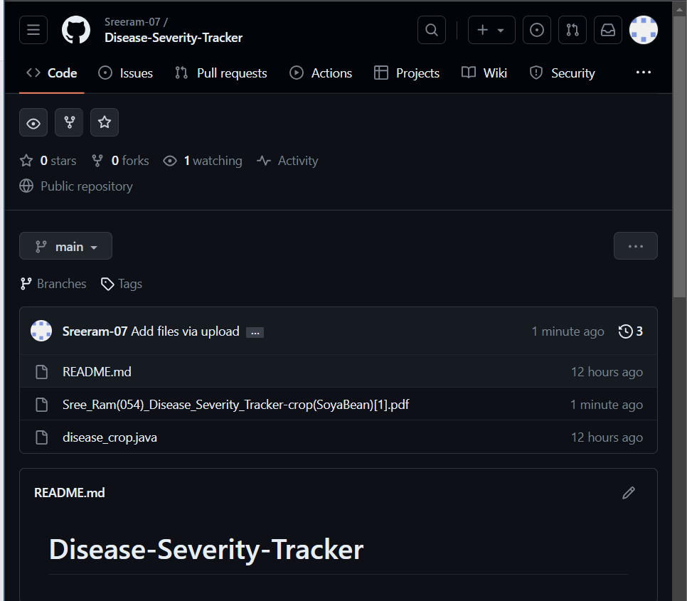

Outputs

Interface:

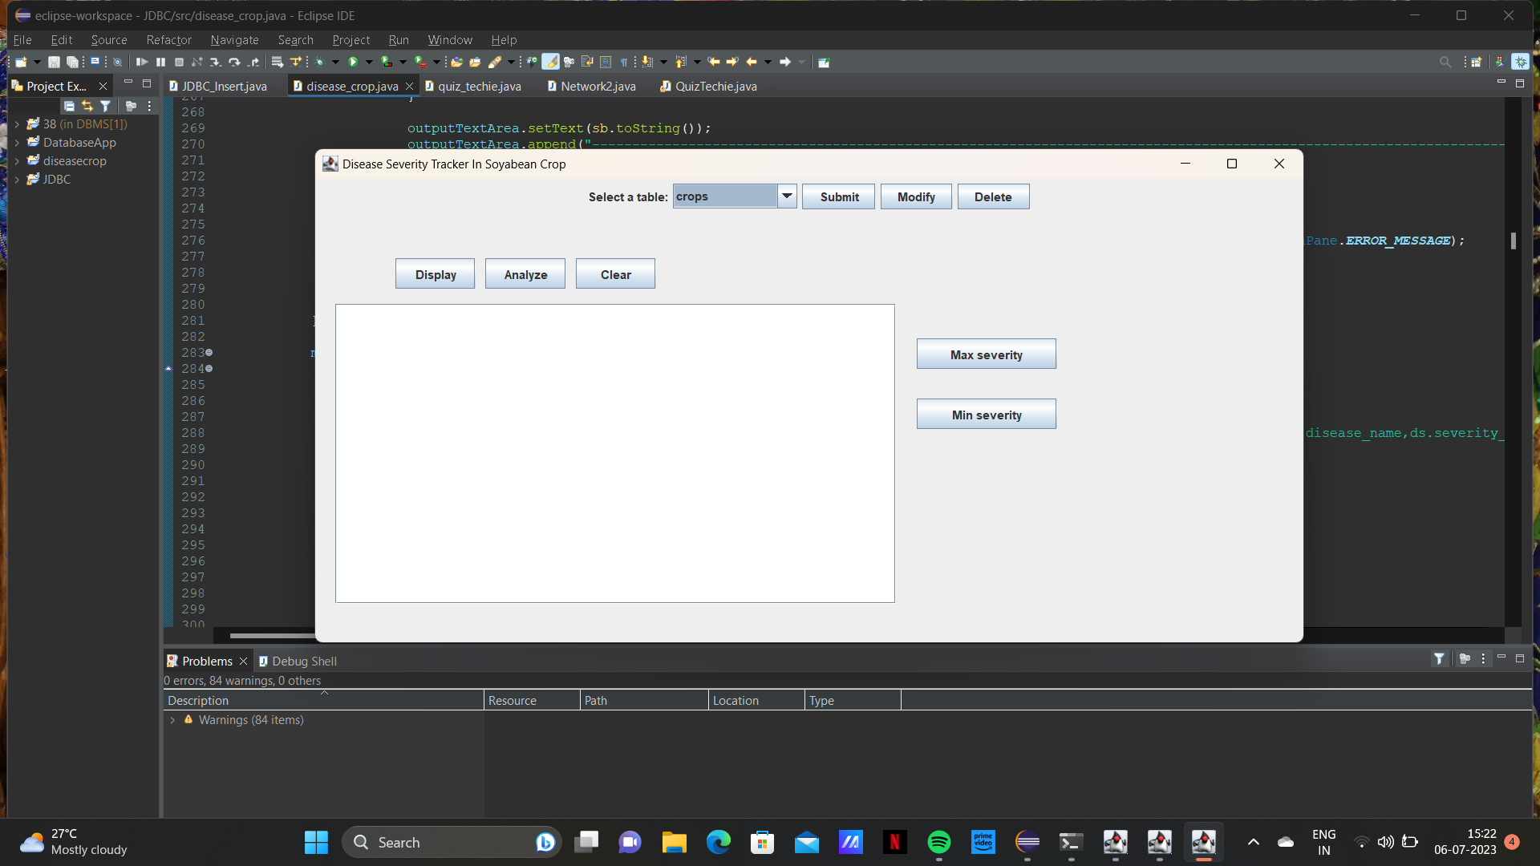

INSERTING :

Crops table:

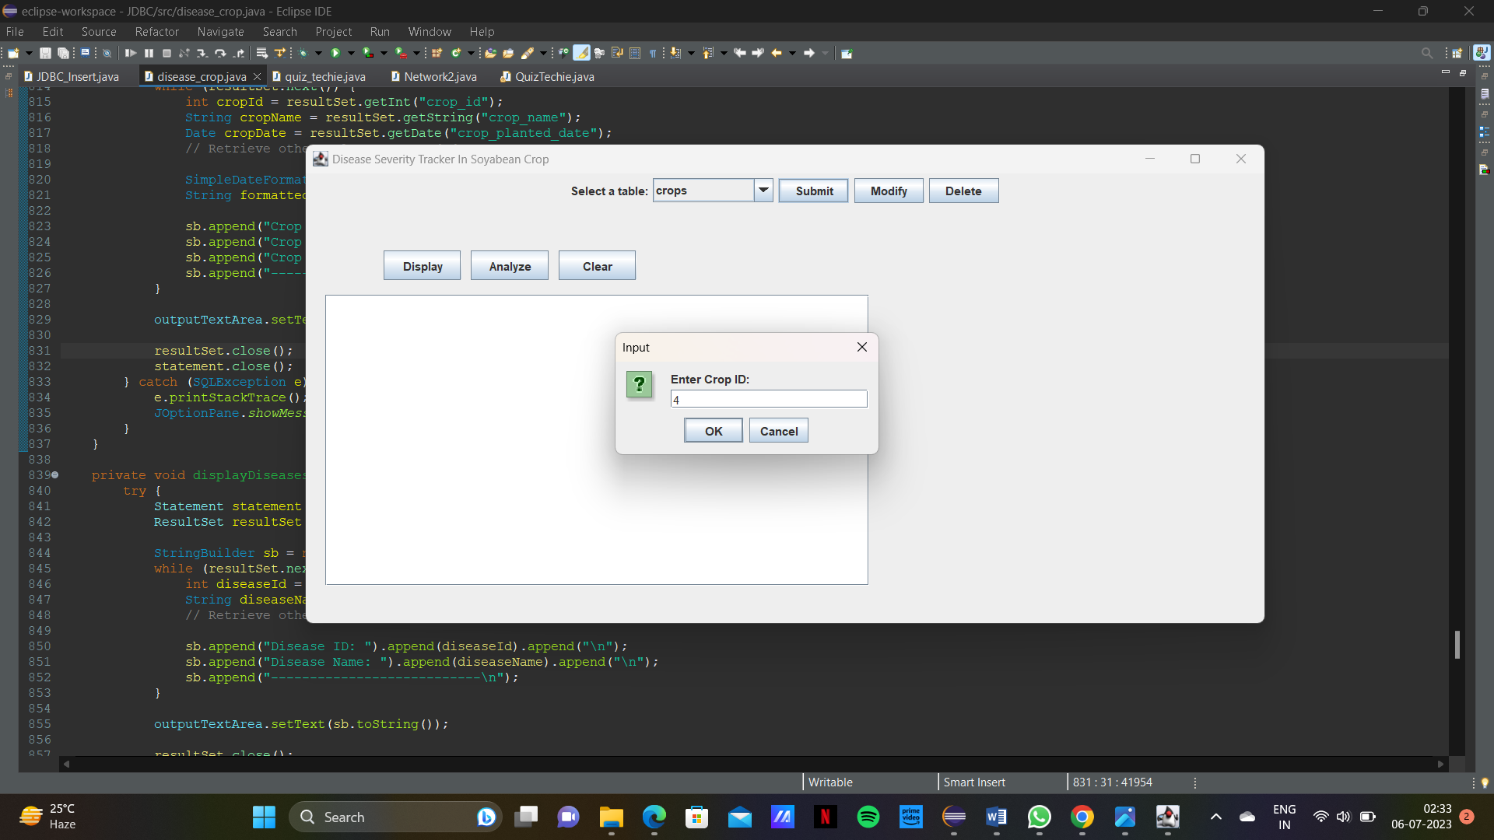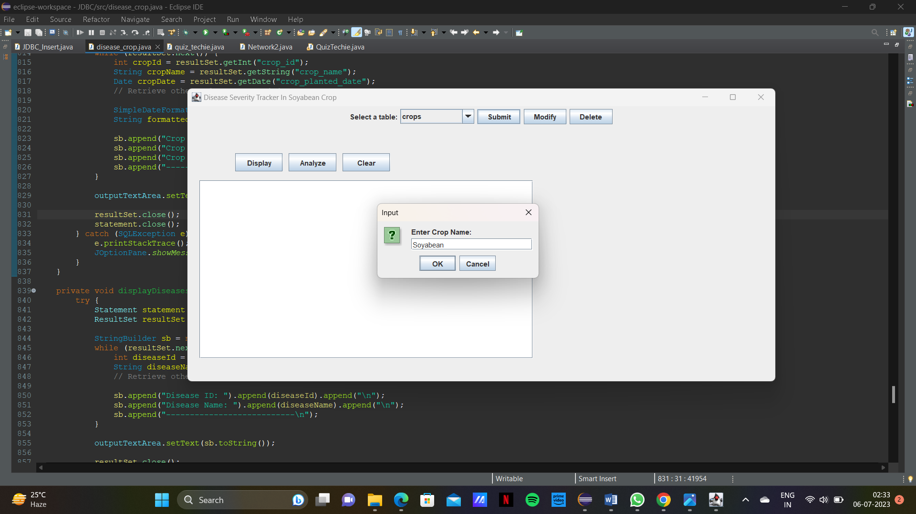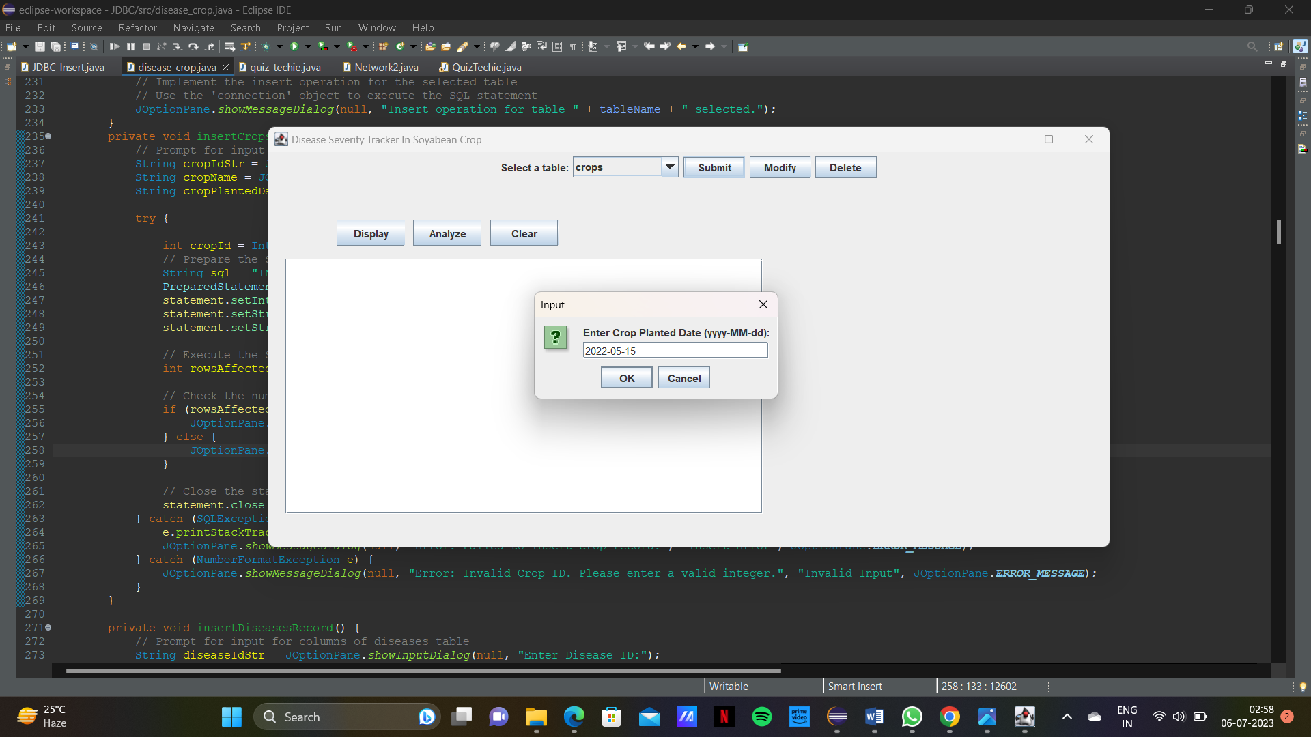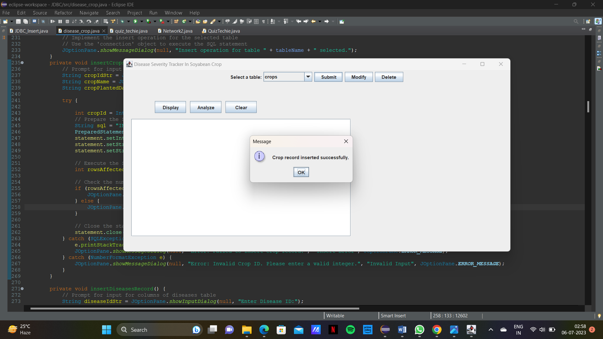

Diseases table:

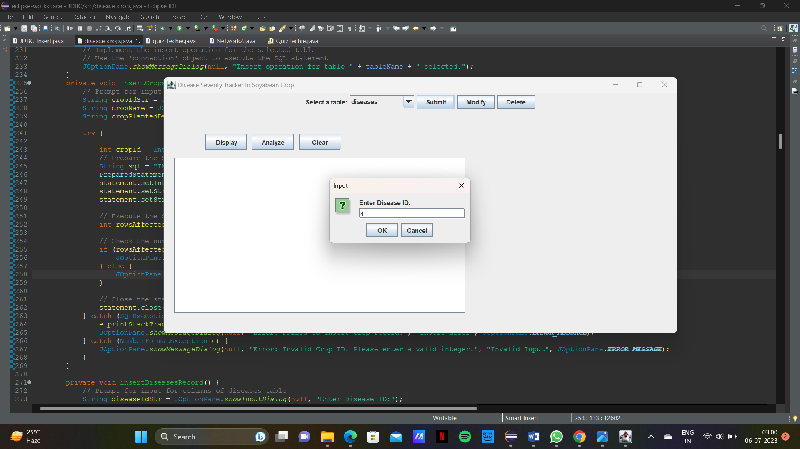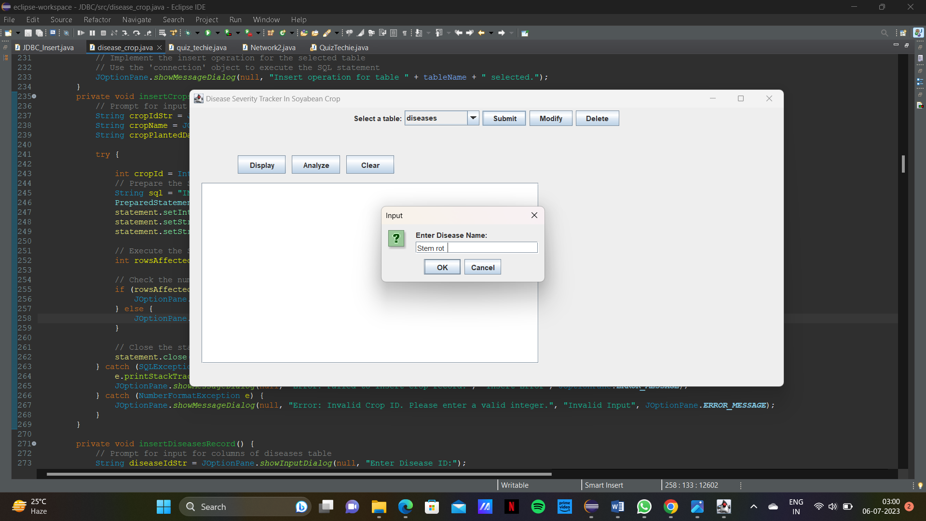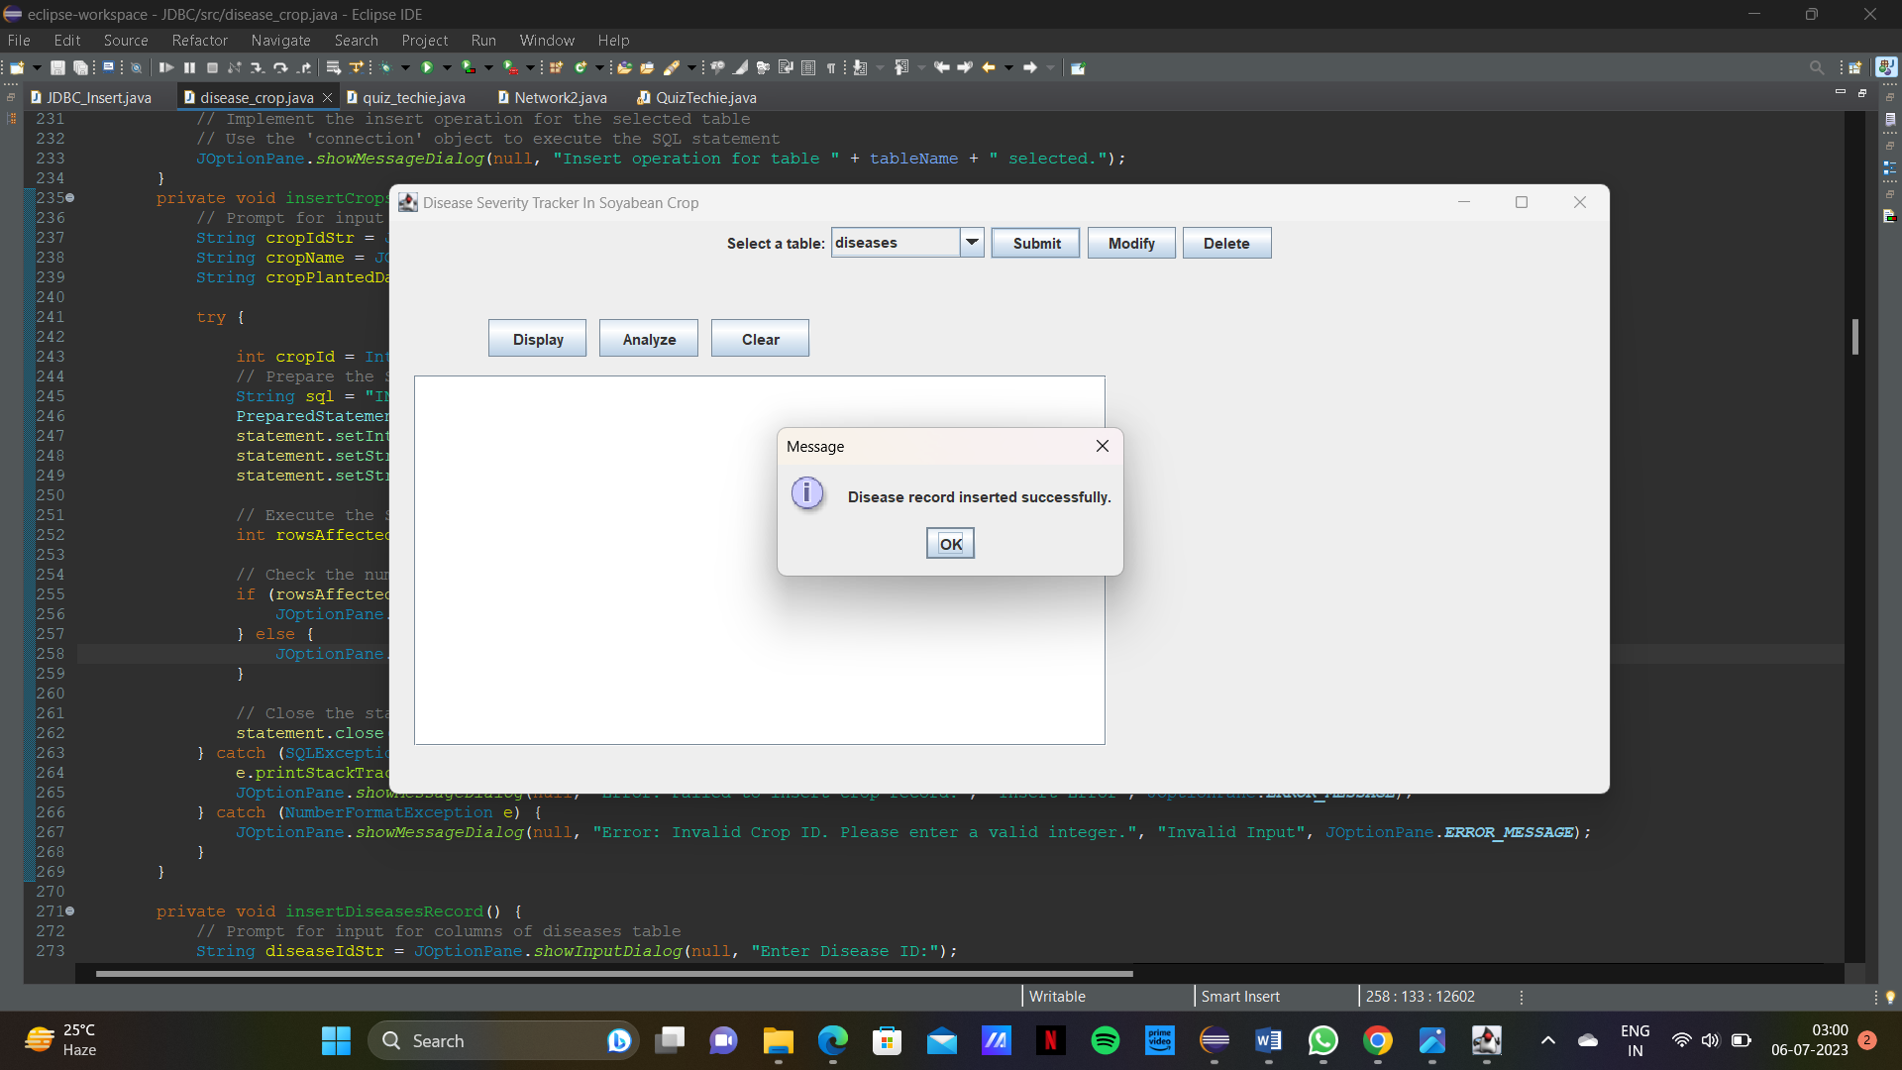

Disease Severity table:

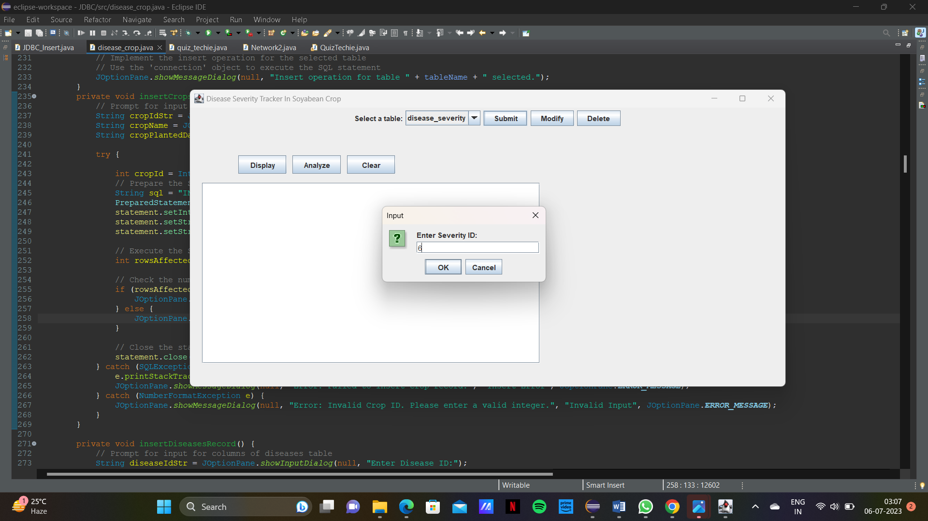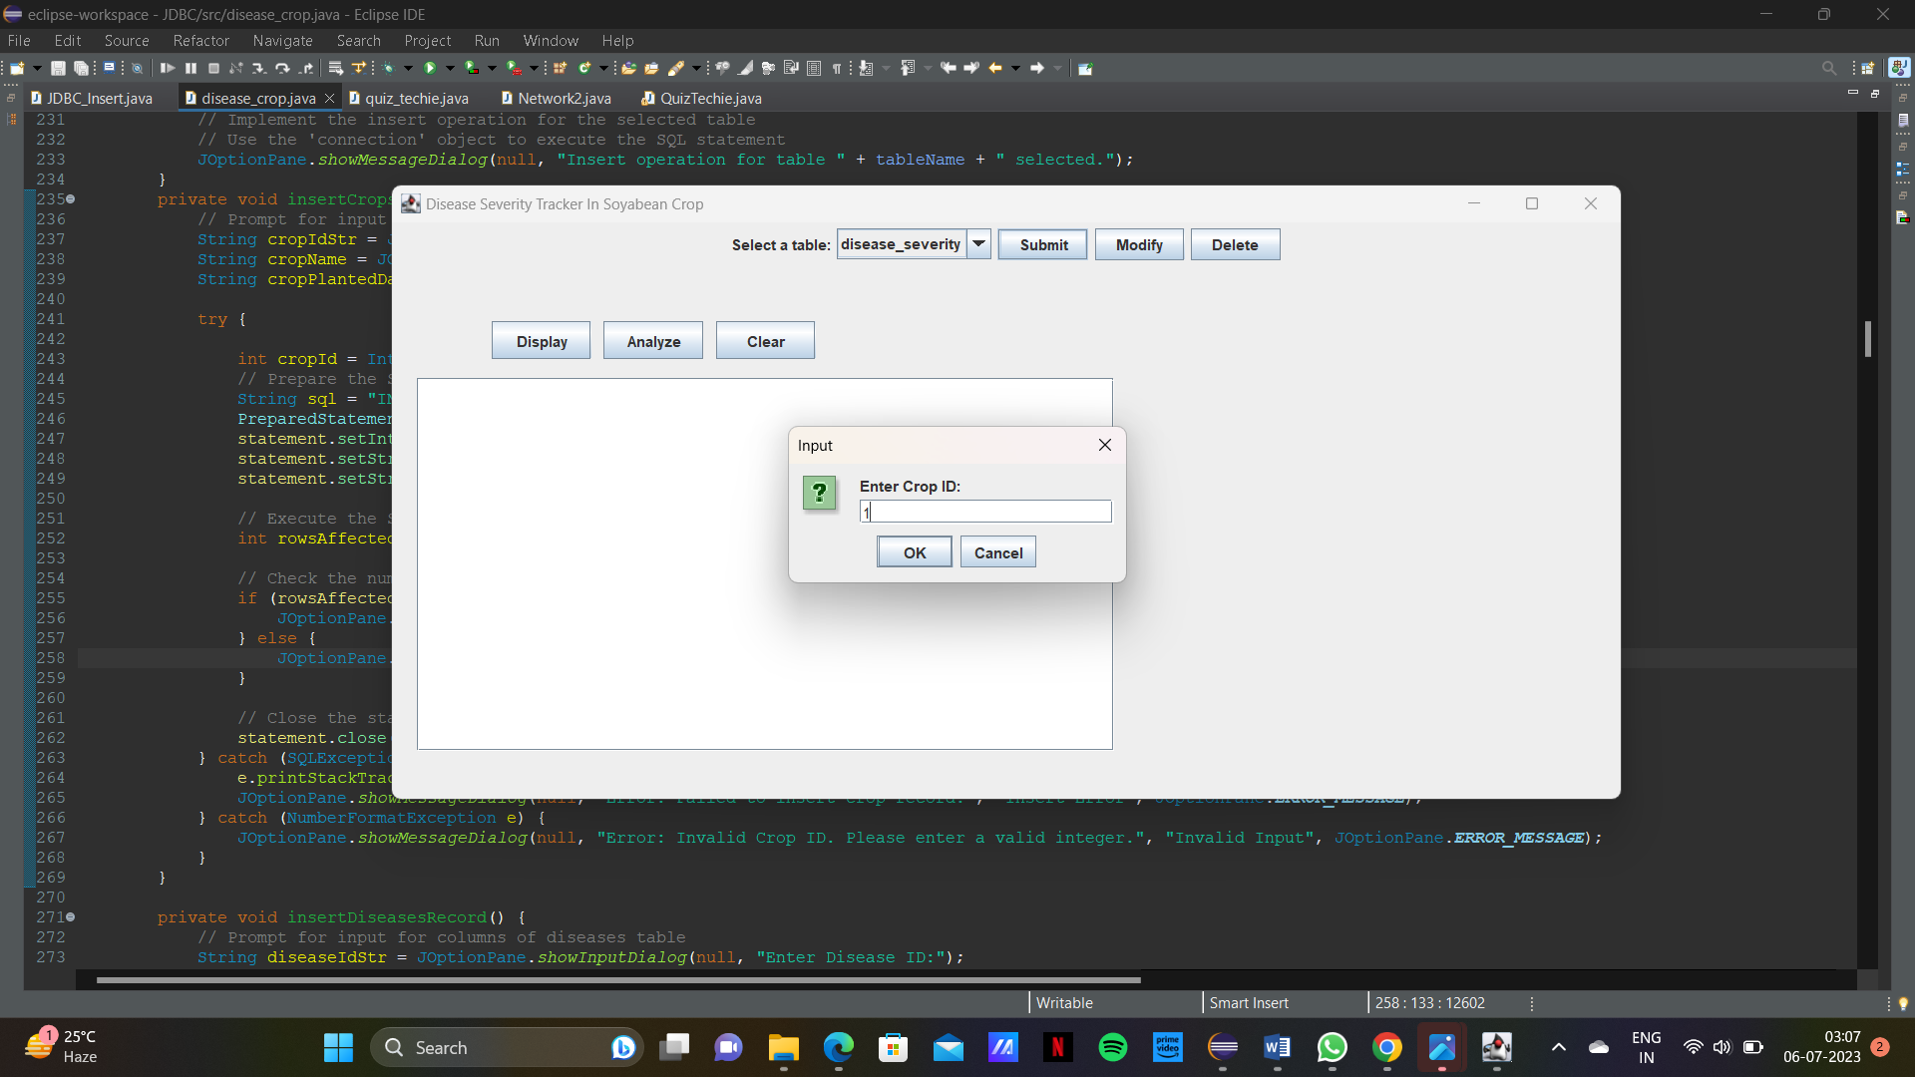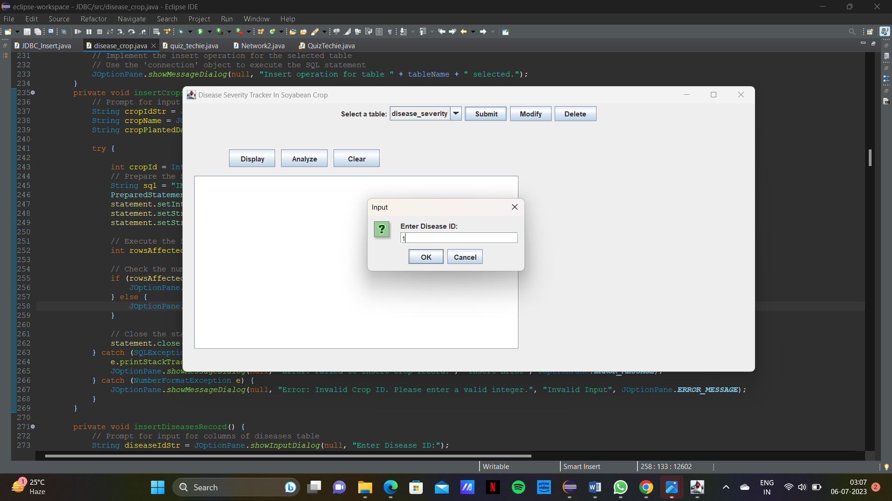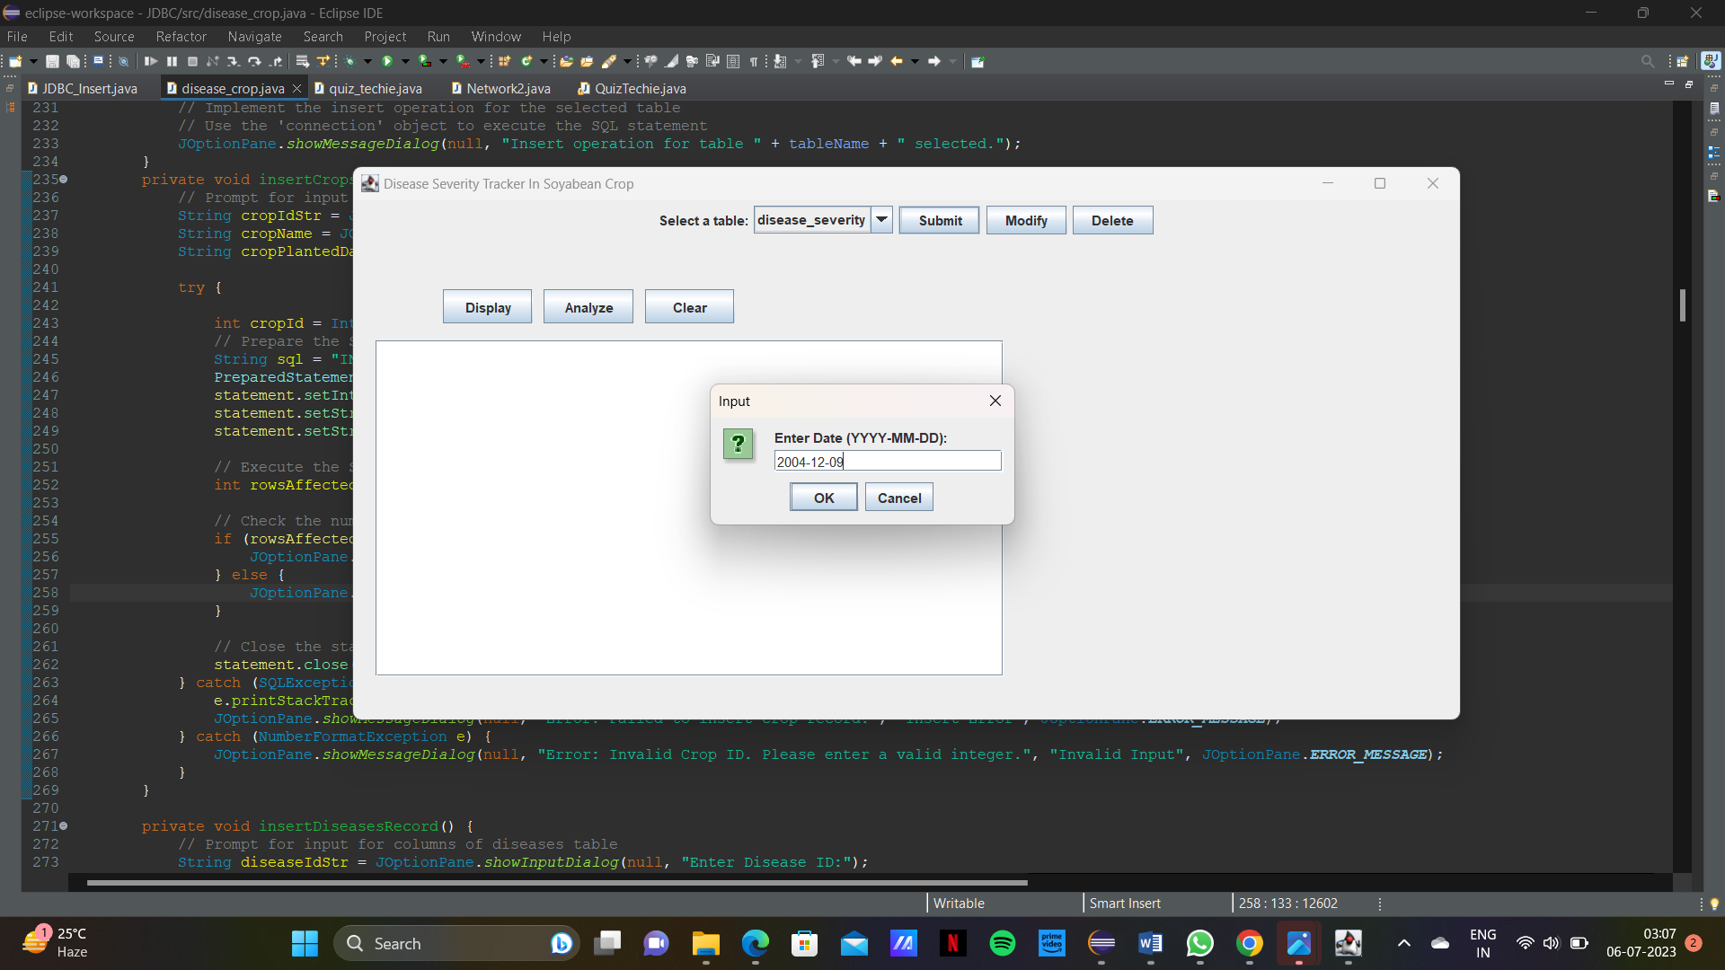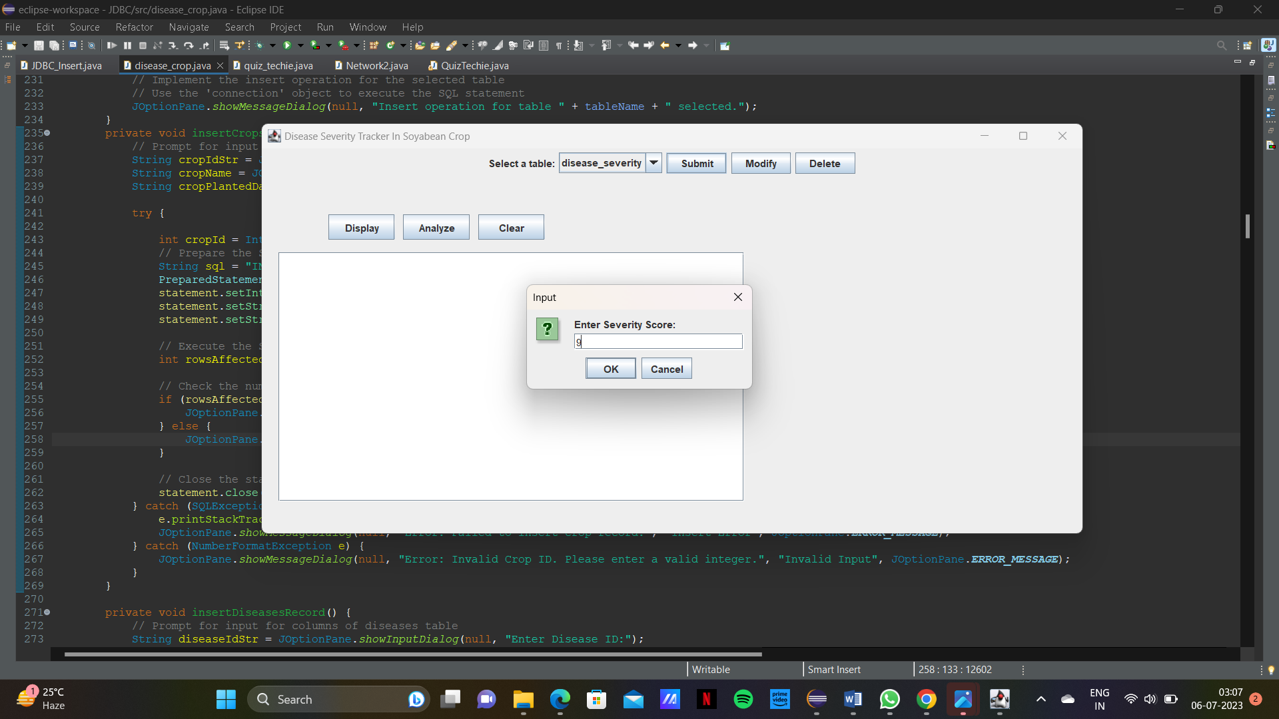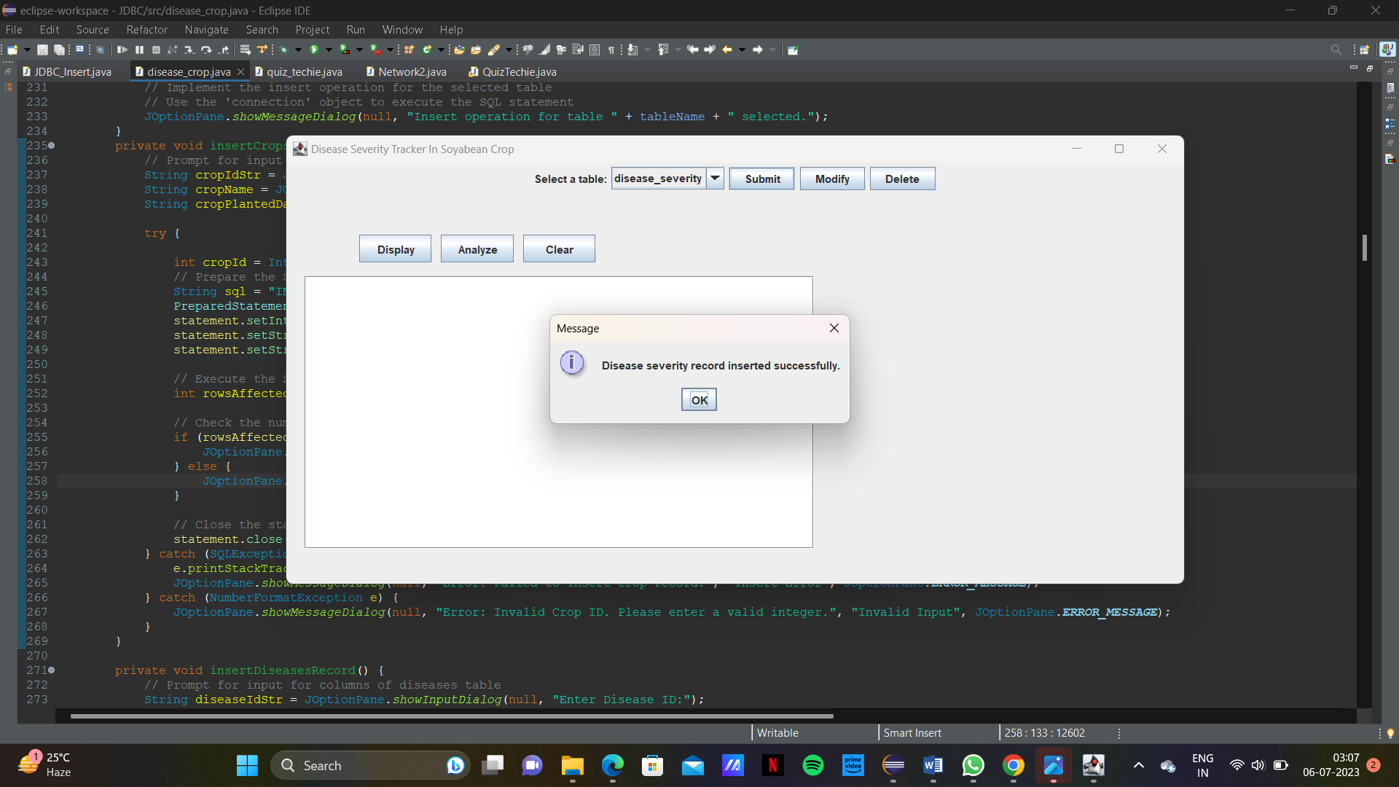

Fields table:

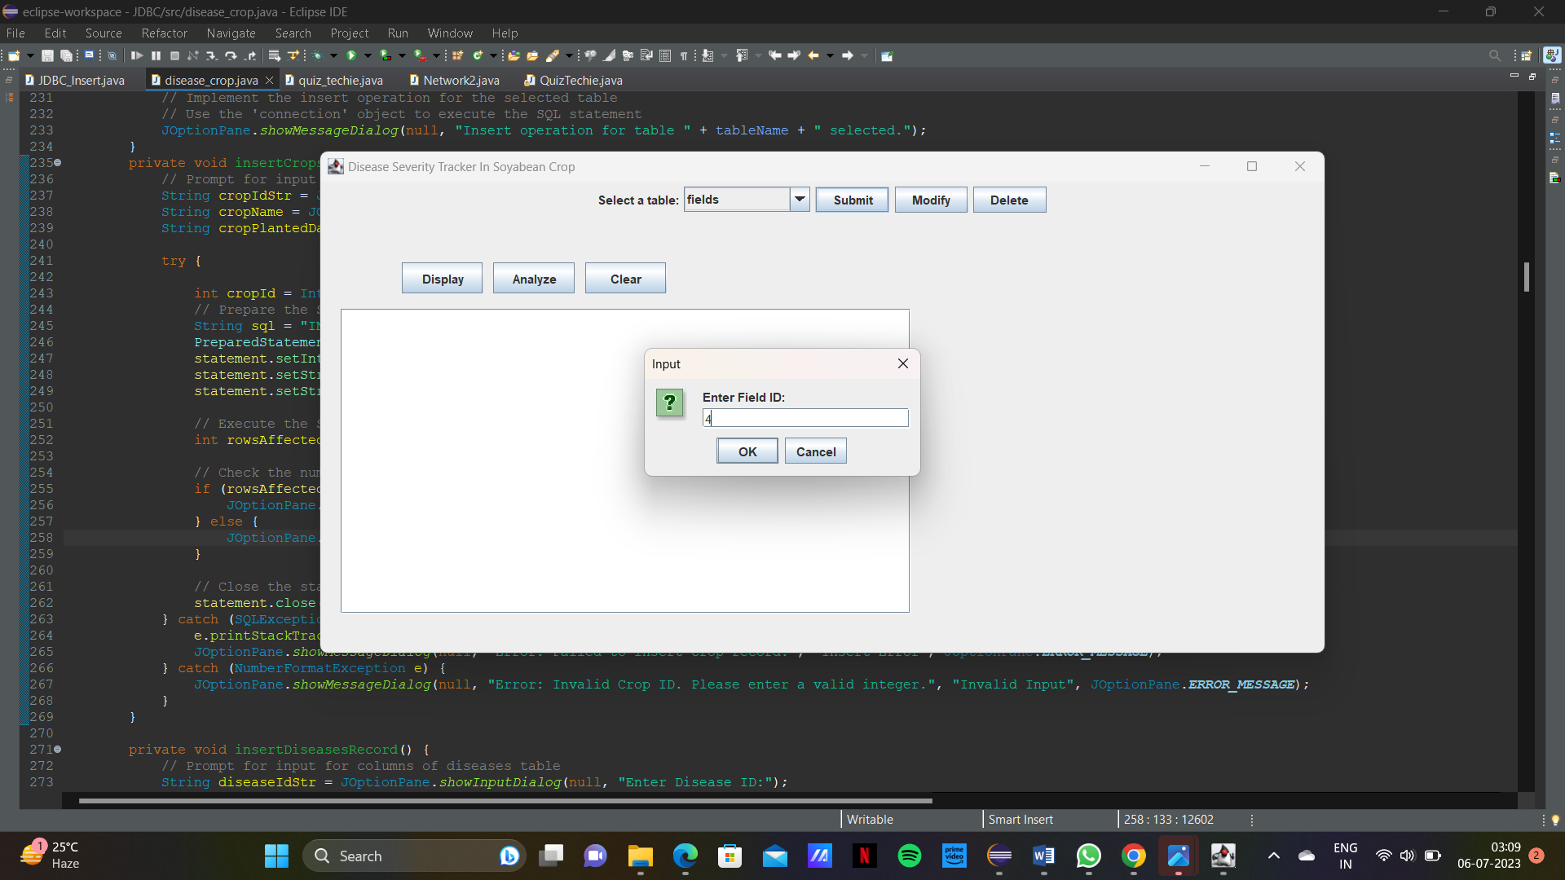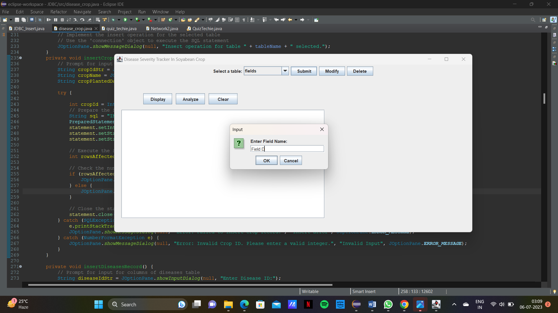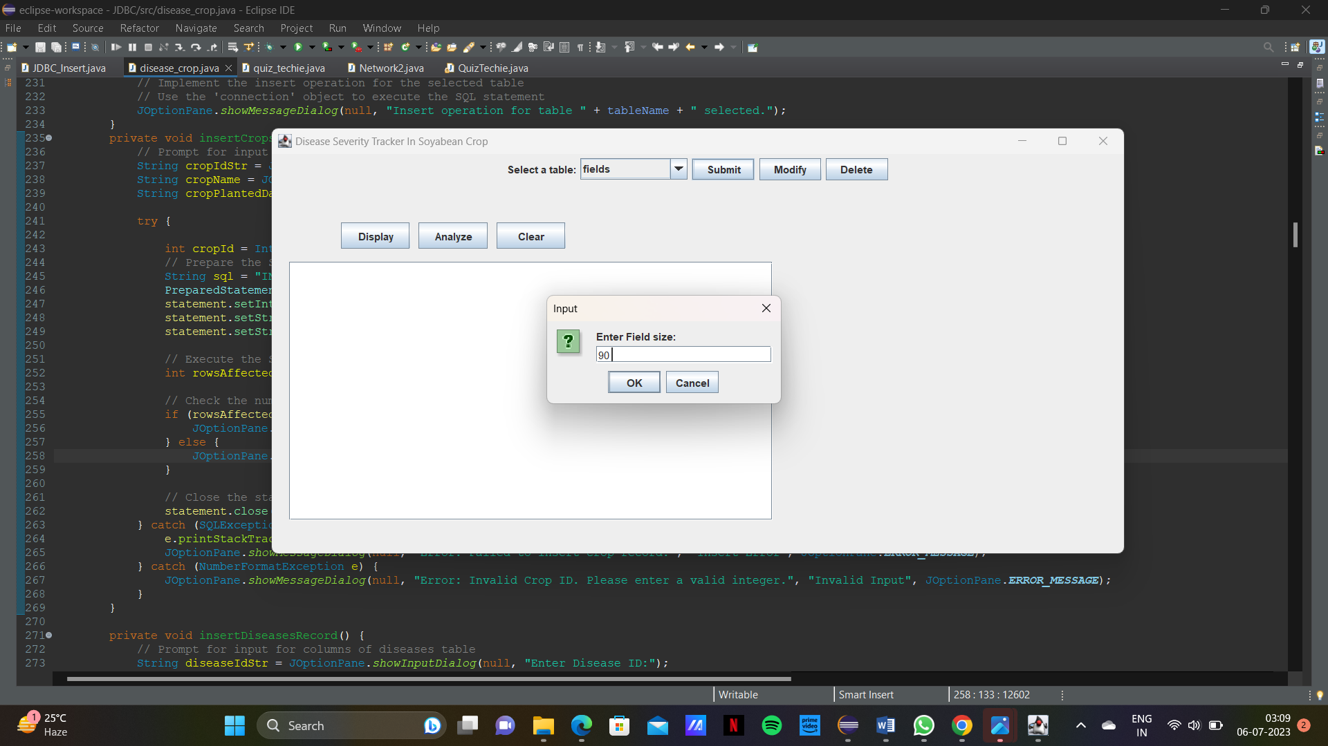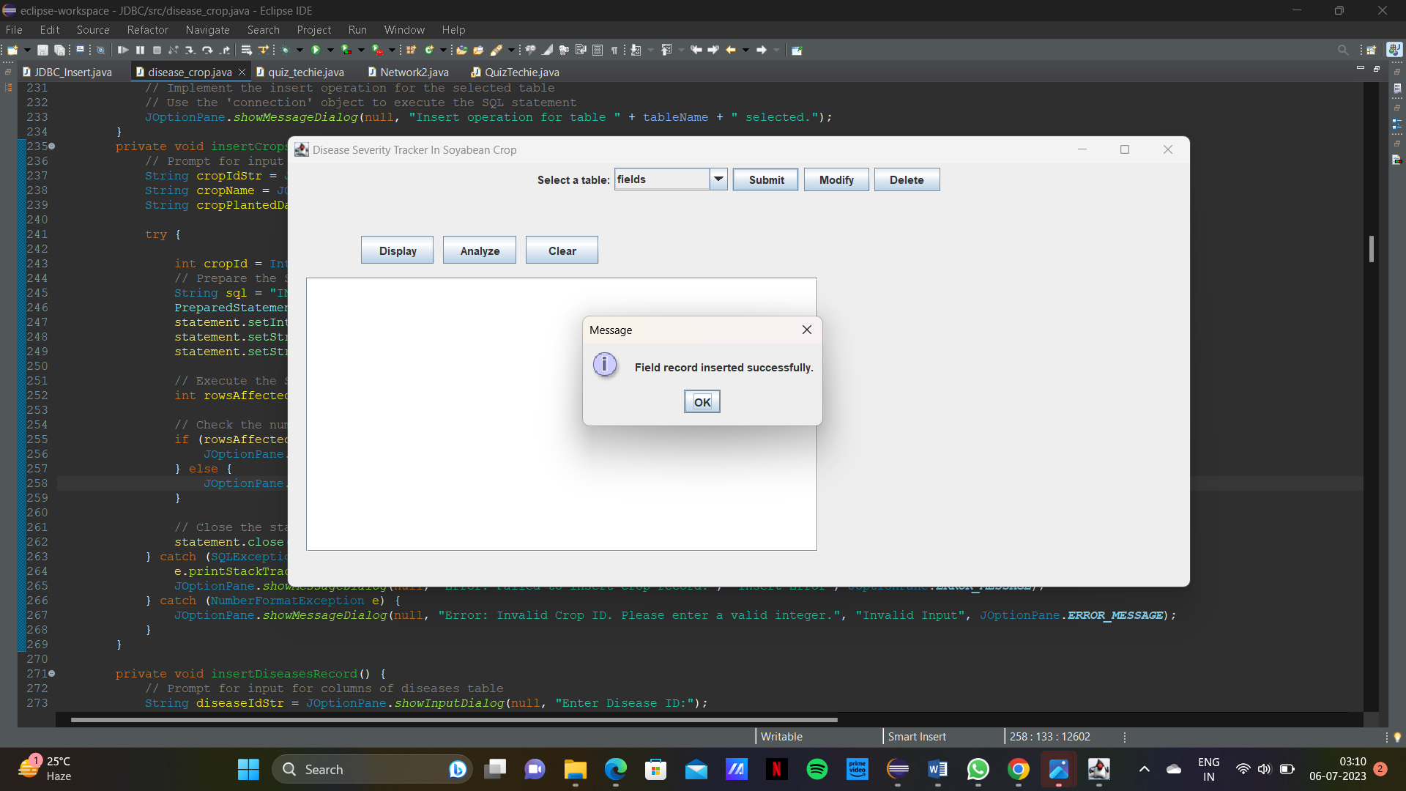

Field_crops table:

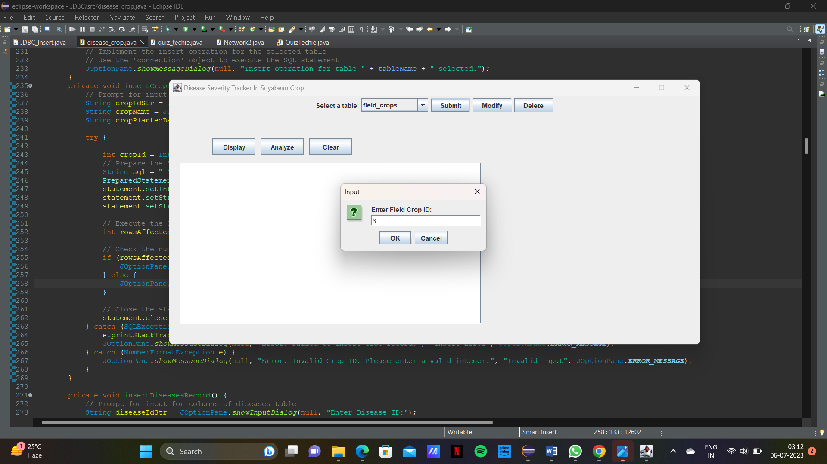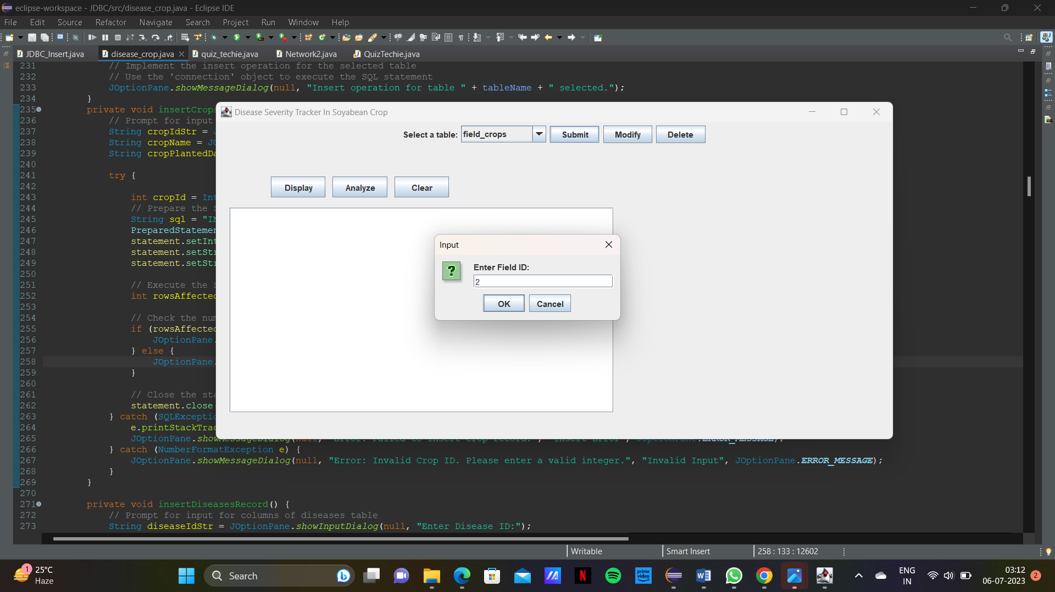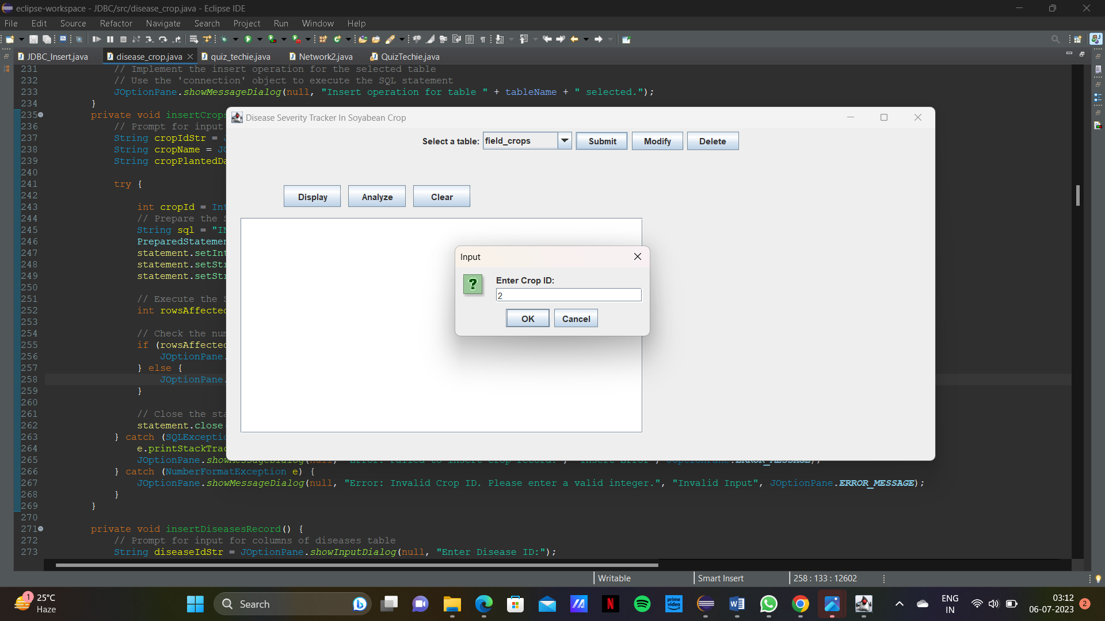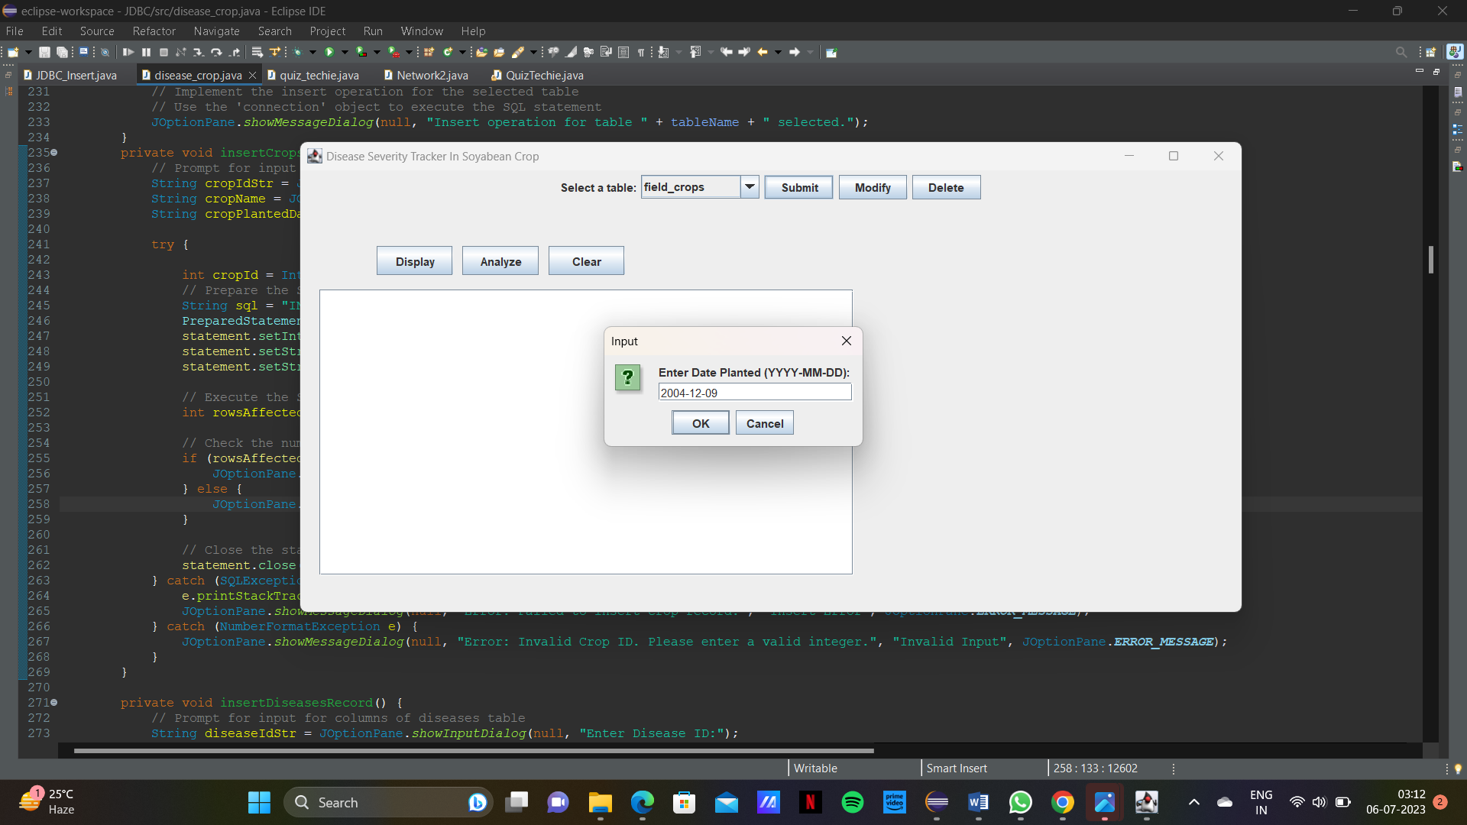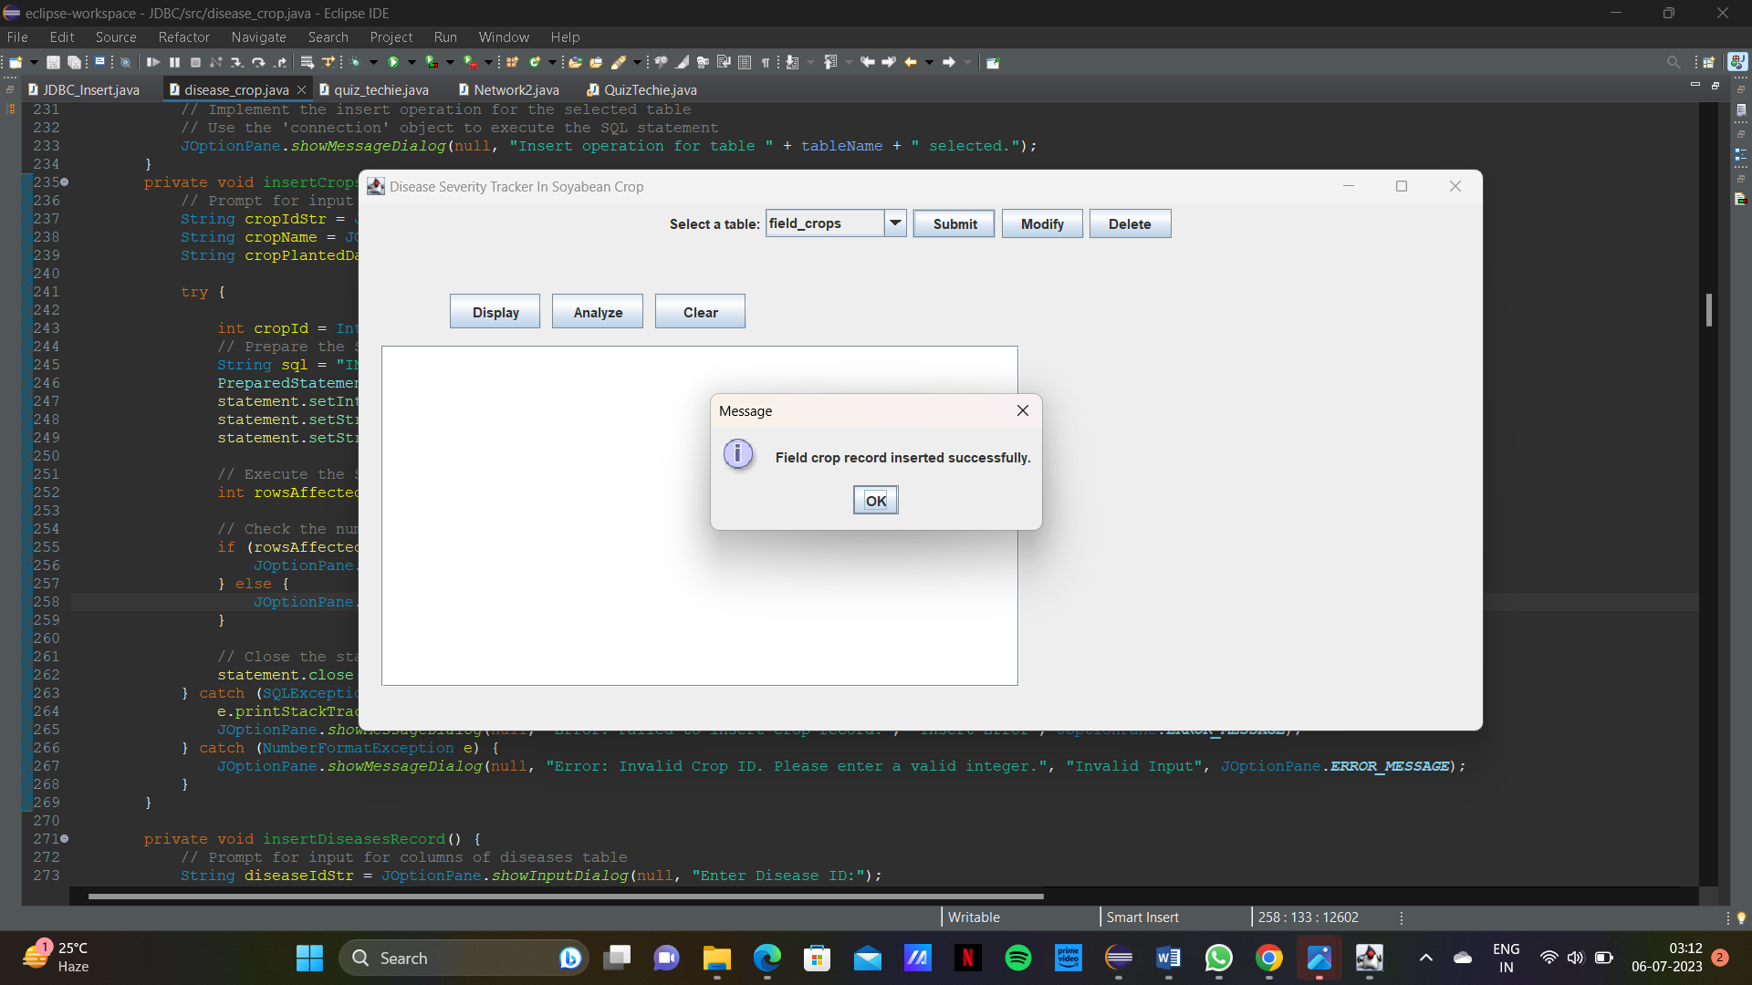

UPDATING:

Crops table:

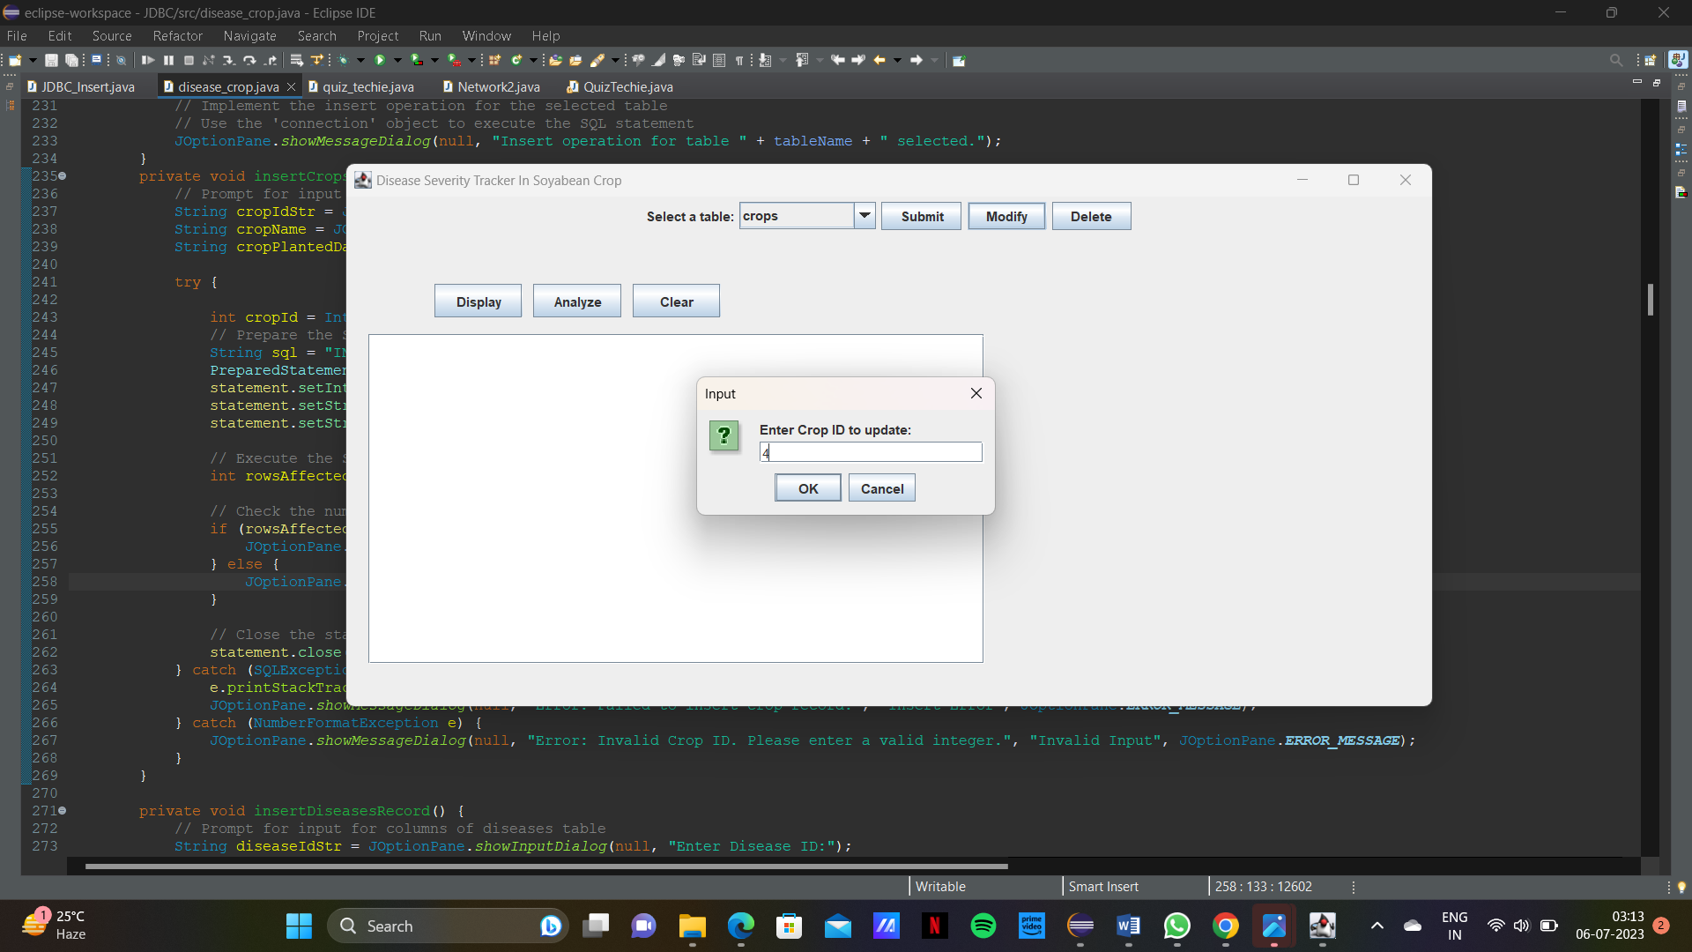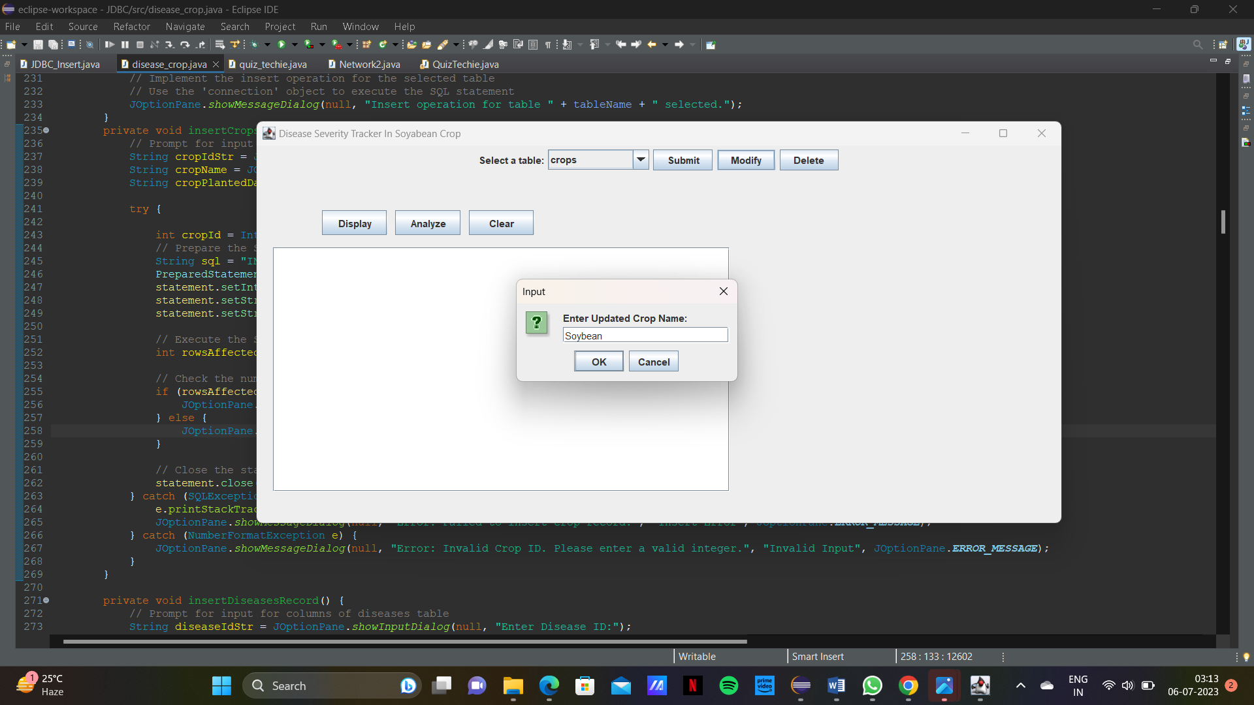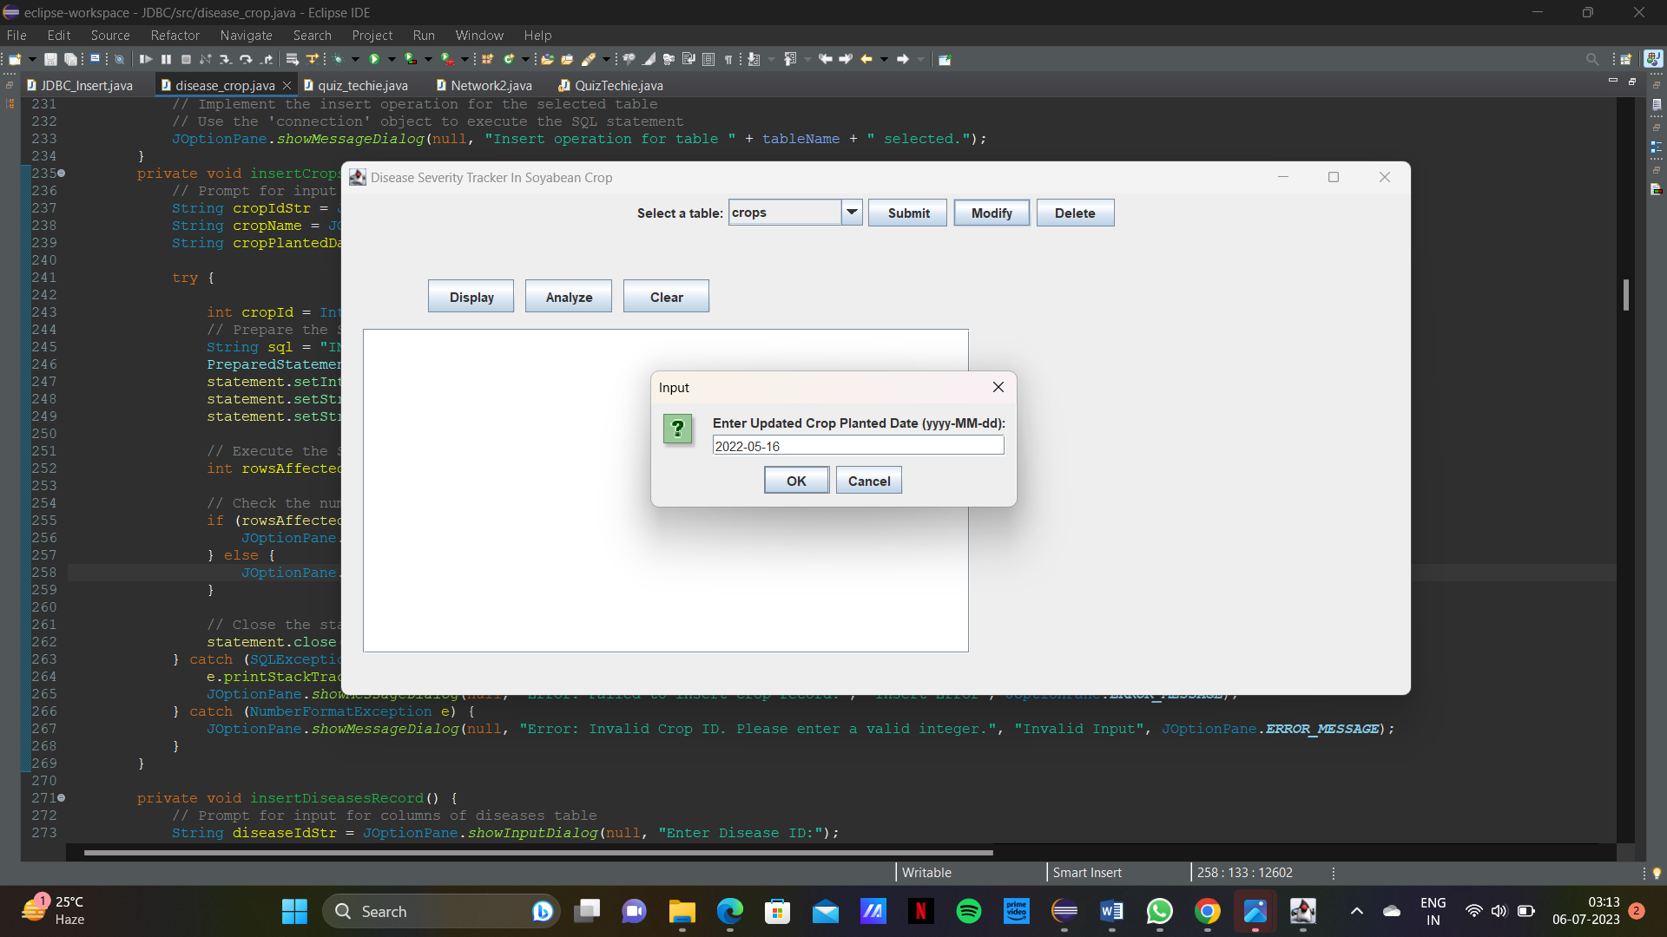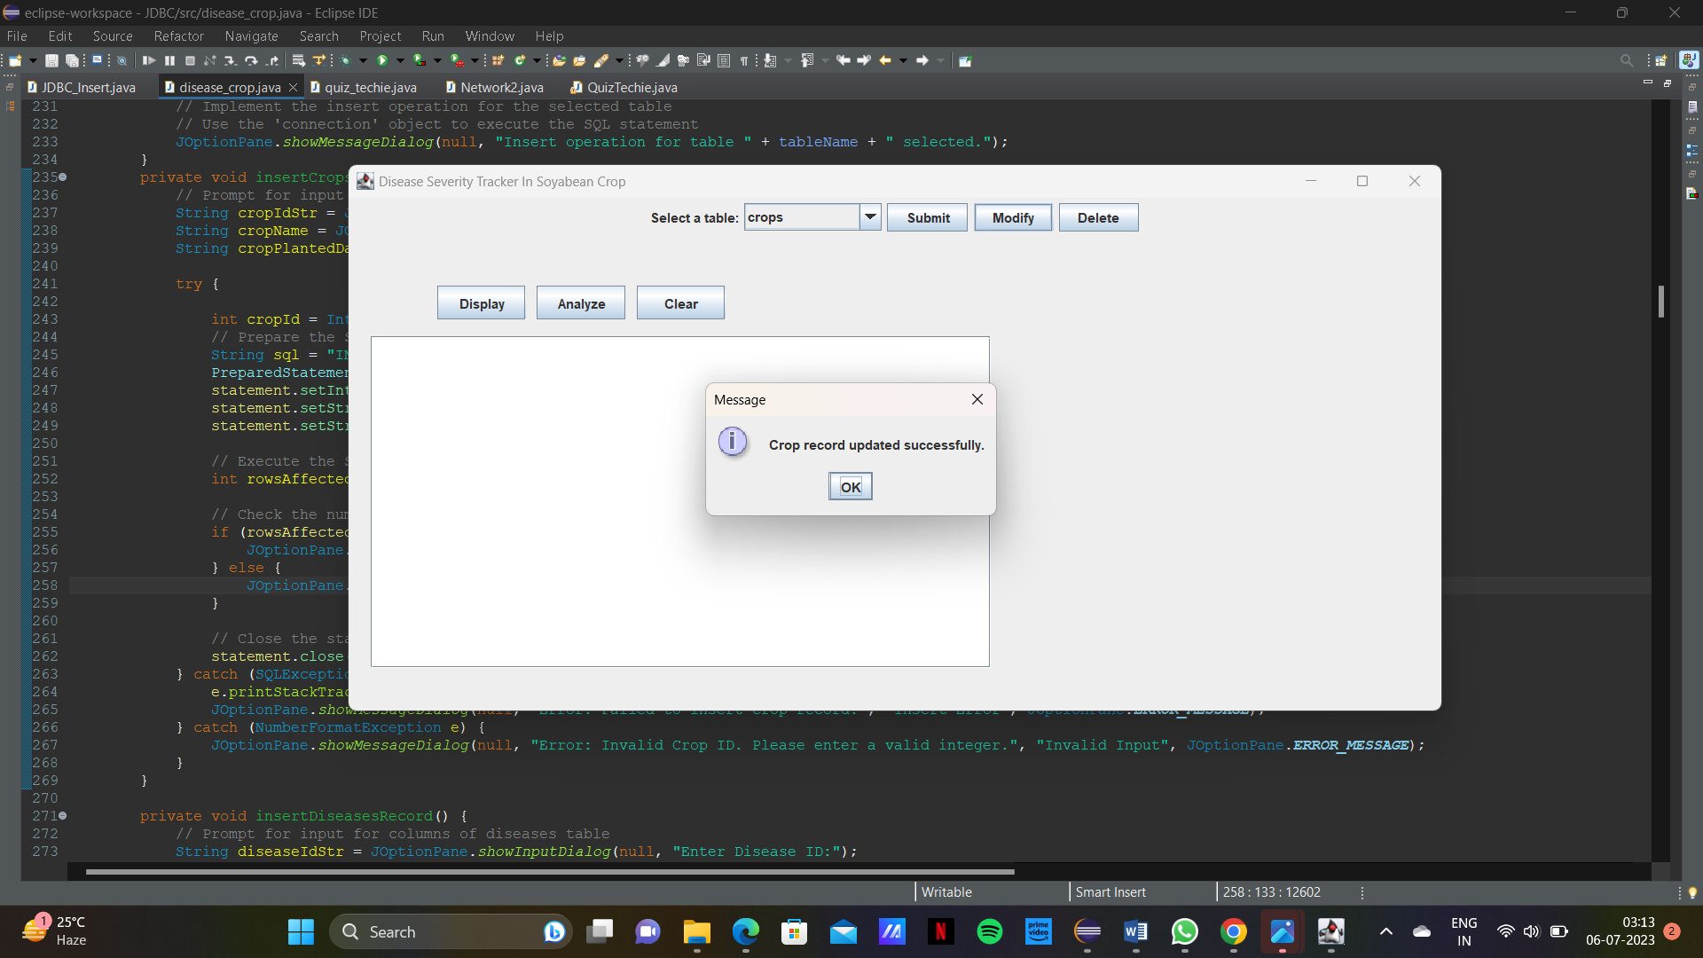

Diseases table:

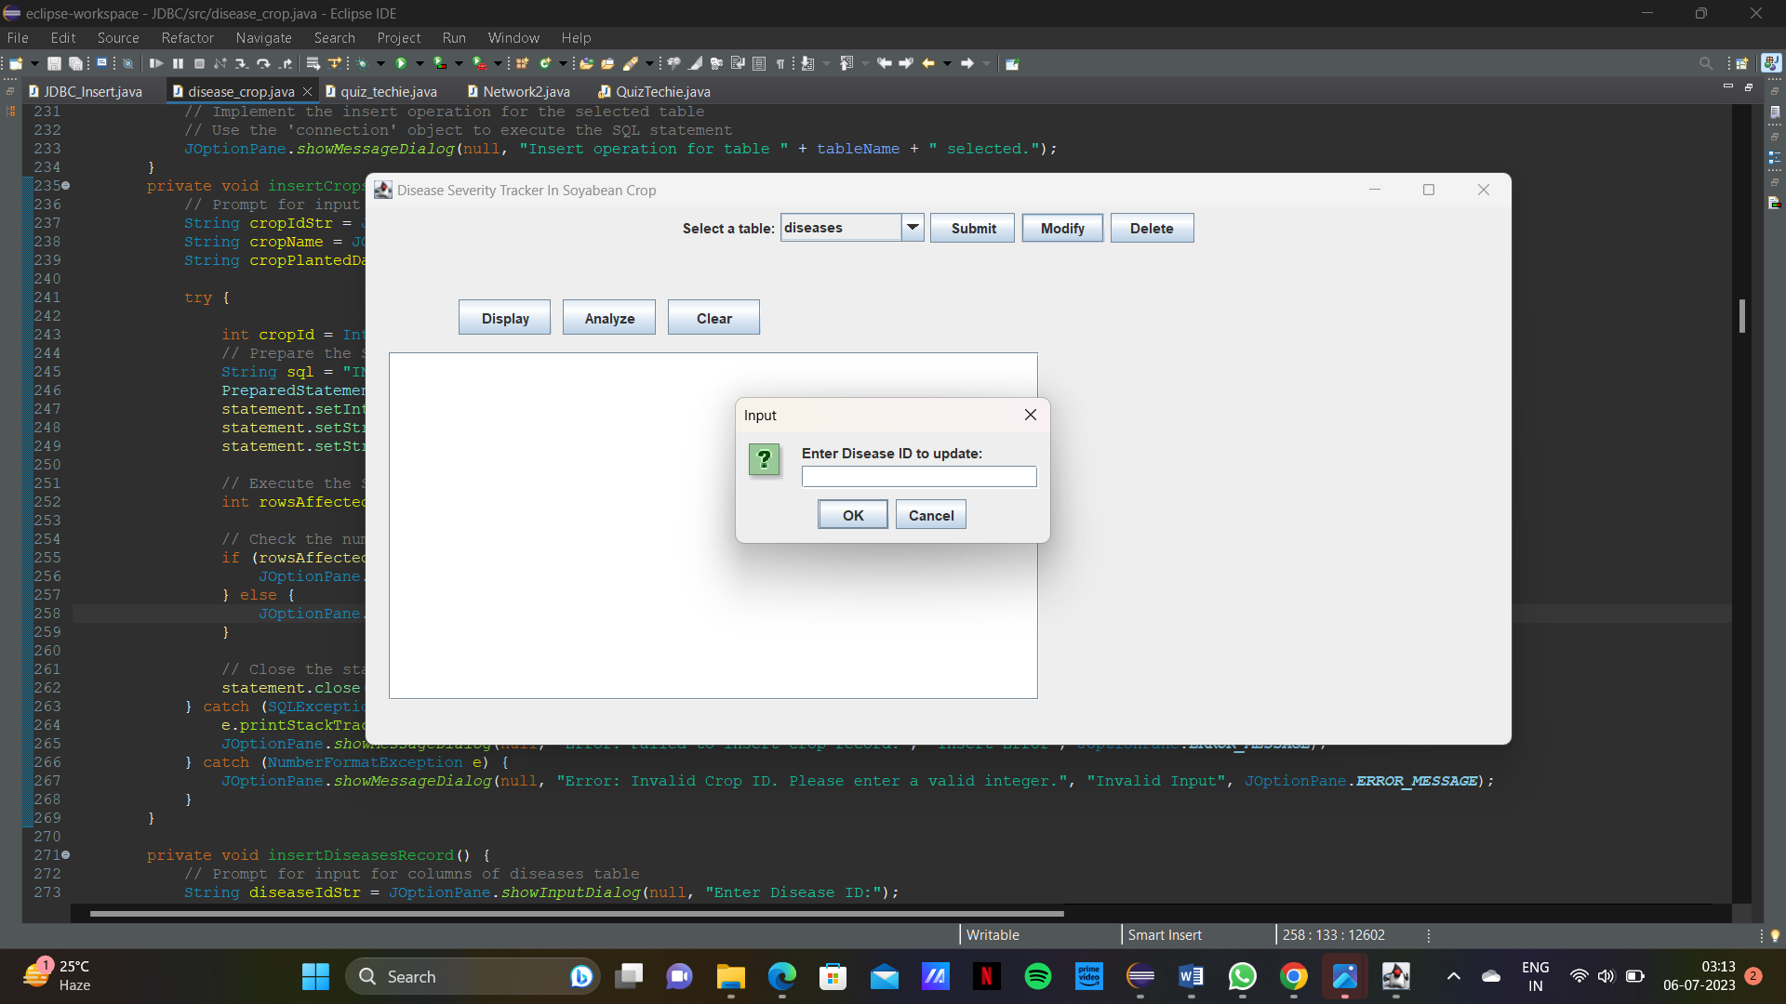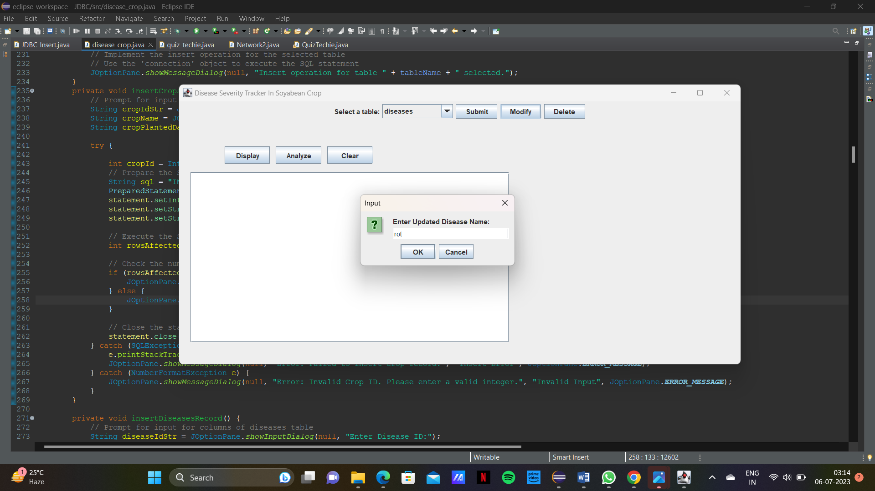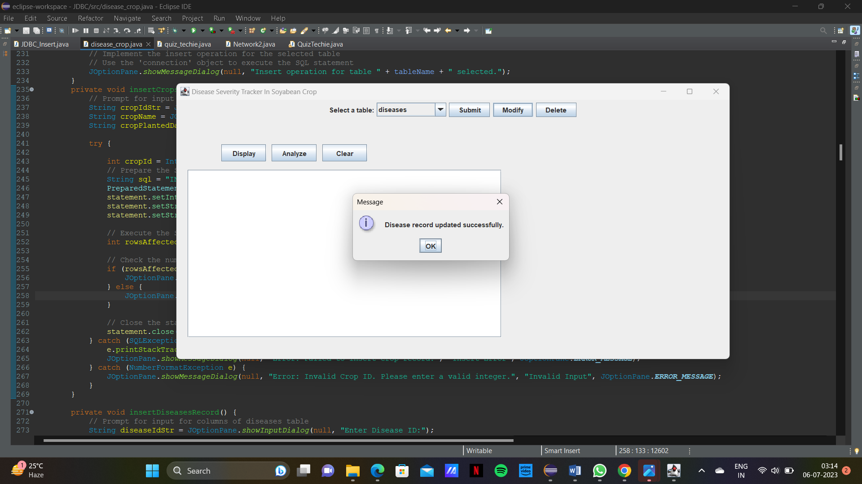

Disease Severity table:

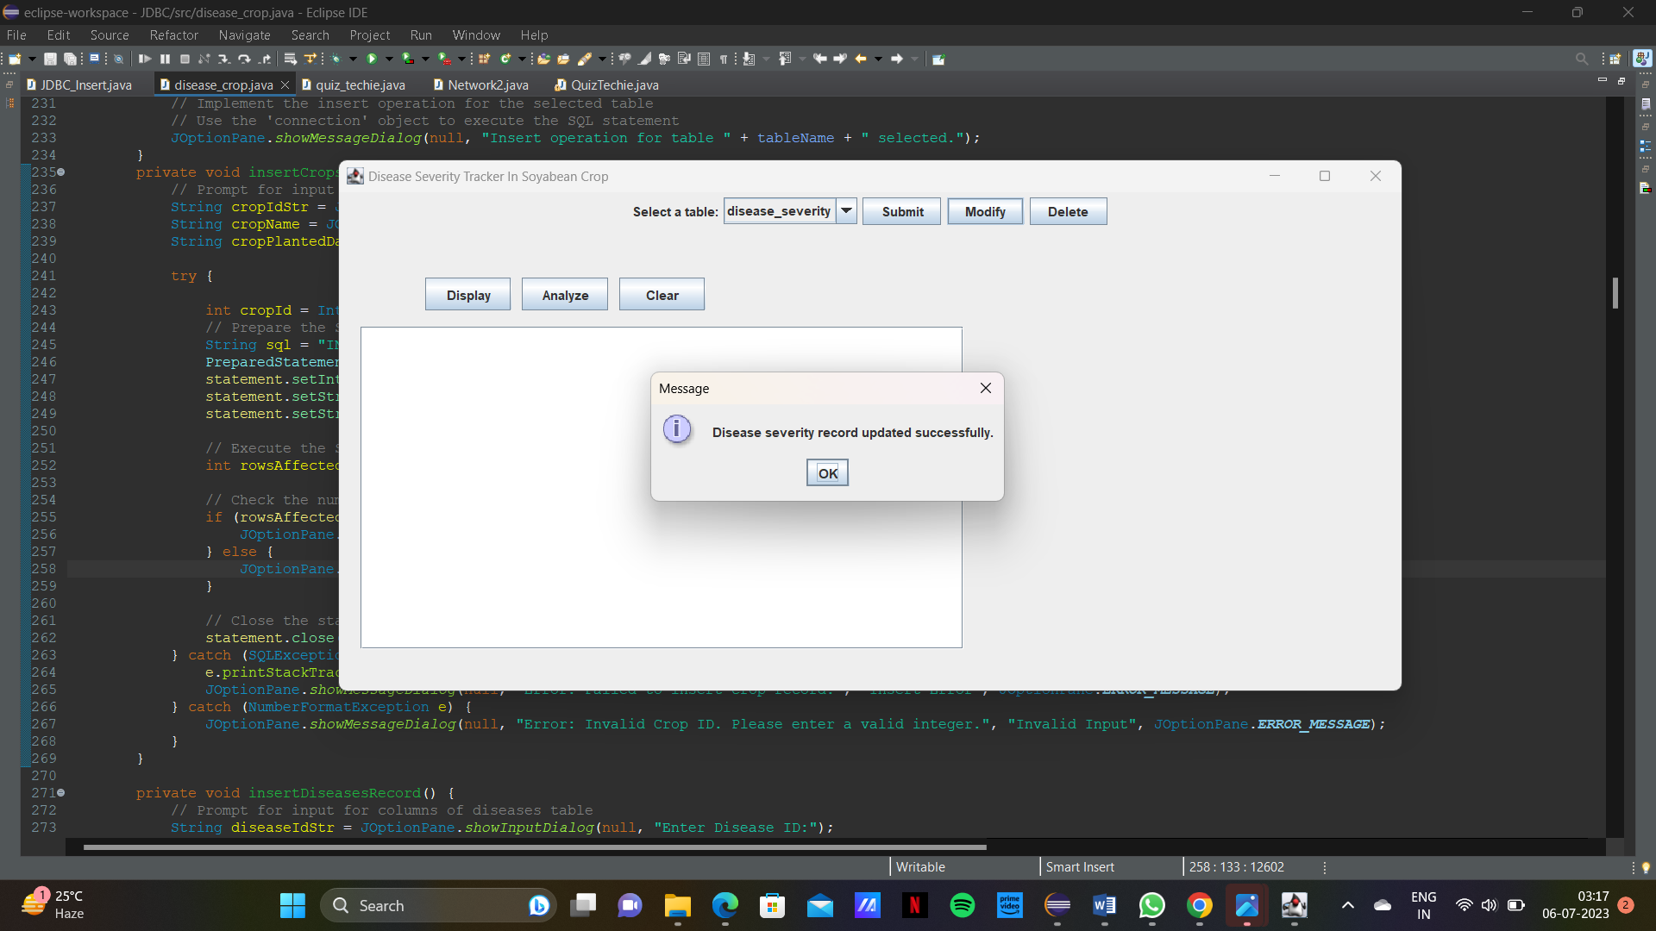

Fields table:

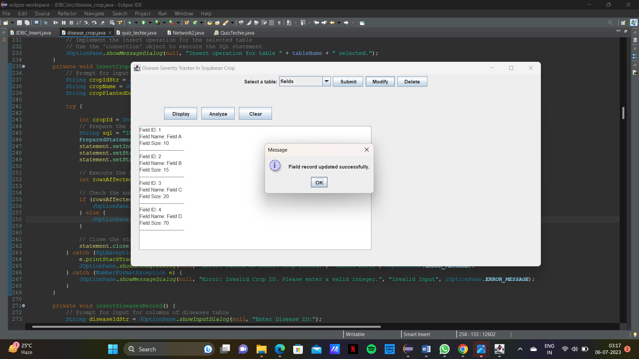

Field Crops Table:

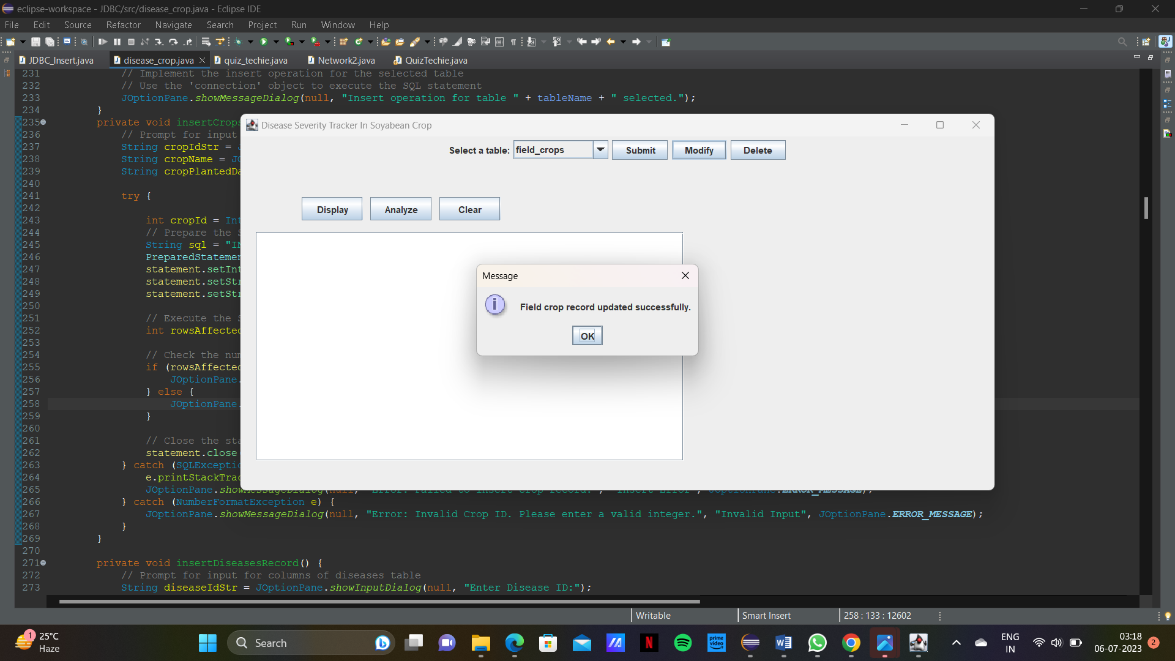

DELETION:

Crops table:

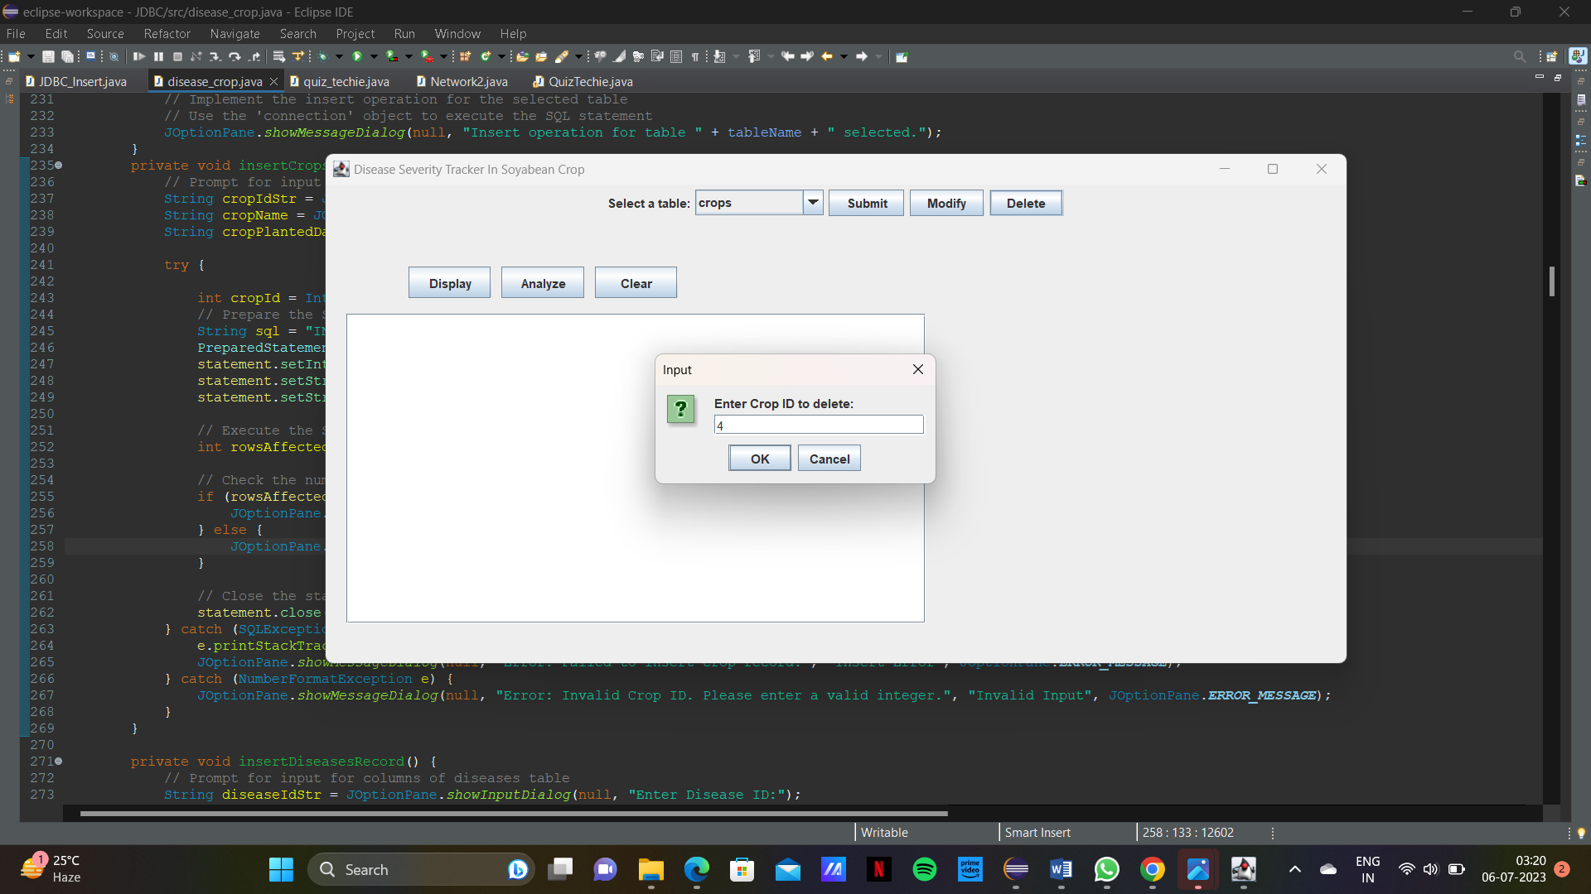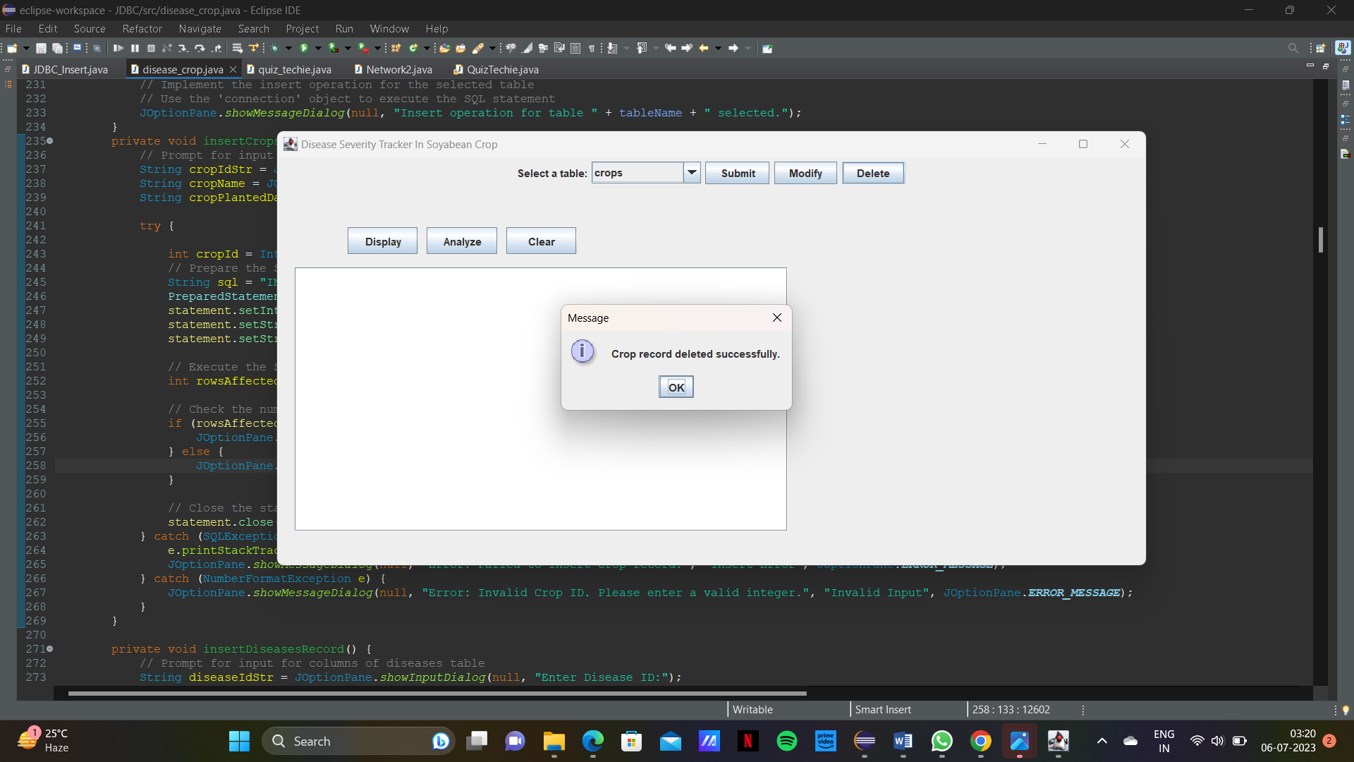

Diseases table:

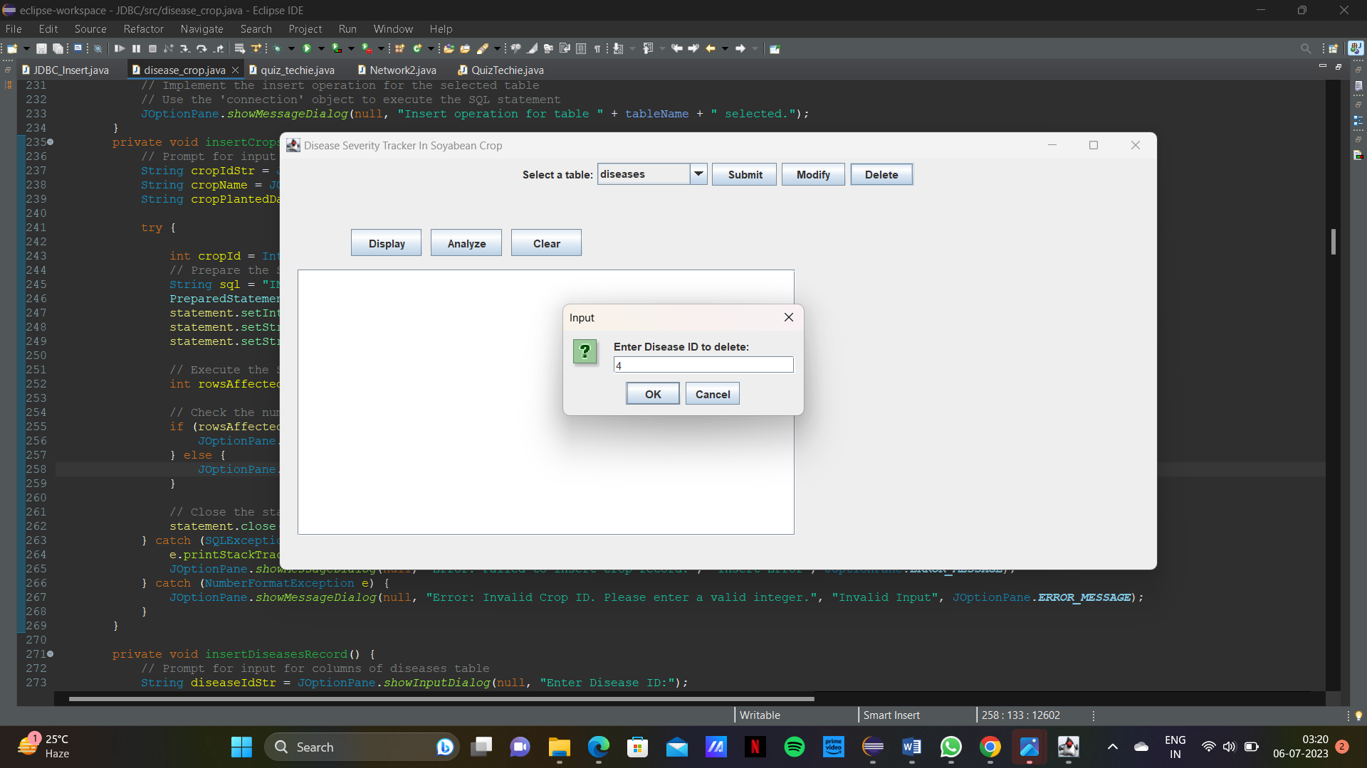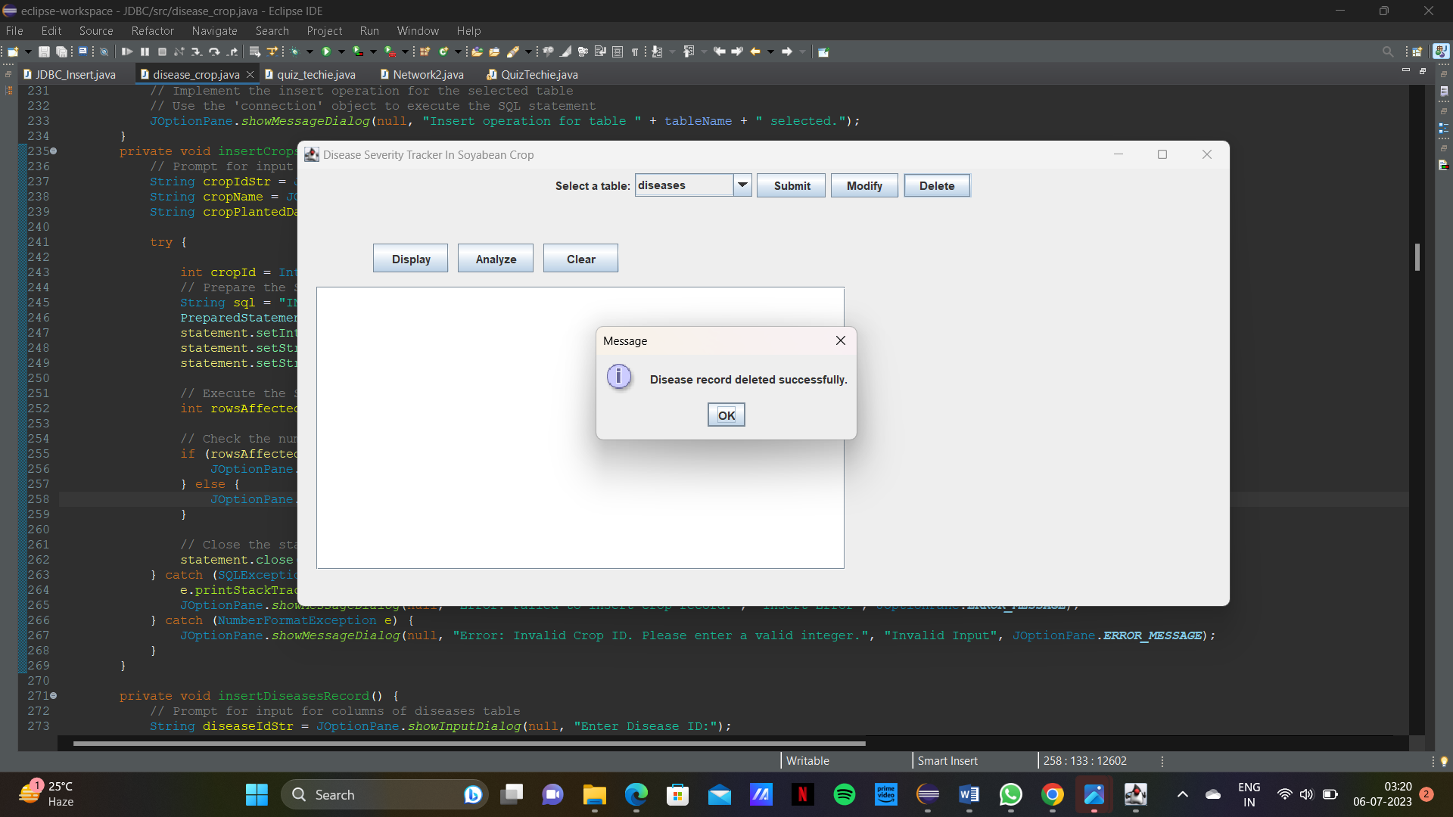

Disease Severity table:

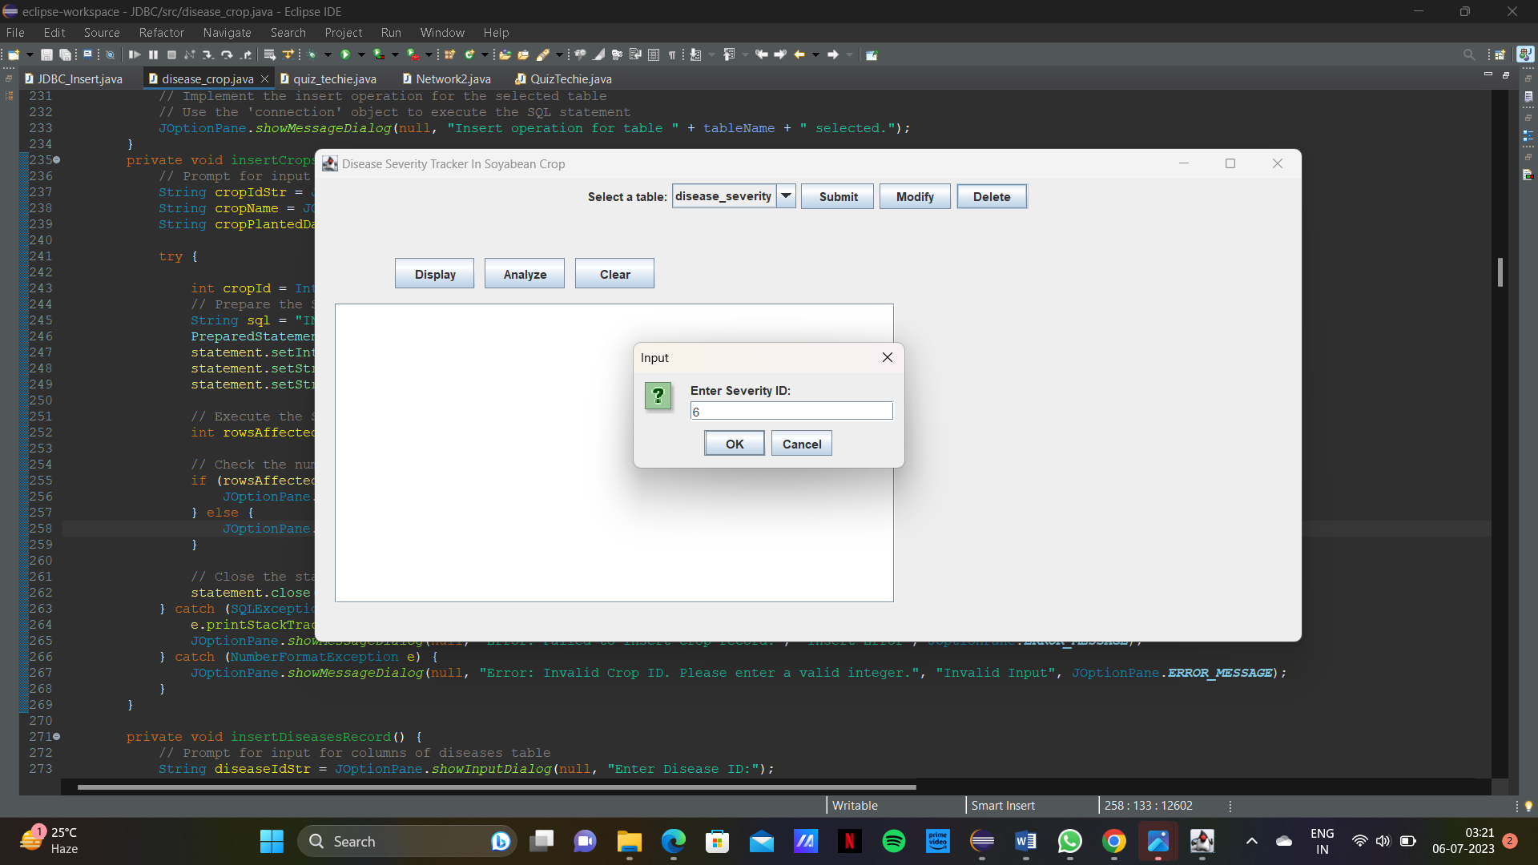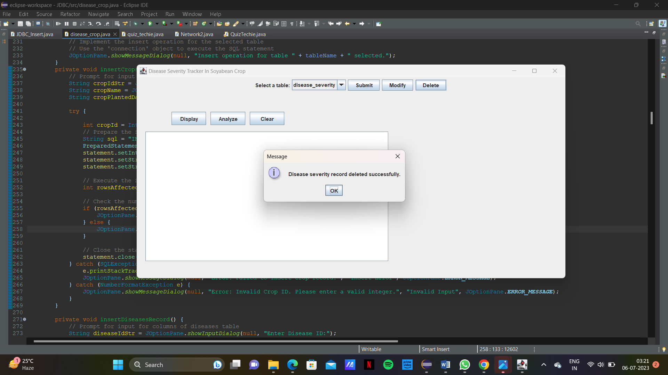

Fields table:

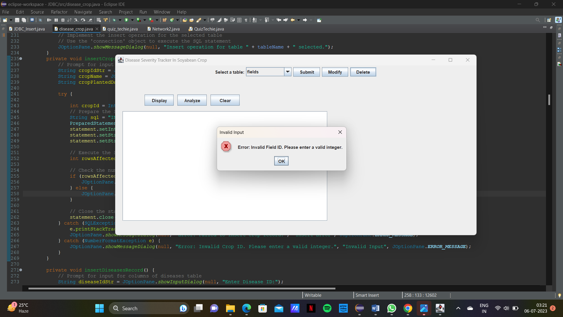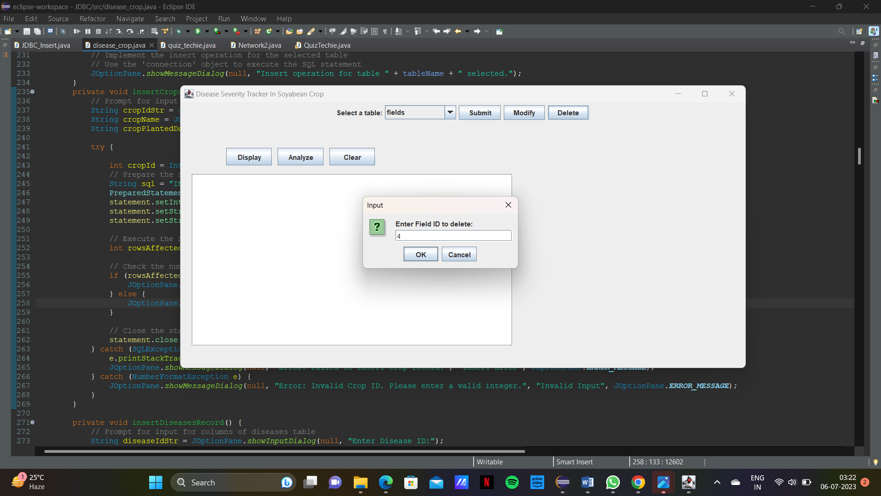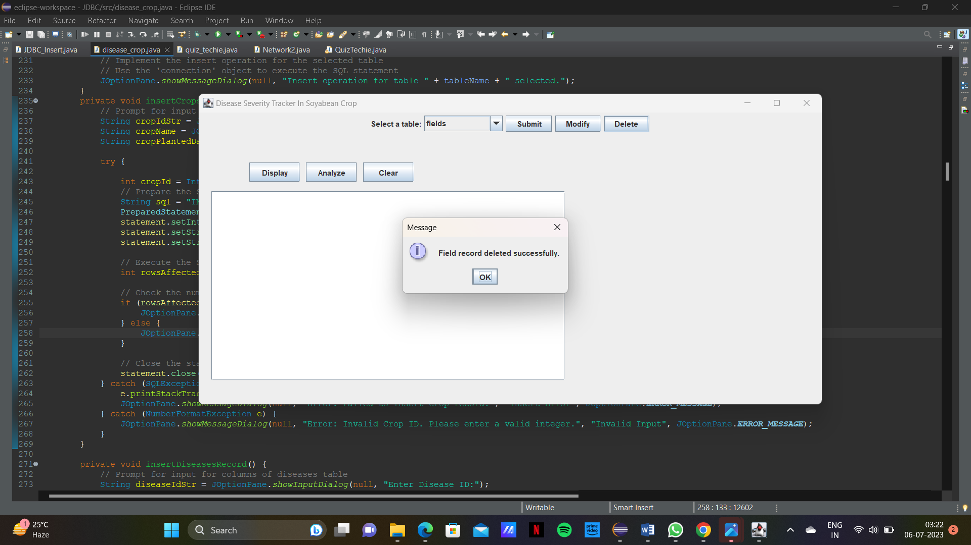

Field Crops Table:

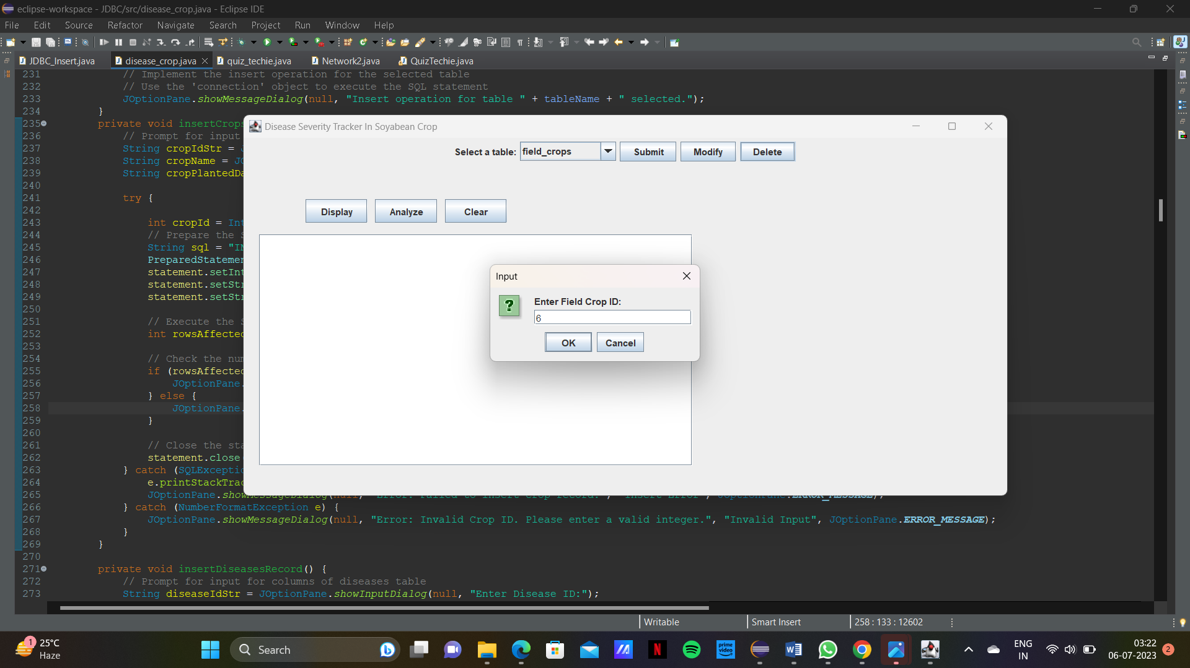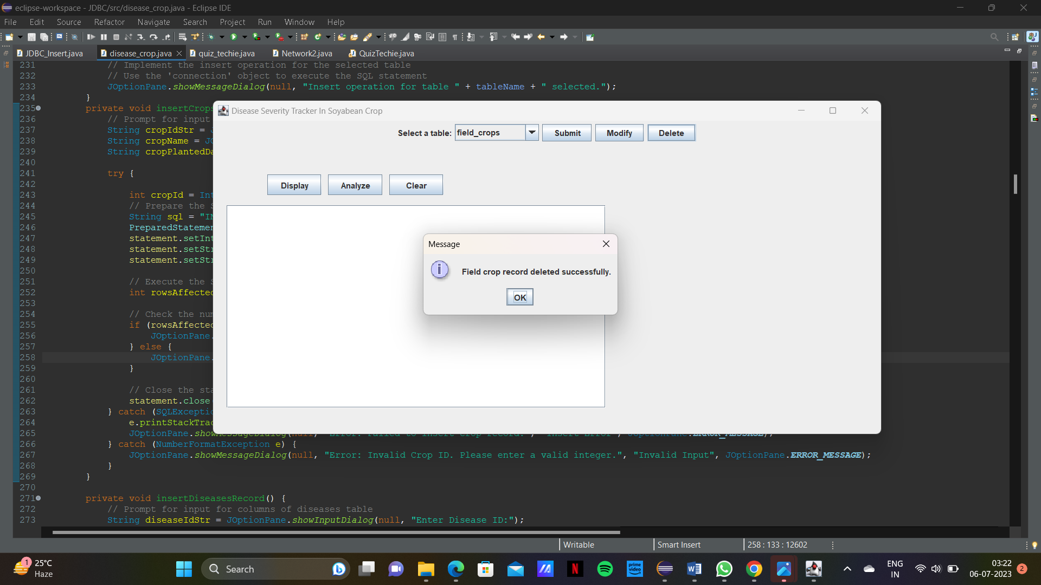

DISPLAYING CONTENTS OF TABLE:

Crops table:

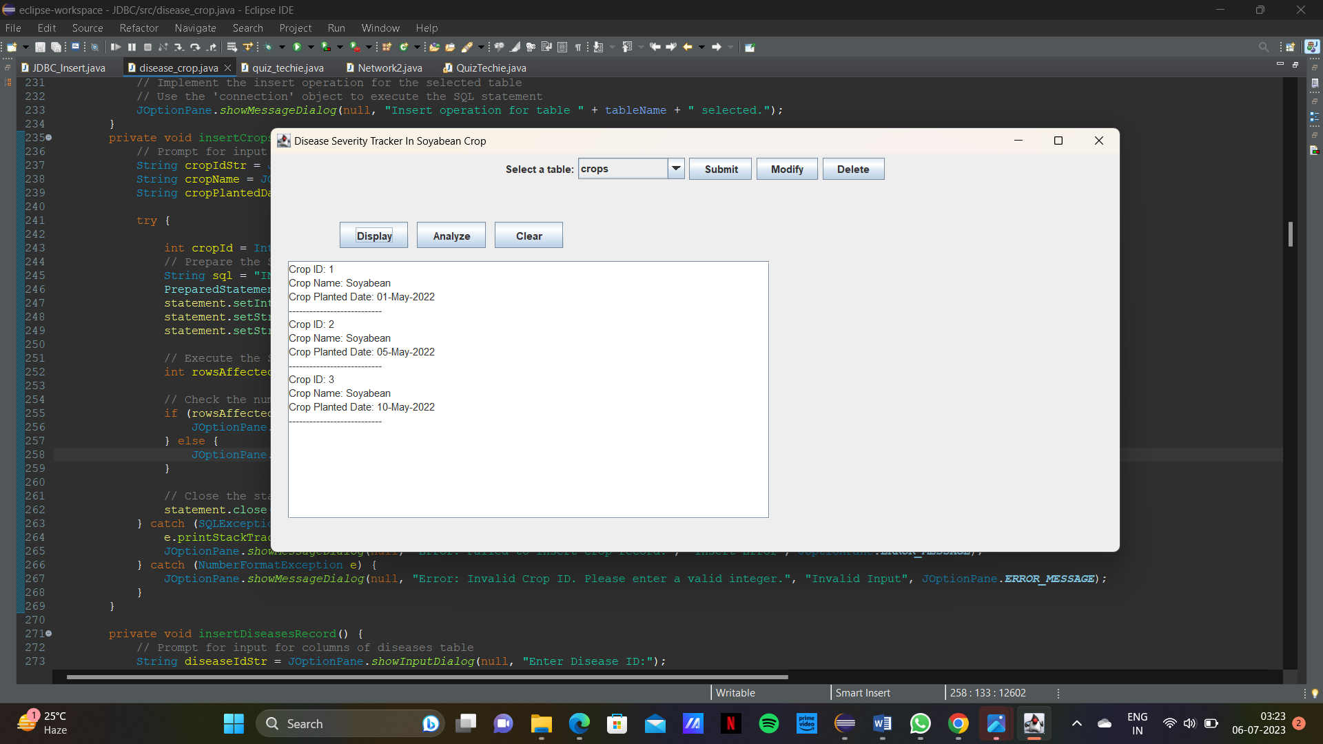

Diseases table:

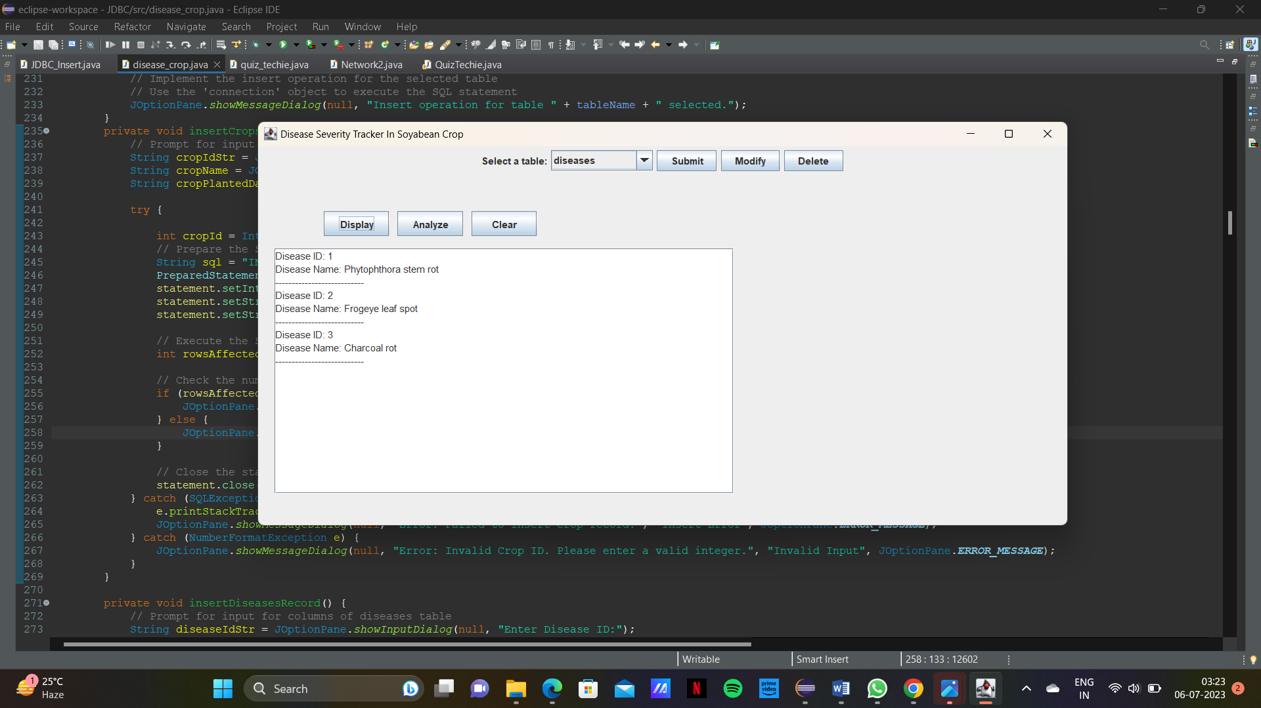

Disease Severity table:

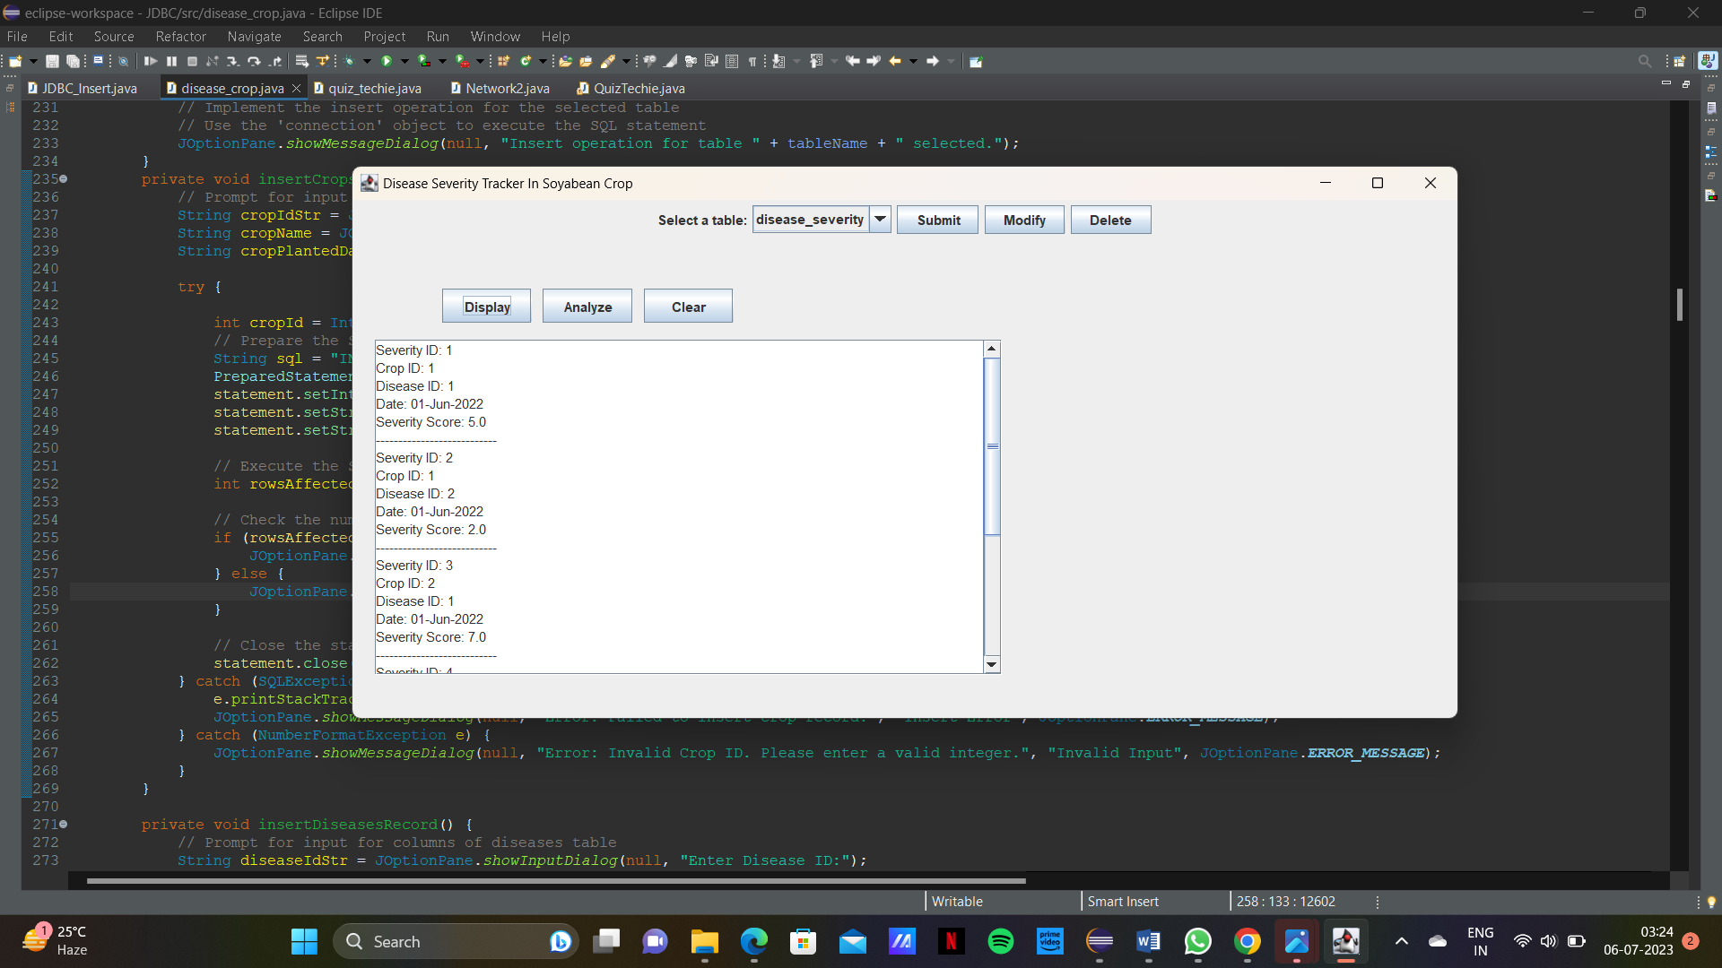

Fields table:

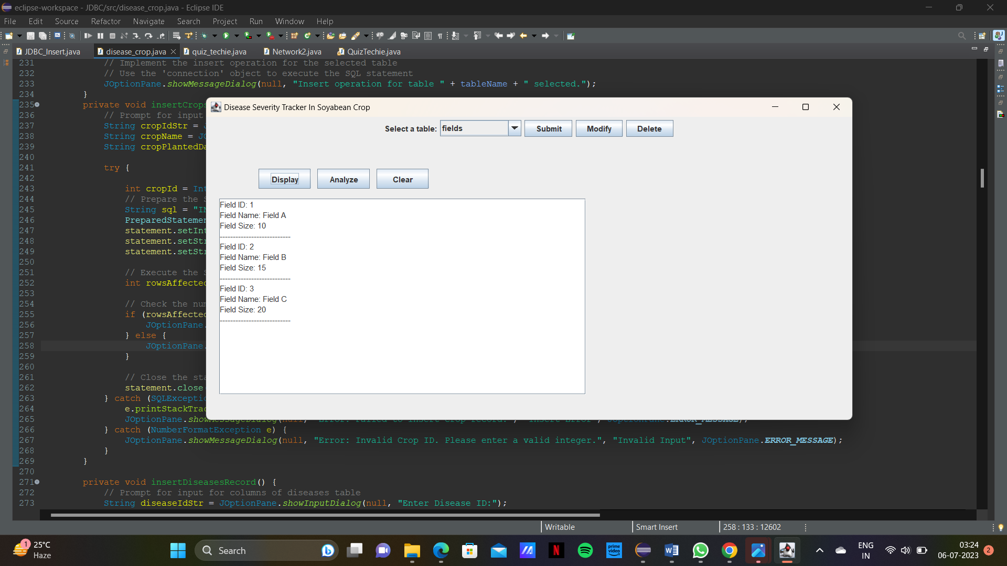

Field Crops table:

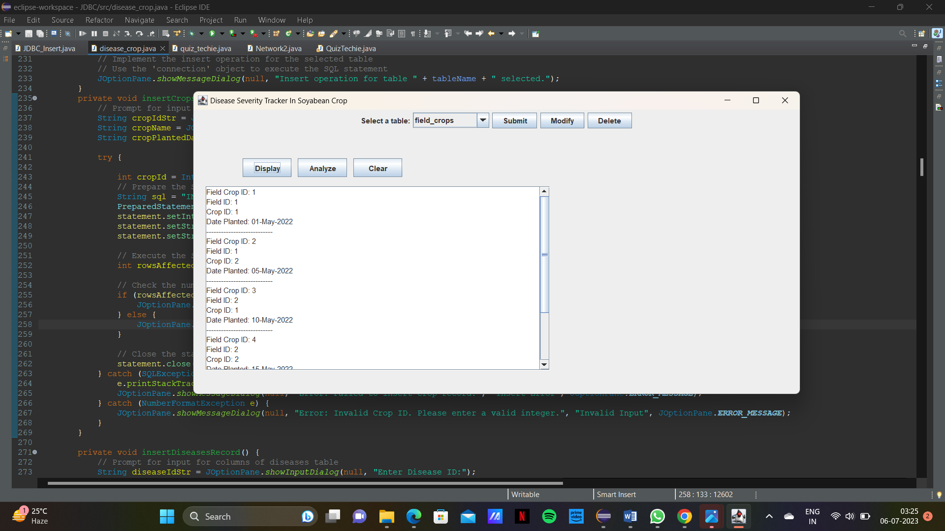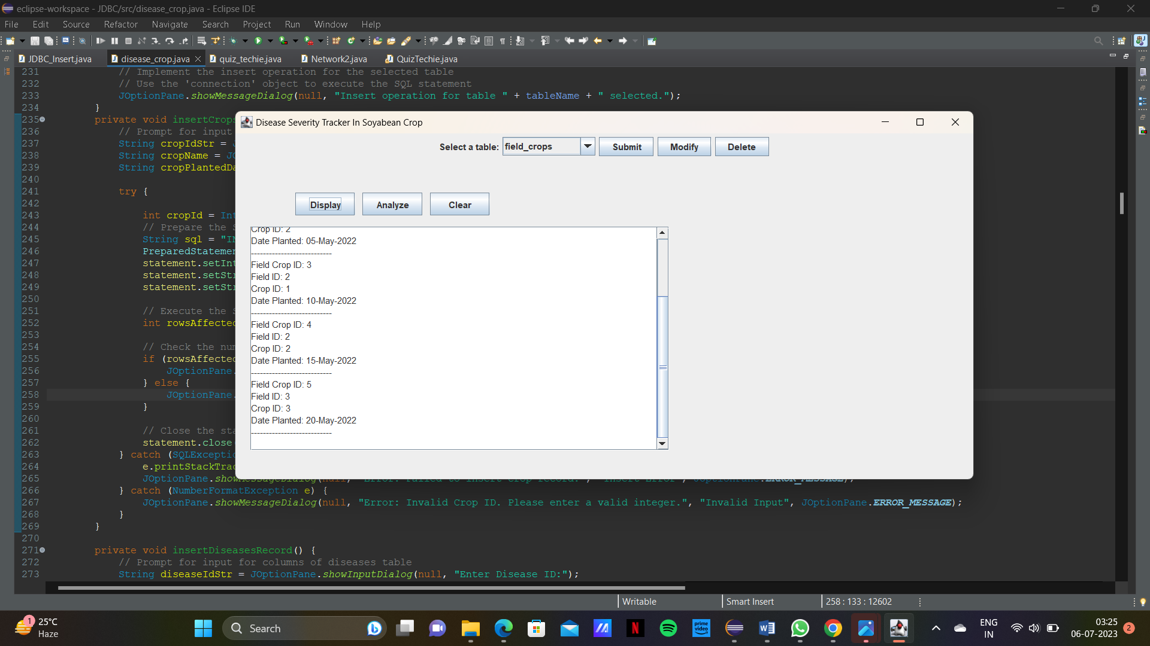

Clearing the text area:

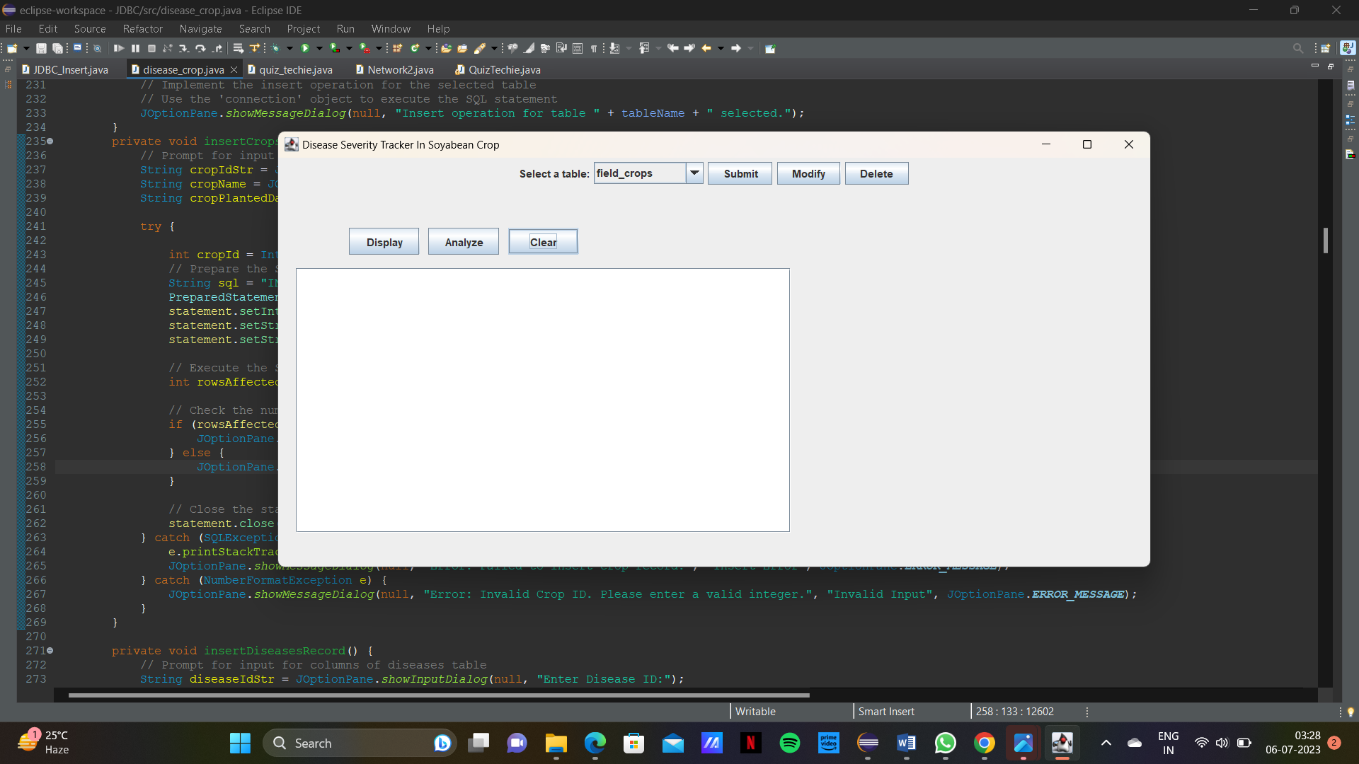

ANALYZING:

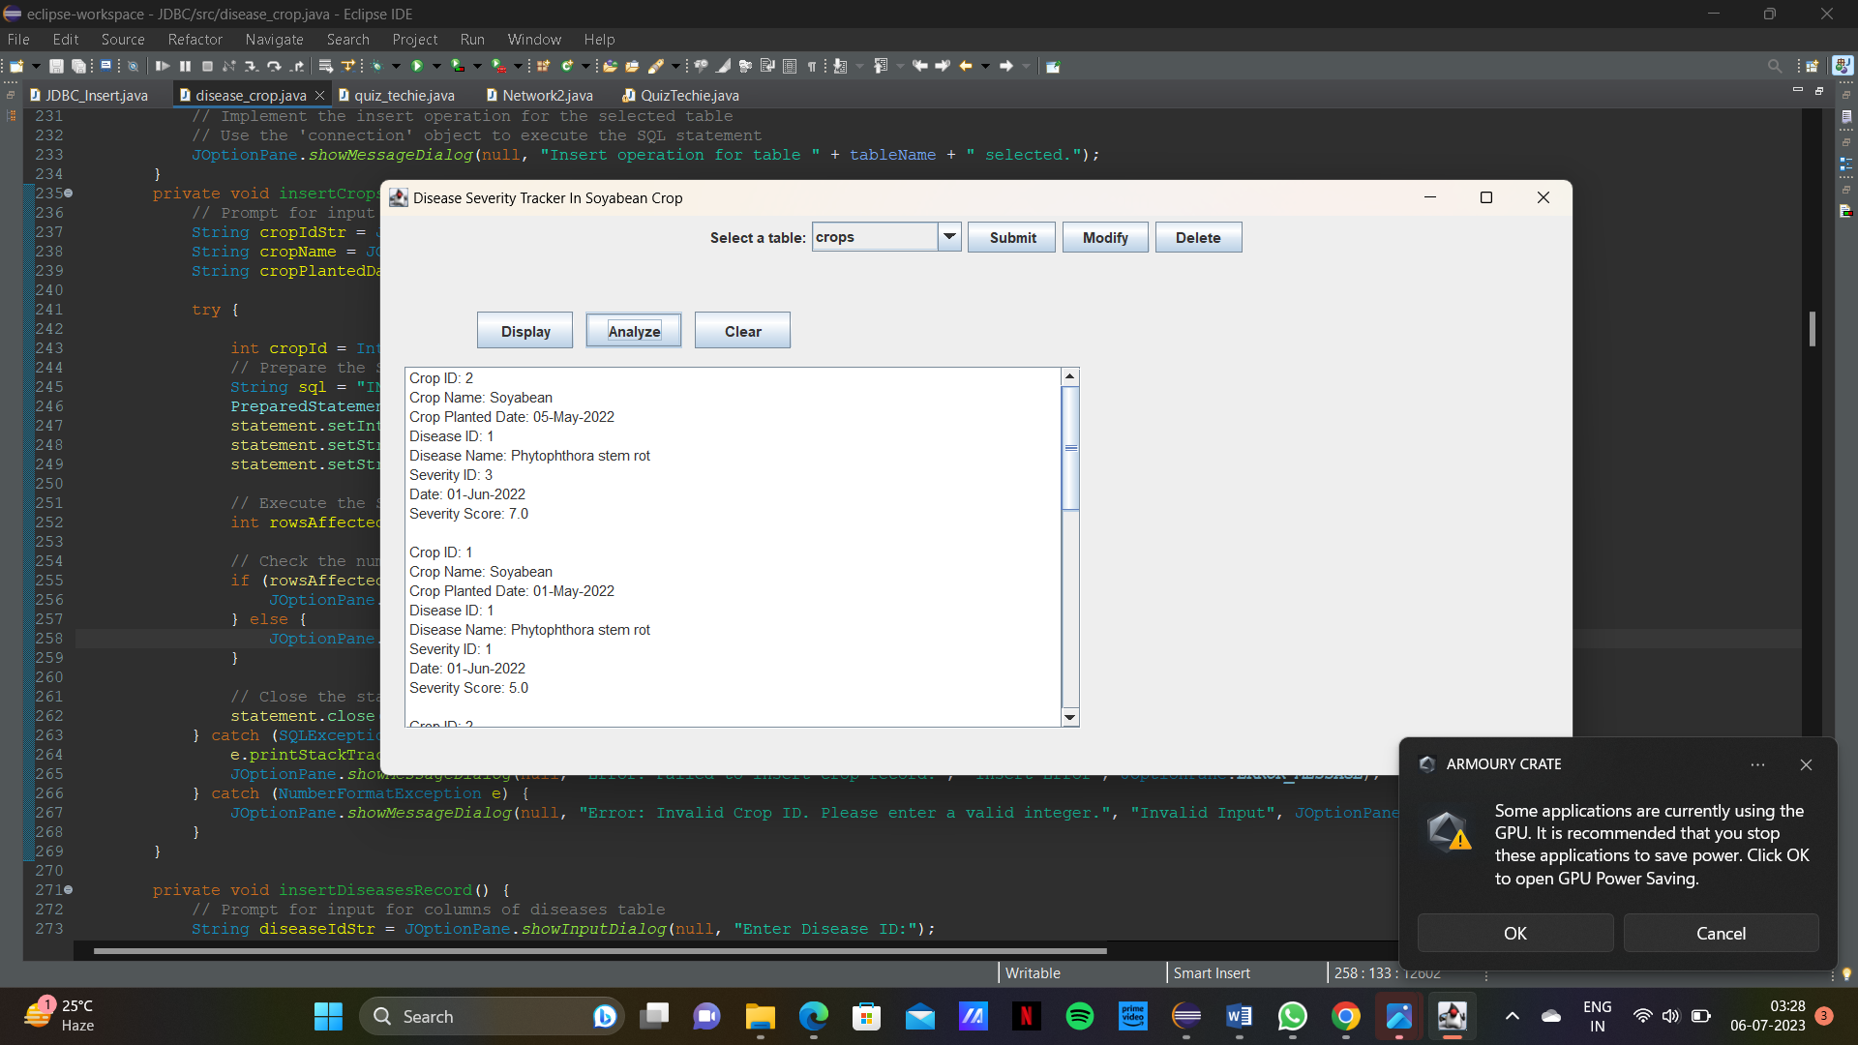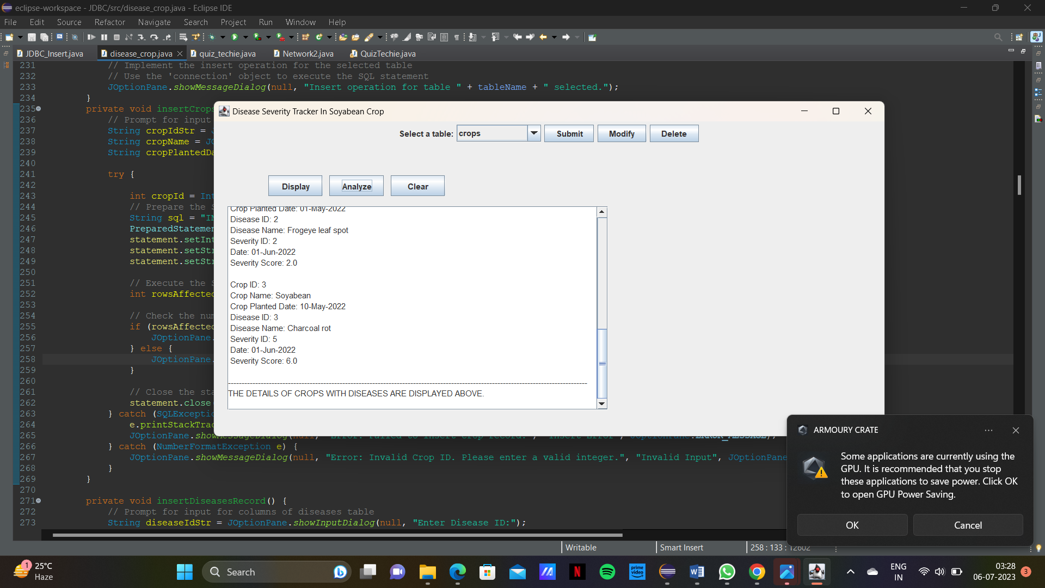

Maximum severity:

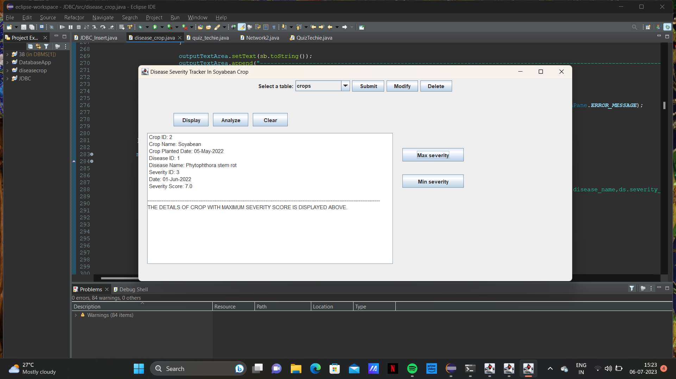

Minimum severity score:

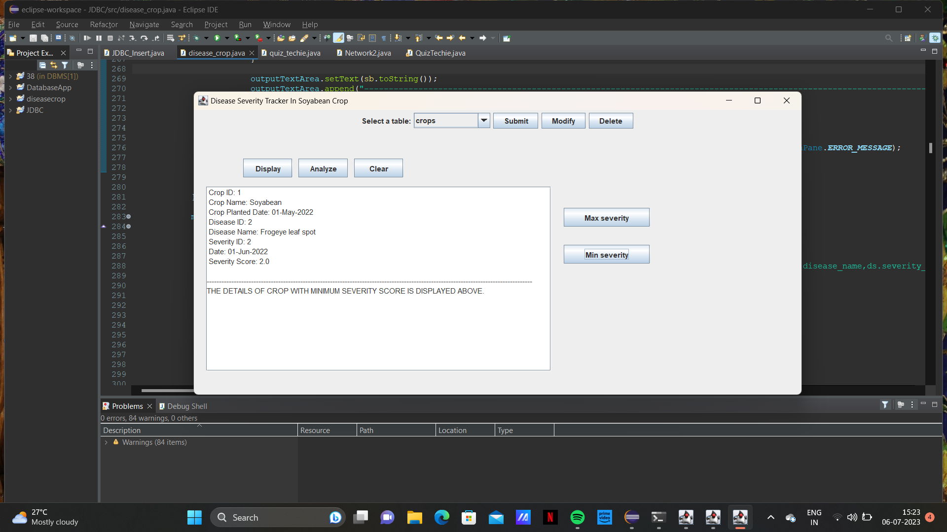

RESULTS

I have successfully completed the DBMS mini project “DISEASE SEVERITY TRACKER IN SOYABEAN CROP”.

DISCUSSION AND FUTURE WORK

This project contains the basic soyabean crop disease detection. It has a very basic user interface. Future Scope would be to make this UI more appealing by using graphics.

Making this project to work on a wider scale would be an improvement.

REFERENCES

* <https://docs.oracle.com/javase/7/docs/api/>
* <https://www.javatpoint.com/java-swing>
* <https://stackoverflow.com/>